Primary 1
Week beginning 08/06/20

Daily Numeracy activities

- Counting in 2s. We learned last week that Counting in 2’s means when you count you skip one number on the number line. Start at a different number every day and see how far you can get counting in 2s. Are you starting at an even or odd number?
- Count forward and backwards using different voices – can you use a quiet voice, a loud voice or even a singing voice? Start quiet and get louder as you count forward, or start loud and make your voice quiet as you count backwards.

Weekly Numeracy activities

Use the weekly activity grid and try to complete as many of the activities as possible throughout the week. If it is an activity that requires writing/recording please use your numeracy jotter. Some of the activities can be completed more than once. The more you do them the easier they will be to complete.

 | Number | Addition/Subtraction n | Beyond Number
Monday 8th June | The Numberblocks have been playing a game with a team of even and a team of odd numbers. Watch them at  https://www.youtube.com/watch?v=0wzyD3qrWUc  Did you enjoy watching? Did you learn anything?  Have a chat with a grown up or leave me a comment on the blog.  What team would you like to be in? Odd or even? | In class I talk about number bonds – numbers that add together to make the same answer.  Can you write down all the number bonds that give the answer 5?  Can you write down all the number bonds that give the answer 6?  Use your maths jotter and remember the “switch it around” strategy to help.  Check your answers with the number bond songs.  https://www.youtube.com/watch?v=y1oa6o0fMKk  https://www.youtube.com/watch?v=wIyEWSoz9UY | Time –  Say the days of the week in the correct order a few times.  Ask an adult to say a day of the week and tell them the day that comes after. Repeat this as many times as you like, how many can you get correct without a mistake?  Challenge – Repeat this task for months of the year.
Tuesday 9th June | Write the short date in your jotter: 09.06.20.  Copy the table below into your jotter, your adult can help you with this.  Odd Even  Sort the following numbers into the correct column.  0,1,2,3,4,5,6,7,8,9,10.  Challenge 1 – Sort the numbers up to 20 into the correct column.  Challenge 2 – Get an adult to give you any number and write it in the correct column – is it an odd or even number? How do you know? | Work on your subtraction skills by playing the following game.  https://www.topmarks.co.uk/maths-games/mental-maths-train  Select subtraction up to 10. Use the number line or number track to help if this is tricky.  You can also use some dry pasta to help take away and find the answer.  Challenge – select subtraction up to 20. | Time –  Say the days of the week in the correct order a few times.  Ask an adult to say a day of the week and tell them the day that comes before. Repeat this as many times as you like, how many can you get correct without a mistake?  Challenge – Repeat this task for months of the year.
Wednesday 10th June | Work on your number ordering skills by playing the game.  https://www.topmarks.co.uk/ordering-and-sequencing/coconut-ordering  Select numbers up to 10 or numbers up to 20.  Challenge – Select numbers up to 100. | In class I talk about number bonds – numbers that add together to make the same answer.  Can you write down all the number bonds that give the answer 7?  Can you write down all the number bonds that give the answer 8?  Use your maths jotter and remember the “switch it around” strategy to help.  Check your answers with the number bond songs.  https://www.youtube.com/watch?v=Ihl_9qjvWuc  https://www.youtube.com/watch?v=M0Kb6hpwB2U | Measure –  Get a small container, like a glass, tub or jug. Use a spoon and cold water.  How many spoonful’s of water does it take to fill the container so it is  - Full.  - Half full.  Challenge – Repeat this activity with a different size of container.  You can record your results in your jotter by drawing a picture if you like.
Thursday 11th June | Write the short date in your jotter: 11.06.20.  Copy these numbers down the left-hand side.  10  1  3  8  0  7  2  4  9  5  6  write the correct number word to match the numeral.  Use the list of number words below to help if this is tricky.  Challenge 1 – ask your adult to write numbers to 20 mixed up down the left-hand side and find the number word.  Challenge 2 – Ask your adult to give you a number between o and 20 and write the  number word. | Task 1 - In class I talk about number bonds – numbers that add together to make the same answer.  Can you write down all the number bonds that give the answer 9?  Check your answers with the number bond songs.  https://www.youtube.com/watch?v=edQvjdtQR7A  Task 2 - Ask a grown up to give you a number between 0 and 10. Keep that number in your head and try to subtract 1, 2 or 3 – use the counting back strategy.  Keep going to see how many times you can subtract in your head.  Challenge – ask for a bigger number to keep in your head | Money –  Log onto  https://www.topmarks.co.uk/money/coins-game  Use the sorting and ordering features to work on your recognition of coins.  Challenge – Try the counting the coins feature up to 20p.
Friday 12th June | Write the short date in your jotter: 12.06.20  Order the numbers from smallest to biggest.  - 6, 3, 2, 7  - 8, 10, 1, 5  - 7, 4, 2, 0  - 11, 2, 1, 9  - 13, 14, 0, 18  - 20, 12, 6, 2  - 8, 15, 18, 9  - 20, 16, 10, 19  - 2, 20, 12, 5  - 10, 0, 17, 1  Challenge – Ask for more sequences to order. Try it with bigger numbers or more numbers each time. | Last week you found numbers that add to give the answer 10. Watch the number bonds to 10 song to remind yourself of these.  https://www.youtube.com/watch?v=lD9tjBUiXs0  Use your knowledge of number bonds to find the missing numbers. You can do this task in your head or write it in your jotter.  - 5 + ____ = 10  - 0 + ____ = 10  - 7 + ____ = 10  - 3 + ____ = 10  - 10 + ____ = 10  - 8 + ____ = 10  - 1 + ____ =10  - 6 + ____ = 10  - 4 + ____= 10  - + ____ = 10  What number bond is missing? Leave me a comment on the blog.  Challenge – Create your own missing number sums for any set of number bonds. | Measure –  The Numberjacks have been investigating how to measure length.  Watch them at  https://www.youtube.com/watch?v=OqhVCeIlOSs  Did you enjoy watching? Did you learn anything?  Have a chat with a grown up or leave me a comment on the blog.  Challenge – Can you find things in your house that are the same length? Is there anything you can use to check they measure the same length?
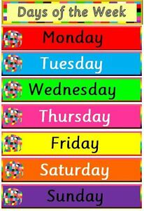
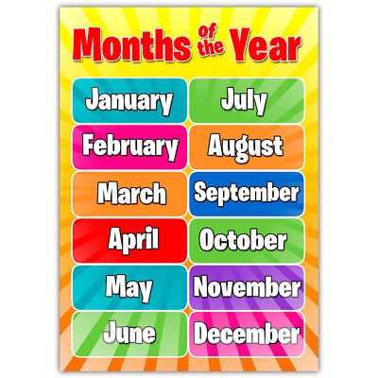
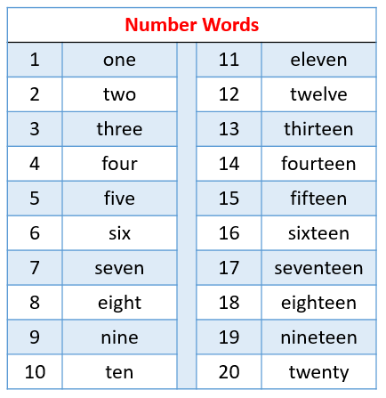

Use this resource to help with number word tasks. This can be printed or used online. Alternatively, you can write the words in your child’s jotter for them to copy underneath.

Use this number line to help with counting in 2s or any addition/subtraction tasks your child is finding tricky. This will help to build confidence with adding and subtracting mentally. (This resource can be printed, written into a jotter or used here.)

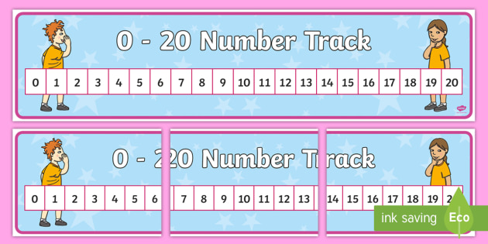
The number track can also be used for these tasks.

