 | Mental maths | Daily 10 | Challenge
Monday 8th June | 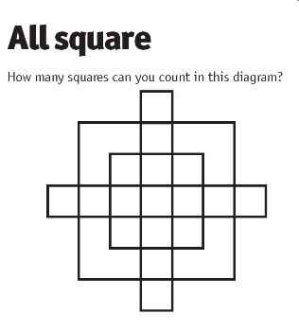 | *Simplify these fractions to their smallest amount*  (remember to find a common factor between the top and bottom number)  - 3/6  - 2/12  - 21/30  - 60/100  - 49/70  - 14/32  - 100/1000  - 25/50  - 56/64  - 81/90 | Tom was on the way to KLCC Park. He met a guy with 7 wives and each of them came with 7 sacks. All these sacks contain 7 cats and each of these 7 cats had 7 kits. So in total, how many were going to KLCC Park?
Tuesday 9th June | Write down as many different calculations as you for the answer:  48 | *use formal calculations*  - 3456 + 8723  - 10,000 – 4539  - 12,873 + 243  - 23,410 – 10,343  - 65,345 – 64,984  - 30,000 + 45,674  - 83,642 + 21,840  - 87,365 – 77,777  - 100,000 – 45,984  - 100,000 + 34,764 | A grandfather, two fathers and two sons drove to park together. Each of them bought one entry ticket each. How many tickets have they bought in total?
Wednesday 10th June | 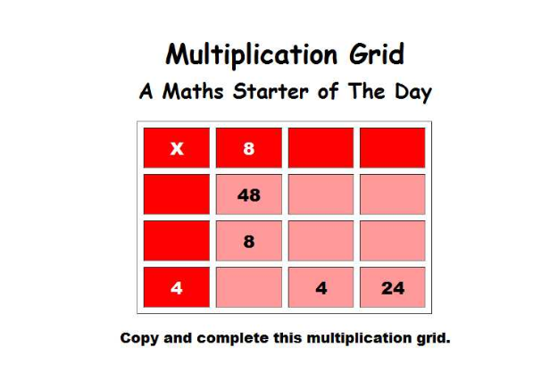 | *use either formal or mental math strategies to complete*  - 300 x 2  - 123 x 6  - 393 x 9  - 1000 x 10  - 4532 x 3  - 567 x 9  - 672 x 4  - 9234 x 7  - 2342 x 9  - 8453 x 4 | Two airplanes started the voyage. One flight is flying from London to KL at a speed of 400 MPH. The other flight is flying from KL to London at a speed of 600 MPH. Both these flights met at a point. Which of these flights will be closer to KL
Thursday 11th June | Write as many facts you can about the number:  2654  For example, it is a four digit number | Write the following numbers in words.  - 5874  - 30,654  - 23,875  - 67,983  - 100,874  - 300,873  - 567,932  - 1,564,874  - 2,785,700  - 10,345,879 | Mary has 7 daughters and each of them has a brother. Can you figure out the total number of kids Mary have?
Friday 12th June | Try and get as close to the target number using three of the six numbers below:  100 75 20 4 9 5  Target Number: 645 | *Use the chunking method to calculate the following, some will have remainders- be careful*  - 245 ÷ 4  - 129 ÷ 3  - 353 ÷ 5  - 985 ÷ 4  - 389 ÷ 5  - 900 ÷ 6  - 468 ÷ 2  - 100 ÷ 3  - 265 ÷ 4  - 875 ÷ 7 | 27 hens were marching towards the farm. 5 of them lost their way, 13 hens returned, and 9 hens finally reached the farm. What happened to the remaining hens?

- Remember to give all the activities a go and always try your best. Make sure you do your activities in your jotter or online and then you can take a picture or upload your work to the blog.
- If you have any questions remember you can post any questions you have on the blog.
- Take care and stay safe

