All Groups | Spelling | Reading | Writing | Talking and Listening
Monday 8th June | Write each work out 5 times and practise spelling out loud with someone in the house. | Read Chapter 6 of JK Rowling’s new online book ‘The Ickabog’.  (can be found here- https://www.theickabog.com/read-the-story/ )  - Write a letter to a friend saying why you would recommend that they read this as well. | A new type of car has been invented: The Spider Car. Write about all the cool features of this car. Then invent your own cool car.  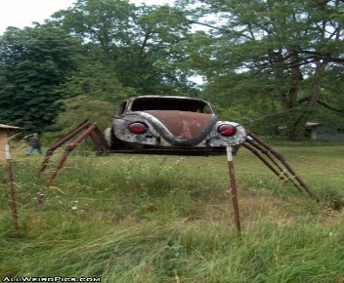 | If you could interview your favourite author. What five questions would you ask this author? Why did you choose this author?
Tuesday 9th June | Choose a spelling strategy and spell and write your words. | Read Chapter 7 of JK Rowling’s new online book ‘The Ickabog’.  (can be found here- https://www.theickabog.com/read-the-story/ )  - Make a list of the characters you have met so far and write a short paragraph about who your favourite is and why. | Use this story starter to write an imaginative story.  “Buzzzzzzzzzz!” The sound of my alarm droned in my ears as I struggled to stay awake. I sat straight up in my bed. This was a big day for me. I had to be on time… | If you were a journalist attending the ‘Daily Briefing’ and got to ask the Prime Minister (Boris Johnson) a question. What would it be?
Wednesday 10th June | Write your words in alphabetical order and choose five words and write them in a sentence. | Read Chapter 8 of JK Rowling’s new online book ‘The Ickabog’.  (can be found here- https://www.theickabog.com/read-the-story/ )  - Make a list of any unusual language or phrases from the last 3 chapters, discuss with someone in the house. | If you could choose any fictional character (fictional someone who is not real for example spiderman) as your best friend, who would you chose and why? What would you do together? What adventures/ trouble would you get into? | Discuss with someone in your house the following statement:  Do you think everyone in the world should speak English?
Thursday 11th June | Put your words in a wordsearch and see if someone in your house can find them. | Read Chapter 9 of JK Rowling’s new online book ‘The Ickabog’.  (can be found here- https://www.theickabog.com/read-the-story/ )  - Draw a picture of what the main characters look like (use what is written about them to help you) | Use this picture as a prompt to help you write a story | Play ‘I went to the shops’ memory game with your family.
Friday 12th June | Spelling test- get someone at home to call out your spelling words for the week and see how many you can get right. | Read Chapter 10 of JK Rowling’s new online book ‘The Ickabog’.  (can be found here- https://www.theickabog.com/read-the-story/ )  - Design a front and back cover for the book. Remember to include a blurb. | If you were forced to spend the rest of your life in a library, museum, or a zoo, which would you choose and why. | Drawing on Demand.  - Think of an object.  - Give someone in your house a set of instructions of how to draw this object without telling them what it is.  - After your instructions does the picture match the object you had.  - You could even swap roles and you have to follow the instructions and the adult thinks and says the instructions to you.

- Remember to give all the activities a go and always try your best. Make sure you do your activities in your jotter or online and then you can take a picture or upload your work to the blog.
- If you have any questions remember you can post any questions you have on the blog.
- Take care and stay safe

