**Auchinraith Nursery Class**

**Fun activities you can do at home all about**

**‘What the Ladybird Heard’**

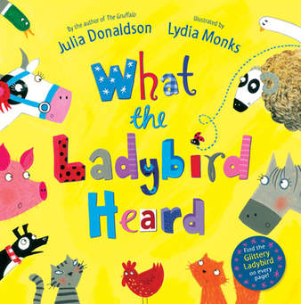

**Health and Wellbeing**

In the story there are lots of different farm animals who eat different food and live on the farm.

* With an adult, talk about where different animals live on the farm. Can you draw a picture of an animal and its house?
* Do you know what the baby animals are called on the farm?
* Different farm animals produce different food, watch this video below to find out what animals give us food:

<https://www.youtube.com/watch?v=8M8siMgbVkA>.

* Can you make a fruit or vegetable kebab and talk about where each ingredient comes from?
* Draw a picture of some different foods that farmers grow in their fields.
* Can you help an adult to prepare some ingredients for dinner? Where do they come from?

Learning Across the Curriculum

* Create a picture of a ladybird or farm animals using collage.
* Can you find stones in your garden or on your daily walk and paint them to create a family of bugs or animals?
* Can you gather lots of leaves and use them to create a picture?
* Look at the illustrations of the farm in the book. Look at the different textures used on the tree/grass/building. Can you recreate these using different art materials?
* Can you sing a song about farm animals?

<https://www.youtube.com/watch?v=s-g8UswAh_s>.

Numeracy

* Number songs/rhymes for this week:
* 1,2 Buckle my shoe:

<https://www.youtube.com/watch?v=MMCBFCrZcdg>.

* One Potato, Two Potato:

<https://www.youtube.com/watch?v=vBXv6rmI58I>.

**With your child**

* Count the animals with two legs.
* Count the animals with four legs.
* Can you write the number for each amount?
* How many animals have a beak?
* How many animals have a nose?
* Can you sort the animals from smallest to biggest?
* Can you sort the animals from heaviest to lightest?

**Extra Challenge**

* In what other ways can you sort the animals? How many animals are there altogether?

**Please find below links to activities relating to the learning above.**

**Counting:**

<https://www.topmarks.co.uk/learning-to-count/ladybird-spots>.

<http://www.hbschool.com/activity/olivia_octagon/activity3/a3Shell_3.html>.

<https://www.topmarks.co.uk/learning-to-count/helicopter-rescue>.

**Sorting/Measure:**

<http://resources.hwb.wales.gov.uk/VTC/the_zoo/eng/Introduction/mainsession1.htm>.

<https://www.topmarks.co.uk/early-years/lets-compare>.

**Number Formation/Same/Different:**

[**https://www.doorwayonline.org.uk/activities/letterformation/**](https://www.doorwayonline.org.uk/activities/letterformation/)**.**

<https://www.doorwayonline.org.uk/memoryandmatching/sameordifferent/>.

**Literacy**

**Reading**

* If you have the story book, please read this to your child.
* Alternatively, please use the following link to access the story:

<https://www.youtube.com/watch?v=Eu9mPX7DuLA>.

**With your child, talk about**:

* Title, Author and Illustrator
* What animals lived on the farm?
* What noise did each animal make?
* What did the Ladybird see and hear?
* Can you identify the rhyming words used throughout the story?

**Extra Challenge**

* Can you make your own rhyming book, adding other rhyming words for the ones you have found in the book?

**Talking and Listening**

With your child, listen to the link below of ‘Down on the Farm’. While listening, pause and ask your child to discuss what they hear.

<https://www.bbc.co.uk/cbeebies/radio/down-on-the-farm-spring>.

**Writing**

* Draw or paint a picture of a farm. What animals will you include?
* Draw or paint a picture of a ladybird. How many spots will it have? Does it have a name?
* Talk to an adult about your picture.

**Extra Challenge**

* Hefty Hugh and Lanky Len both have same sound at the beginning of their names (remember we call this alliteration). Can you think of alliteration for your name?