Health and Wellbeing – Week Beginning 1st June 2020
 | Monday | Tuesday | Wednesday | Thursday | Friday
P1 and P2 | First Aid – When and How to call 999  Use this link to help teach/remind your child about when to call for an ambulance and how to do so.  There are 3 short sections to looks at:  - When to call 99  - How to call 99  - What to do when the ambulance is coming  You could get your child to make a sign to stick on the fridge with the phone number and address to give to the operator. You may want to do some role play so they can practise what to say to an operator.  https://www.neas.nhs.uk/patient-info/learning-disability-zone/how-can-the-ambulance-service-help-me/emergency-care999.aspx | Yoga Time!  Yoga is a fantastic way to relax and exercise at the same time. It’s especially good for stretching out muscles that might be achy from sitting in the house over the last few weeks. Cosmic Kids is a great YouTube yoga resource. Why not get all of the family involved?!  https://www.youtube.com/user/CosmicKidsYoga | Kindness  Discuss what kindness is  - Being friendly  - Looking after other people  - Helping people  - Being nice to others  Discuss ways to show people kindness. E.g.  - Smile at people  - Say hello and wave  - If somebody is upset, ask if they are ok  Discuss why it is good to be kind  - It makes people feel happy  - It helps to make friends  - It stops people feeling upset.  Lastly, think about two kind things you could do today for someone in your house and do them. | Let’s Get Cooking!  Easy Ice Cream  This recipe is specially designed for young children to be able to make (with guidance from an adult) and is perfect for this lovely weather that we’re having!  If you don’t like strawberries then you could use raspberries, ripe bananas, peeled peaches or nectarines for this recipe.  https://www.bbcgoodfood.com/recipes/easy-strawberry-ice-cream | Make a Mindfulness Jar  Create a mindfulness jar using glitter, water and dish soap. Shake it and watch the magic happen! The glitter will begin to  settle the longer the jar is still, just like the thoughts  in your mind when you take a moment to be calm. If you need some time to calm down or relax then this is a good way to do it!
P3 and P4 | First Aid  Knowing some basic first aid skills can be really useful in case you or someone else has an accident in the house or when you are out playing.  Use the Red Cross website to look at this first section of the first aid programme.  - Read the ‘What is First Aid?’ section  - Click on the ‘How First Aid Works’ section  - Read the ‘Why the big deal?’ section  - Lastly watch the six ‘How to’ videos which shows you how to deal with things like burns, choking and cuts.  https://lifeliveit.redcross.org.uk/What-is-first-aid | Yoga Time!  As with P1 and P2, your task is to do some yoga, however this is link to one that is for children who are a bit older. Yoga is a really good way to relax, stretch your muscles, and build your flexibility and strength. This clip is only 17 minutes long so if you fancy doing some Cosmic Kids yoga afterwards, then click on the link in the P1 and 2 section.  https://www.youtube.com/watch?v=4ZpkRAcgws4 | Self Esteem Building  Use the activity sheet from the link in my post called “I Am an Amazing Person” to remind yourself about why you are amazing. If you can’t print it out then you can make your own poster using the headings from the sheet. Stick it up on your bedroom wall so you never forget how wonderful you are!  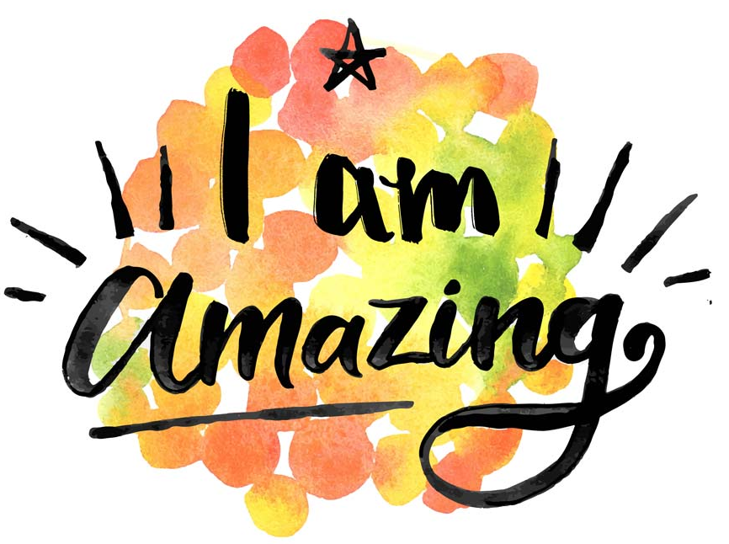 | Let’s Get Cooking!  Fruit Faces  Today you are going to focus on practising some basic knife skills whilst making a fun and healthy snack!  PLEASE MAKE SURE YOU DO THIS WITH AN ADULT.  - Choose the different fruit that you want to use to make your face.  - Make sure you wash any fruit that isn’t going to have its skin taken off e.g. grapes, apples.  - With an adult’s guidance, use a sharp knife to slice up the fruit.  - Arrange the fruit on the plate so it looks like a face and voila! A delicious and healthy snack.  Have a look at the pictures below for some ideas.  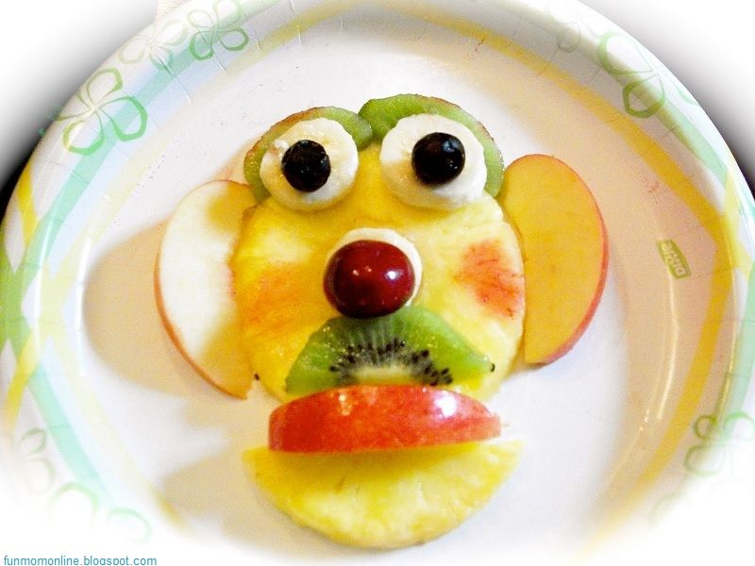  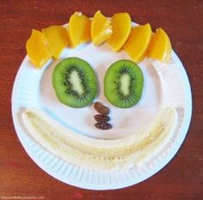 | Things to Look Forward to Jar  Create your own wellbeing jar. Having things to look forward to can make you feel happier and improve your wellbeing. Each time you think of something you would like to do in the future, write it on a piece of paper and put it in your decorated jar. Once lockdown is over, work your way through all the things you want to do! You could also use it for ideas to keep you busy during lockdown e.g. I want to learn how to bake a cake, I want to grow a plant etc.  I have put instructions for this in a link in my post. If you don’t have certain materials, don’t worry – the jar can be decorated in any way you wish.  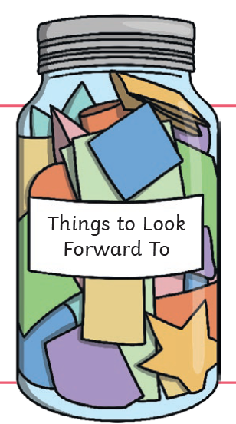
P5, P6 and P7 | First Aid  Knowing some basic first aid skills can be really useful in case you or someone else has an accident in the house or when you are out playing.  Use the Red Cross website to look at this first section of the first aid programme.  - Read the ‘What is First Aid?’ section  - Click on the ‘How First Aid Works’ section  - Read the ‘Why the big deal?’ section  Lastly watch the six ‘How to’ videos which shows you how to deal with things like burns, choking and cuts.  https://lifeliveit.redcross.org.uk/What-is-first-aid | Yoga Time!  This first link is a yoga video focused on your breathing. When you change your breathing to slow, deep breaths it can have a really amazing effect on your state of mind and feelings in your body. Learning breathing techniques has really helped me in times when I have felt nervous or stressed and I wish I’d learnt about it when I was your age! Give it your best shot but remember it might take a bit of practise.  https://www.youtube.com/watch?v=5EI6fiWY_I4&list=PLtKFn2-K_dbB0uljE2gZaInrx0LDjfrHm&index=11&t=0s  If you want to do some more floor based yoga then here is another short video:  https://www.youtube.com/watch?v=ck-Y_SE4m9U&list=PLtKFn2-K_dbB0uljE2gZaInrx0LDjfrHm&index=1 | See the Good in Every Day  Sometimes when you aren’t feeling your best, it can help to remind yourself about the good things in your life. Make a list of things you are grateful for or good things that have happened today. Keep this somewhere safe so you can look at it whenever you feel you need it. It can be good to get into a routine of making a quick list every night before bed. (You can have more than 3).  For example:  - I am grateful for the good weather so I can sit in the garden.  - I am grateful that I am feeling healthy.  - I am grateful that I can spend more time with my family  OR  Today was a good day because…  - I got to watch my favourite TV programme.  - I facetimed my friends.  - I beat my speed for writing out my 7 times table. | Let’s Get Cooking!  Homemade Burgers  This is a great way to practise your weighing, mixing and slicing skills. Seeing as the weather has been so good, why not ask if your parents if they can help you to cook them on the BBQ!  https://www.bbcgoodfood.com/recipes/cheeseburgers-0  If you fancy being a little more creative than a standard cheeseburger, take a look at these burger recipes for kids:  https://www.bbcgoodfood.com/recipes/collection/kids-burger  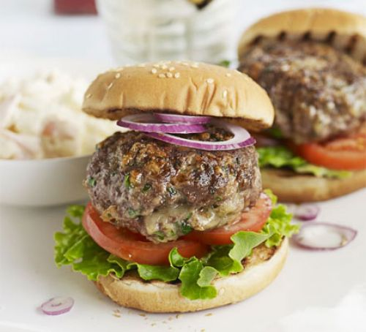 | Friendship Portrait  I know you will all be missing your friends so why not make this to show a friend how special they are.  Draw a picture of one of your friends and around this, label all their positive attributes. For example, you are kind-hearted, you always know what to say to cheer me up, you are a good listener etc.  You could show it to them on Face Time or send them a picture of it. I’m sure it will brighten up their day!

