P7 Transition Activity 2 – Timetables
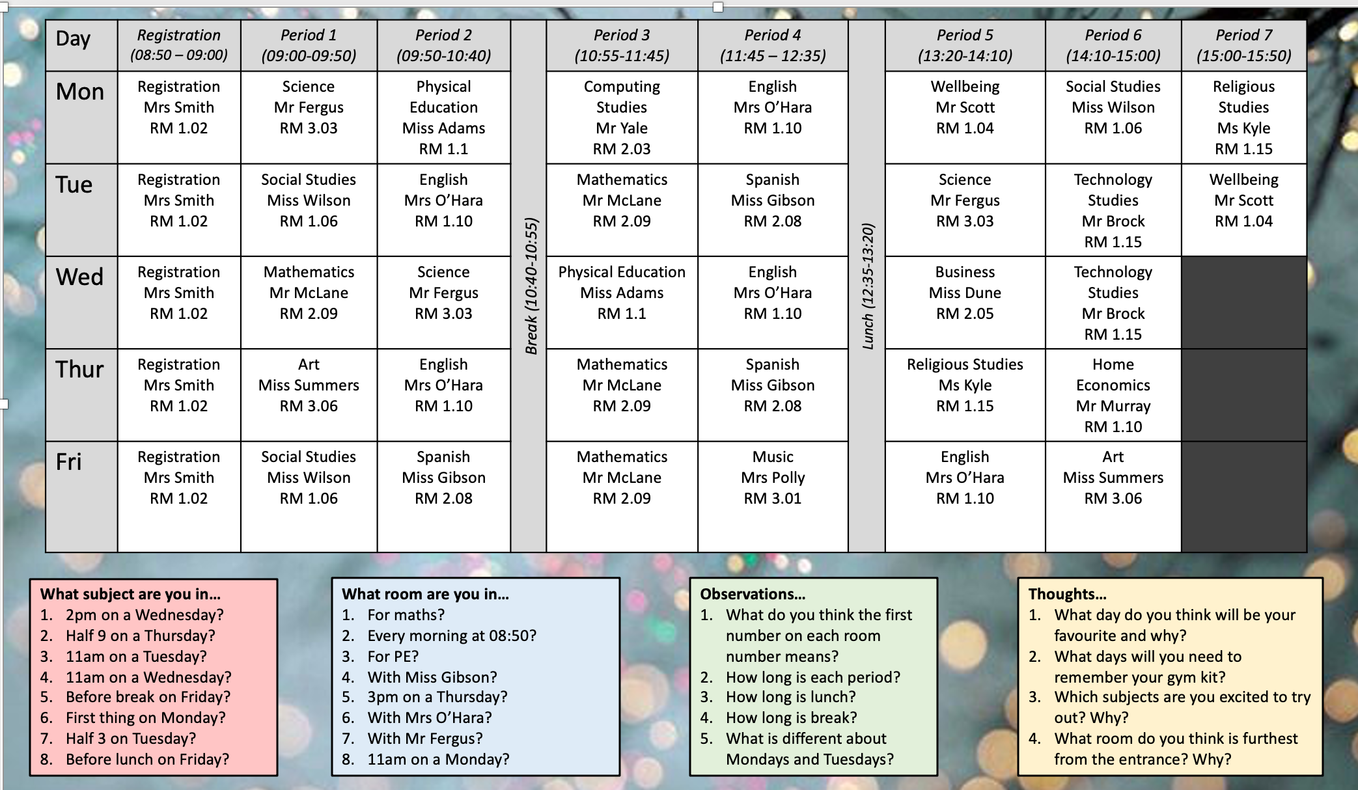
This is an illustrative example only and may not accurately reflect the secondary school you will attend.

