Look at the different learning tasks below. Try to complete one or two tasks each day.
Number
Practice counting in 1s, 2s, 5s and 10s. How high can you go?

Challenge:
- Can you count backwards all the way?
- Can you try counting in 3s?

Choose 5 two-digit numbers. Can you subtract 10 from each of them?
Example: 12 - 10 = 2 24 – 10 = 14 …etc

Here is a reminder of the bridging through 10 strategy for both addition and subtraction, you could use this to help you try the challenge!

https://www.bbc.co.uk/bitesize/articles/zb8gcqt

Challenge:
- Can you use your mental strategies to subtract a two-digit number from a two-digit number?
Example: 34 – 22 = 12 (Partitioning strategy with working)
30 – 20 = 10
4 – 2 = 2
If you need a reminder of the strategies, check out the Extra Resources page on the blog for some handy tips.
Practice writing out your numbers 0-9. Make sure they are facing the right way and are not too big, not too small…just right!
If you have squared paper, make sure you have one digit in each box.

Try out this Number Fact Families game!

Can you spot the links between the addition and subtraction calculations?

Choose your level:

Within 10
Within 20
Within 50
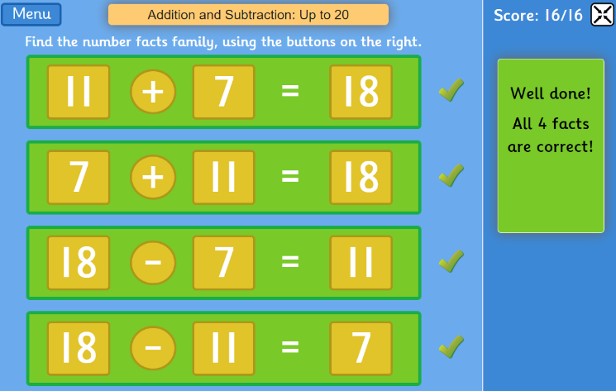
Who can beat my score of
16/16? Send your
screenshot to the email
address!
Beyond Number
Can you write the days of the week in order?

Can you write the calendar months in order?

Try out the days of the week and months of the year game here:

https://www.roythezebra.com/reading-games-high-frequency-words.html

Watch this video about telling the time on a clock face (analogue):

https://www.bbc.co.uk/bitesize/topics/zhk82hv/articles/zcmdwxs

The long hand is called the minute hand.
The short hand is called the hour hand.
There are 60 minutes in one hour.

There are 12 numbers on a clock face, 1 – 12, with 12 at the top in the middle.

When the minute hand points to 12, the clock is showing an o’clock time (exact hour). The hour hand will be exactly at one of the numbers on the face.
When the minute hand points to 6, the clock is showing a half past time (30 minutes past the hour). The hour hand will be in between two numbers on the face.
Challenge:
- Draw a clock face and label its parts: face minute hand hour hand
- Make your own clock face using some paper, you will need to cut out a big circle, a long thin rectangle for minute hand and a short thin rectangle for the hour, like this:

Ask an adult to ask you to show different o’clock and half past times.

If you don’t have paper, you can try this game:
https://mathsframe.co.uk/en/resources/resource/116/telling_the_time#
Choose level 1 (o’clock only) or level 2 (o’clock and half past).
Problem Solving
Read the chilli challenges below. Choose the mild option for an easier challenge, and spicy to test yourself! Can you work out the answers? Remember, if you want me to check your problem solving…or you need a clue, leave me a comment here or ask a parent to send me an email and I will reply here on the blog.
Mild

Can you work out the value of each shape?

Spicy

Tom has six 10p coins and three 5p coins. He buys an apple for 59p and two pencils.
He has no money left. How much does a pencil cost?

Hot

Amir and Donna each make a three-digit number using all these number cards.

Amir notices that when he subtracts his number from Donna's number he gets an answer greater than 300 but less than 400.
What numbers did they make?

