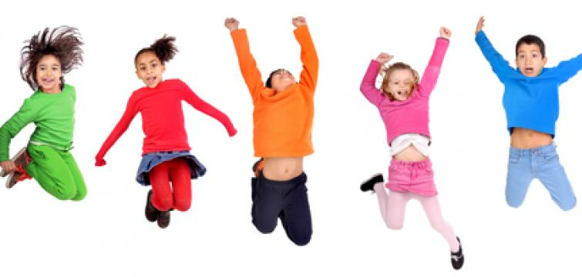

P.E. – Week Beginning 1st June 2020

Monday

Gymnastics – Let’s see what you can remember from our gymnastics lessons last term! Try out these 3 activities. If you don’t have a dice, you could always write the numbers 1-6 on pieces of paper, scrunch them up and choose one.

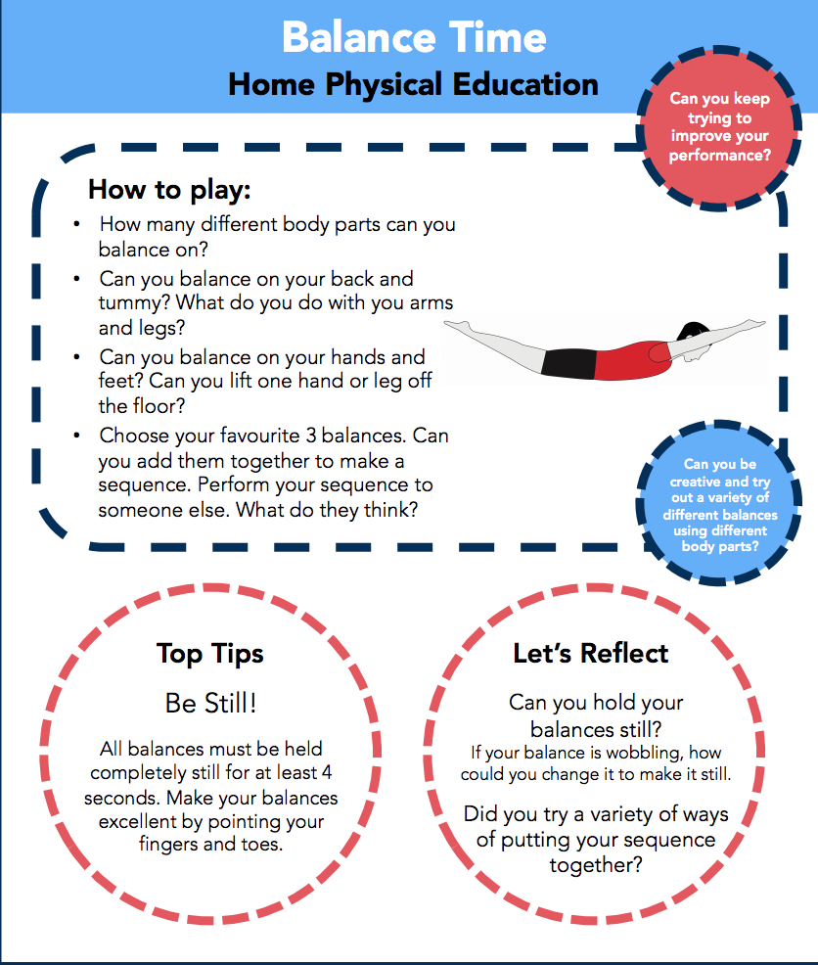

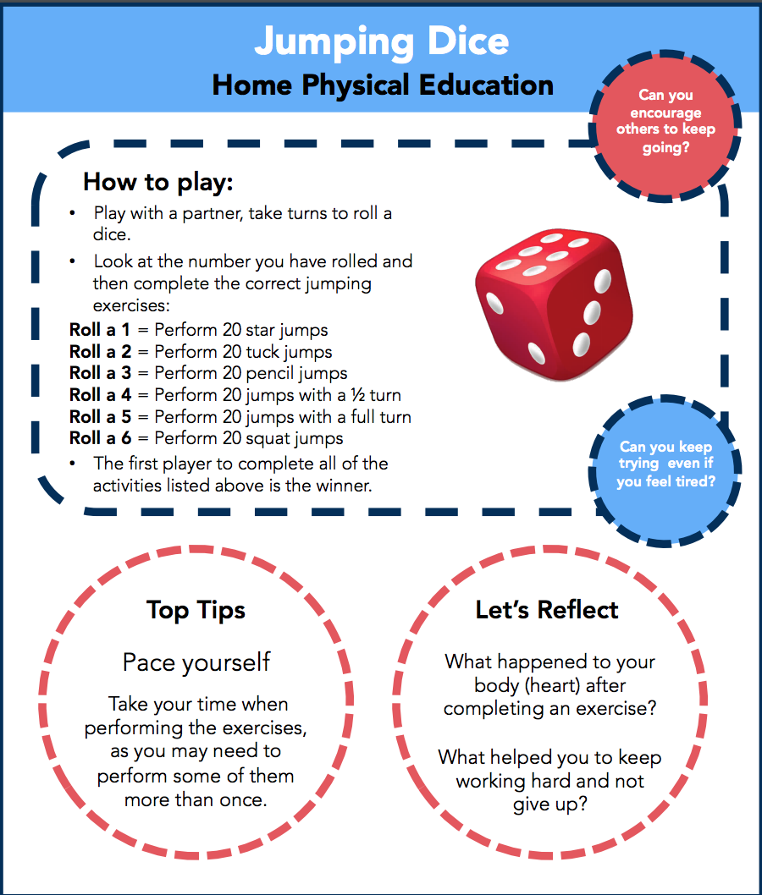

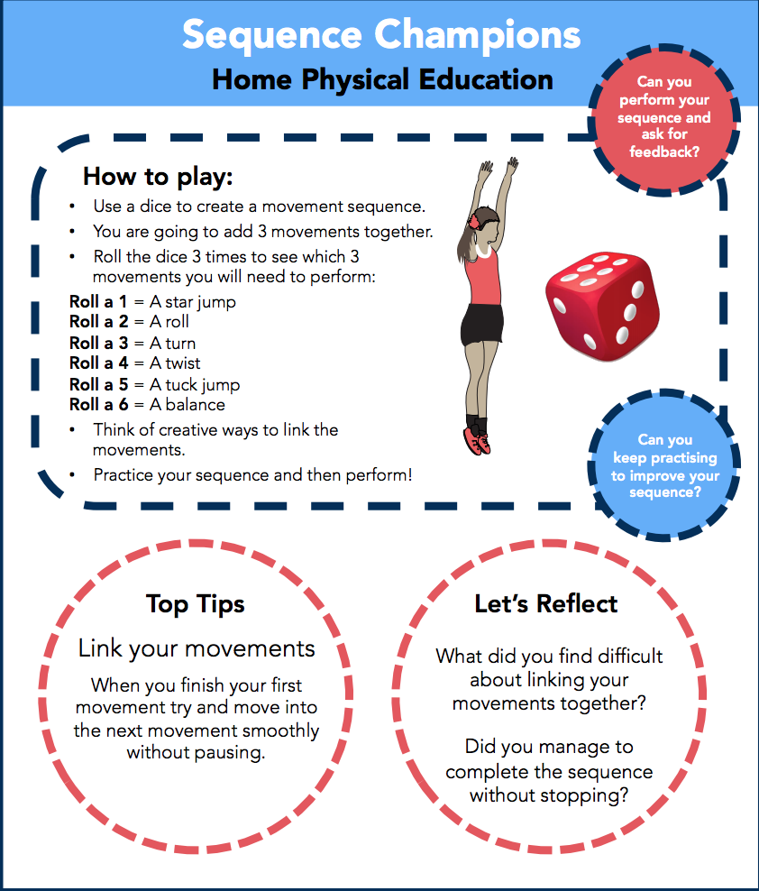

Tuesday

First to 100 Fitness Challenge – I found this online and I think it looks really fun! I have uploaded the game board for this separately (see post for this week). Again, if you don’t have dice you can write numbers 1-6 on little pieces of paper and pull them out of a hat. If you can’t print the file then you can still play - maybe just keep a note of what number you’re on on paper/your phone.

Wednesday
Today I’d like you to do a Joe Wicks workout. These are live on his YouTube channel at 9am but if you aren’t ready to do your workout then, don’t worry because he posts the video on his page straight away.
Here’s the link: https://www.youtube.com/user/thebodycoach1/featured

Thursday

Dance, dance, dance! You all know how much I love to dance and you all showed me some fantastic moves during our dance lessons, so today I would like you to either create your own dance to your favourite song or dance along to some of our favourites from GoNoodle’s YouTube channel: https://www.youtube.com/user/GoNoodleGames/videos

Friday
Athletics – usually this term you would be practising your running, jumping and throwing skills so I thought we could do some athletics today!

- Hurdles – find objects from your house/garden that you could safely jump over e.g. pile of cushions, cardboard box, washing/ironing basket/build a Lego bridge etc. Set up a course in your garden/street/largest room in your house with the objects. Can you jump over all the objects without touching them? How many laps can you do? What is the fastest time you can do a lap of hurdles in?

- Long jump

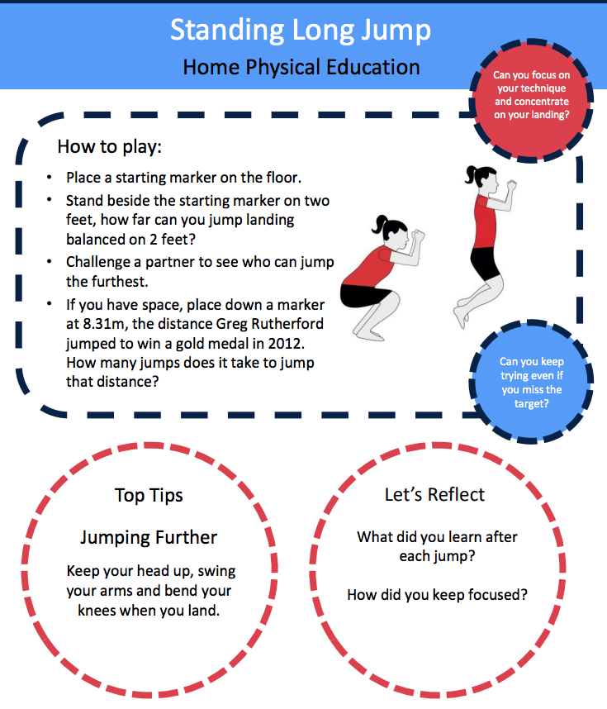

- Throwing – set out some markers (anything can be used as a marker!) at different distances. First try to use an underarm throw to reach each of the targets. Keep practising so that you become very accurate. Now try this again with an overarm throw. Which throwing technique did you find easier?

If you take a ball to the park you could see how far you could throw the ball. Which type of throw allows the ball to travel further?
