 |  | Challenge of the day
Monday  1st June | Place Value – Correct Order  Put these numbers in the correct order starting from the smallest.  - 30, 175, 51, 237, 19.  - 60, 191, 38, 17, 33.  - 305, 190, 23, 101, 17.  - 21, 5, 69, 18, 9.  - 71, 53, 190, 25, 2.  Ask someone in your household to make up more examples.  Remember you can change the range of numbers to make them easier or harder. You can also add more numbers to the list. | Can you find any numbers in your house?  What is the biggest number you can find?  What is the smallest number you can find?  Can you put the numbers you have found in order, starting from the smallest?
 |  | Challenge of the day
Tuesday  2nd June | Number Bonds  Number bonds are pairs of numbers which add together to make a certain number. For example:  1 + 4 = 5 or 1 + 9 = 10 or 1 + 99 = 100  2 + 3 = 5 2 + 8 = 10 2 + 98 = 100  You can access BBC Bitesize for further explanation:  https://www.bbc.co.uk/bitesize/topics/zwv39j6/articles/zx3982p  Write down as many number bonds as you can which add up to the following numbers:  Choose from the following numbers:  5 10 20 100 1000 | What is the biggest number you can think of?  What is the smallest number you can think of?  Can you write your numbers down?  Ask another person in your household the same questions.  Can you write their numbers down?
 |  | Challenge of the day
Wednesday  3rd June | Multiplication  Choose from these times table options:  2 x The 2 times table is the same as doubling the number. 2 x 2 = 4 double 2 = 4 5x 10x 4x 3x 8x 6x 9x 7x  Learn your times tables off by heart. You can choose from the following activities:  - Say them out loud  - Write them out in your jotter  - Ask another person in your household to test you  - Say the answers forwards and backwards, for example: 2 x 3 = 6 and 6 is 2 x 3 | There are four Wednesdays in the month of June.  The first date is today:  3rd  The second date will be:  10th  Can you work out the next two dates?  Can you add up all the dates?
 |  | Challenge of the day
Thursday  4th June | Shape  Look for different shapes around your house or outdoors.  Use the shape mat, which can be found below, to look for 2D and 3D shapes.  Remember there are 2D shapes within 3D shapes.  For example: a box of cereal is a cuboid but it is made up of 6 rectangles.  If you can, write down the shapes you found and where you found them.  For example:  2D 3D  cereal box – rectangle cereal - cuboid  tin of beans – circle tin of beans - cylinder  Then play the following maths game:  Google - Topmarks Shape Pattern Blocks | Find a pattern in your house, for example:  wallpaper  tiles  duvet cover  curtains  Can you describe it?  It could have squares, rectangles, circles, triangles or hexagons in it.  Then try to draw your own pattern.
 |  | Challenge of the day
Friday  5th June | Problem Solving - Bean-bag buckets  Dan threw 3 bean-bags.  Each bag went in a bucket.  More than one bag can go in a bucket.  score 3  score 2  score 4  score 1  1. What is the highest score Dan can get?  2. Find three ways to score 6.  3. Find three ways to score 9.  4. What other scores can Dan get? | Nim Game  You need two people to play this game.  Make a pile of ten items. Pens, pencils or dried pasta shapes are all suitable.  Each player takes it in turn to remove one, two or three items.  The player to remove the last item is the winner.  Play the game four or five times. If you can, talk about any strategies you are using.
Please continue to use the websites detailed on your learning packs to play maths games.
You can focus on adding and subtracting without using a number line and learning your times tables off by heart.

Have fun!

2D Shapes
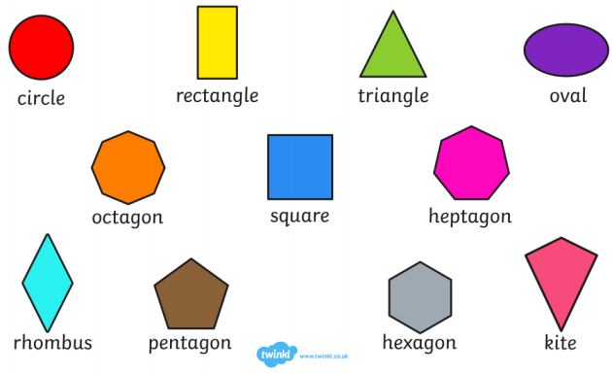

3D Shapes
