Access the book ‘Cornflake Coin’ via the following link. You may need to create an account. https://www.oxfordowl.co.uk/api/digital_books/1235.html

 | Reading | Spelling | Writing | Listening and Talking
Monday  1st June | Read or ask someone to read chapter 1 to you.  A noun is a naming word: a person, a place, an animal or a thing.  Look at pages 4 and 5.  Try to find at least 5 nouns, for example:  coin  sun  Write them in your jotter.  Challenge: use an adjective to describe the nouns you have found. | How many 2 or 3 letter common words can you find in chapter 1?  Put them into two columns:  2 letters 3 letters  in the  Challenge: write them into your literacy jotter in alphabetical order. | It was lunchtime, and Kerry and Omar were out in the school field.  (page 3)  Using your knowledge of vocabulary, connectives, openers and punctuation (VCOP).  Write a sentence about your lunchtime.  For example:  It was lunchtime, and my mum made me a sandwich.  or  It was lunchtime, and since I was hungry I made a cheese and tomato sandwich and ate it outside.  Remember to write your sentence in your neatest handwriting. If you think you can do neater handwriting, try writing it again. | In chapter 1, the local newspaper was running a competition on finding treasure. Talk to someone in your family and discuss where you could look for treasure.
Tuesday  2nd June | Read or ask someone to read chapter 2 to you.  A verb is a doing word, for example:  run walk sing  Look at chapter 2.  Try to find at least 5 verbs, for example:  dropped  panted  Write them in your jotter.  Challenge: can you think of another 5 verbs?  Think of what you are doing right now, for example:  sitting  breathing | How many 4 letter common words can you find in chapter 2?  Put them into a column:  4 letters  mean  You can also do the same for 5 letter common words.  Challenge: write them into your literacy jotter in alphabetical order. | On page 9, Mr Hart told Kerry that he was sorry.  Using your knowledge of vocabulary, connectives, openers and punctuation (VCOP).  Write a sentence about the last time you were sorry for something.  For example:  I am sorry I broke the plate.  or  I am sorry I dropped the milk carton but it was heavy and I couldn’t hold it any longer.  Remember to write your sentence in your neatest handwriting. If you think you can do neater handwriting, try writing it again. | In chapter 2, on page 9 it says:  ‘Kerry felt her heart sink’  This means Kerry suddenly felt disappointed and sad.  Talk to someone in your family about the last time either they or you felt this way and what either they or you did to cheer yourself up.
Wednesday  3rd June | Read or ask someone to read chapter 3 to you.  Proper nouns which can also be known as special naming words. They have capital letters. They are special to a particular person, place or thing.  For example:  Mrs Gillespie  Auchinraith  How many special naming words can you find in chapter 3?  Write them in your jotter.  Challenge: how many other special naming words can you think of? | A contraction is a shorter way to say two words. An apostrophe fills the space of the missing letter(s), for example:  it’s he’s isn’t  How many contractions can you find in chapter 3?  Write them in your jotter.  Challenge: play some online contraction games. Follow the link:  https://www.learninggamesforkids.com/vocabulary-games/contractions.html | The book is called ‘Cornflake Coin’.  If you have a cereal box in your house, have a look at it. You can also see an example below or can look online.  Look at the writing on the front, the back and the sides of the box. They give lots of information about the cereal.  Design your own cereal box. You can design the whole box or just the front of the box. Think about the size of the writing, the size of the picture and how colourful it is. Can you think up a new name for your cereal? My cereal would be called ‘Awfully Good Oats’.  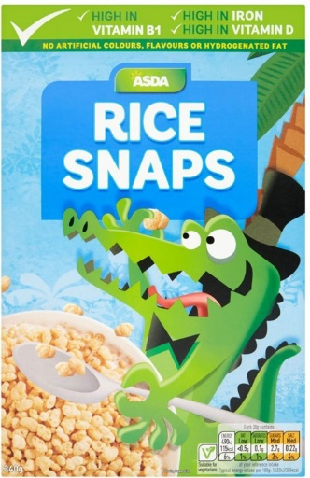  You can take your time as you can complete your design tomorrow. | You have read three chapters so far. Talk to someone in your family about what you like about the book so far and what you don’t like about it.
Thursday  4th June | Read or ask someone to read chapter 4 to you.  Do you know what these words mean?  howling – page 20  trotted – page 22  If not try to find out their meaning. You can read the text before and after the word or use a dictionary. (You can use online dictionaries) | How many 2, 3, 4 letter words can you find in the following word?  cornflake  Can you find any 5 letter words? | Complete your cereal box design. | Play ‘I Spy’ with a member of your household. You can think of items in your house or you could look out a window for ideas.  Challenge: you could play ‘The Minister’s Cat’. Using the alphabet, think of adjectives to describe the cat.
Friday  5th June | Read or ask someone to read chapter 5 to you.  Do you know what these words mean?  ripple – page 27  editor – page 30  If not try to find out their meaning. You can read the text before and after the word or use a dictionary. | How many words can you make using the letters below?  a k l e  r c f n  t d p w  i o v u  Remember, you can only use each letter once in your word. | Book Review  Complete a book review on ‘Cornflake Coin’  Did you like the book? If so, what did you like?  Did you like the illustrations?  What would you give the book out of 5 stars.  1 – did not enjoy the book and 5 – loved the book.  You can follow last week’s example of how to lay it out.  Remember, you can copy it or, if you can, you can complete it as a word document and save it to your computer. | Keep updated with what’s happening in Scotland and around the world by watching BBC Newsround. Talk to an adult about a piece of news that interests you.

