 | Mental maths | Daily 10 | Challenge
Monday 1st June | *Remember, use your strategies*  - Divide 48 by 8  - 24 + 134 + 11  - 102 x 7  - 96 + 812  - 1000- ______ = 163  - _____ + 478 = 1745  - 8 x 5 + 250 =  - ½ of 550 =  - 75 + 70 =  - 23 multiplied by 7 = | *round the following to nearest 10, 100 and 1000*  - 2365  - 7896  - 1026  - 9999  - 10,784 | I have a pound of feathers and a pound of iron? Can you please tell me which one weighs more?
Tuesday 2nd June | Try and get as close to the target number using three of the six numbers below:  100 50 75 3 10 7  Target Number: 423 | *use formal calculations*  - 4591 + 385  - 7412 – 3659  - 9412 – 599  - 2658 + 7456  - 10,032 – 9874  - 7458 + 9658  - 5542 + 8956  - 6052 – 188  - 8450 – 579  - 4966 + 4513 | Robin tosses a coin 10 times and it landed in the heads up position all ten times. So what are the possible chances for him to toss it up again and get landed in heads up position?
Wednesday 3rd June | The security door at a football stadium is 4763.  The door in fact and be opened by any combination of these numbers (3674). How many different combinations are there to open the door? | *use the grid method to calculate the following*  - 39 x 9  - 452 x 8  - 305 x 7  - 965 x 5  - 742 x 4  - 4694 x 3  - 7301 x 2  - 5544 x 6  - 3615 x 8  - 2050 x 7 | If you multiply me by any other number, the answer will always remain the same. Who am I?
Thursday 4th June | 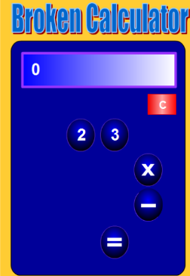  Can you make  the numbers  1 to 20 only  using the  keys on this  broken  calculator? | Write the following numbers in words.  - 45,458  - 3014  - 209,745  - 96,741  - 398,409  - 15,766  - 999,999  - 725, 475  - 4005  - 2,875,023 | Tom and Peter live in different parts of the city but study in the same high school. Tom left for school 10 minutes before Peter started and they happened to meet at a park. At the time of their meeting, who was closer to the school?
Friday 5th June | If this is the answer, how many questions can you come up with?  Answer: 52 | *Use the chunking method to calculate the following, some will have remainders- be careful*  - 138 ÷ 4  - 165 ÷ 3  - 223 ÷ 5  - 173 ÷ 4  - 315 ÷ 5  - 191 ÷ 6  - 482 ÷ 2  - 996 ÷ 3  - 190 ÷ 4  - 452 ÷ 7 | Ravi has two kids. If the elder kid is a boy, then what is the possibility that his other kid is also a boy?

- Remember to give all the activities a go and always try your best. Make sure you do your activities in your jotter or online and then you can take a picture or upload your work to the blog.
- If you have any questions remember you can post any questions you have on the blog.
- Take care and stay safe

