Primary 1
Week beginning 01/06/20

Daily Numeracy activities

- Count forward and backwards starting at a different number each time – choose any number, big or small and see if you can count forwards or backwards from that number. How long can you count for?
- Before and after - Choose a number and see if you know what comes before and after this number. Use the number line to help if you are finding this tricky.

Weekly Numeracy activities

Use the weekly activity grid and try to complete as many of the activities as possible throughout the week. If it is an activity that requires writing/recording please use your numeracy jotter. Some of the activities can be completed more than once. The more you do them the easier they will be to complete.

 | Number | Addition/Subtraction n | Beyond Number
Monday 1st June | Counting in 2s – I bet with lots of practice you will all be experts at this! Counting in 2’s means when you count you skip one number on the number line.  Start at 2 and say a number, miss a number and so on.  Eg: Say 2, miss 3, say 4.  Try to count in 2s aloud all the way to 10.  2,4,6,8,10.  Challenge – Count in 2s all the way to 20 and beyond. | Ask a grown up to write the following sums in your jotter and find the answers.  - 2 + 0 =  - 6 + 0 =  - 10 + 0 =  - 8 – 0 =  - 1 – 0 =  - 9 – 0 =  What do you notice about the answers when we add or subtract 0? Leave me a comment on the blog.  Challenge – Create sums in your jotter adding and subtracting 0 with numbers up to 20. | Time –  Click on the link to learn all about the different seasons then answer the questions about the seasons.  Can you tell your adult the names of any the seasons before clicking the link?  https://www.turtlediary.com/game/seasons.html  Challenge – Choose a season and draw a picture of the things you might see in this season.
Tuesday 2cnd June | Counting in 2s – yesterday you counted in 2s with even numbers – 2,4,6,8,10 …  Today I would like you to count in 2s using odd numbers – 1,3,5,7,9 …  Start at 1 and say a number, miss a number and so on.  Try to count aloud all the way to 11.  Challenge - count in 2s using odd numbers all the way to 21 and beyond. | Write the short date in your jotter: 02.06.20.  Write down as many sums you can think of that = 10  These can be addition and subtraction sums.  You can use 10 pieces of pasta to help you come up with your sums.  Remember to use the “switch it around” strategy with addition calculations.  eg: 9+1 = 10 1+9 = 10  Challenge – choose another number and write down all the sums you can think of that give this answer. | Measure -  Work on your knowledge of size and your sorting skills with part 1 and 2 of this game.  http://resources.hwb.wales.gov.uk/VTC/the_zoo/eng/Introduction/mainsession1.htm
Wednesday 3rd June | The numberjacks have also been working on their counting in 2s skills!  Watch them at  https://www.youtube.com/watch?v=JtjCZ9EP1cE  Did you enjoy watching? Did you learn anything?  Have a chat with a grown up or leave me a comment on the blog. | Ask your adult to give you a number between 1 and ten.  can you tell them its number partner that would add with it to = 10?  Eg: If I said 8, you would say 2 because 8 + 2 = 10.  Remind yourself of the number bonds to 10 by watching  https://www.youtube.com/watch?v=UD_RUVLPvTY  Remember the “switch it around” strategy.  7 +3 = 10 3+7 = 10 | Money-  Attached you will find Miss Arthur and Mrs Smith’s Toy Shop.  Choose 3 items to buy and add them together to see how many pennies you would need. Remember you need a p after your answer.  Use your maths jotter.  Challenge – create your own toy shop and give all your toys a price tag or draw a toy shop. Invite someone in your house into your shop to buy 3 items and see how much it would cost.
Thursday 4th June | At the top of your maths jotter write the short date: 04.01.20.  Down the left hand side write down the even numbers counting in 2s all the way to 10.  Eg: 2  4  6 and so on  across from each number write the corresponding number word. I have attached a list below to help, find the number word and copy it into your jotter.  Challenge – Continue all the way to 20. | Can you help me create some subtraction sums.  If we draw 3 smiley faces and cross one out the subtraction sum would be  3 – 1 = 2  In your maths jotter help me create sums for the following.  1. Draw 5 circles, cross out 3.  2. Draw 3 flowers, cross out 2.  3. Draw 4 squares, cross out 4.  4. Draw 2 hearts, cross out 1.  5. Draw 7 triangles, cross out 1.  Challenge: Get an adult to ask you some - 1 and - 2 sums. Can you work out the answer by counting back in your head. | Time –  Work on reading the O’clock times using this game  https://mathsframe.co.uk/en/resources/resource/116/telling-the-time  Once accessed select  - Read time to the hour  - 12 hour Clock  - You can select timed or untimed game.
Friday  5th June | Complete the same task as yesterday with the odd numbers.  Eg: 1  3  5 and so on  Challenge – Continue all the way to 21. | Log onto  https://www.topmarks.co.uk/maths-games/5-7-years/addition-and-subtraction  Play any game you like to perfect your addition and subtraction skills. | Measure – The numberjacks have been investigating things that are light and heavy.  Watch them at  https://www.youtube.com/watch?v=RrLIai7Wtls  Did you enjoy watching? Did you learn anything?  Have a chat with a grown up or leave me a comment on the blog.  Challenge – At the end of the episode can you help the numberjacks balance the scale?

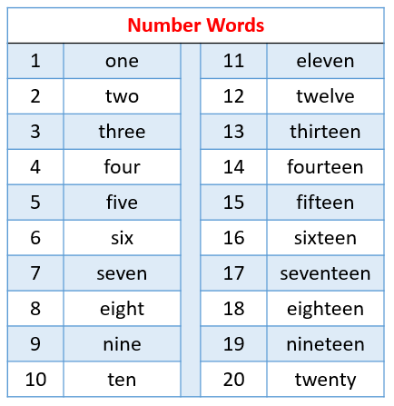

Use this resource to help with number word tasks. This can be printed or used online. Alternatively, you can write the words in your child’s jotter for them to copy underneath.

Use this number line to help with counting in 2s or any addition/subtraction tasks your child is finding tricky. This will help to build confidence with adding and subtracting mentally. (This resource can be printed, written into a jotter or used here.)

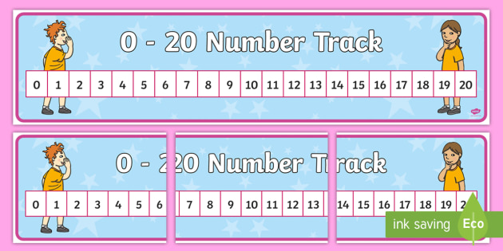
The number track can also be used for these tasks.
Miss Arthur and Mrs Smith’s Toy Shop
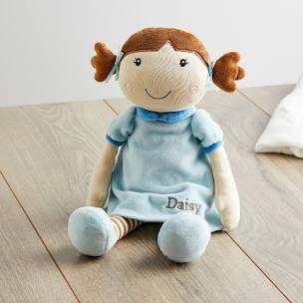
2 p

6 p
10 p
9 p
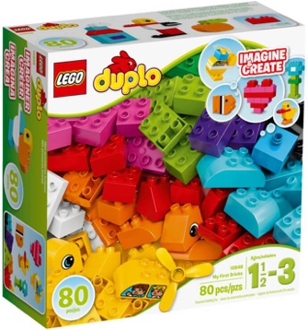
1 p
4 p
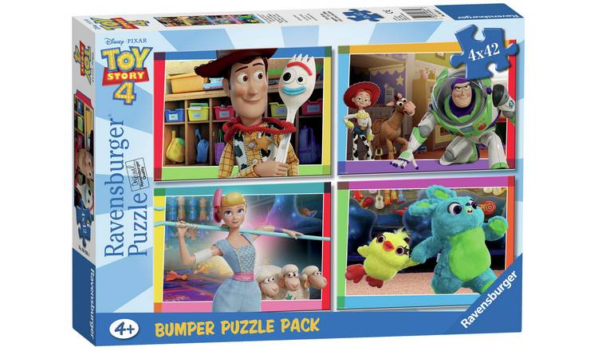
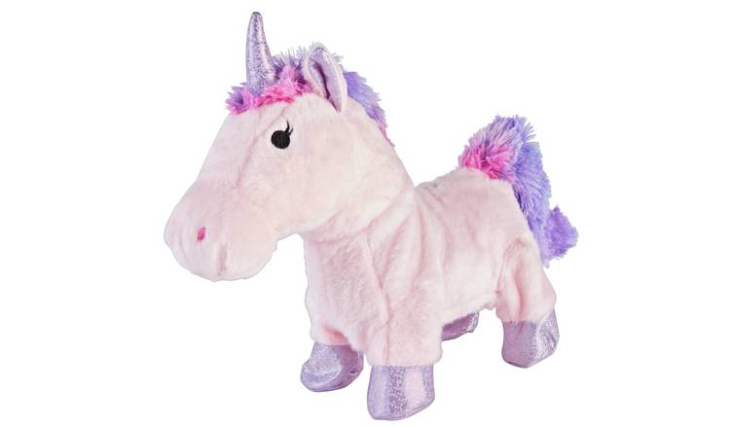
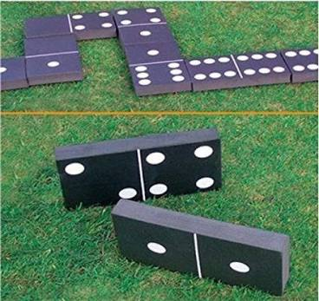
3 p
8 p
5 p

