Health and Wellbeing – Week Beginning 25th May 2020
 | Monday | Tuesday | Wednesday | Thursday | Friday
P1 and P2 | HOLIDAY! | Story time  Here are links to 2 short videos. The first helps to explain to children that sometimes we have ‘blue days’ and that’s ok. The second, follows the same character and how she feels during lockdown.  https://www.youtube.com/watch?v=UmrUV8v-KQg  https://www.youtube.com/watch?v=-RXF5-29VGU  Try to have some discussion after watching the videos about the character’s feelings and whether any of them are the same/different as your child is feeling. | Self-Esteem Building  Make a ‘Me Tree/Flower’.  Draw a tree trunk with branches or the stem and centre of a flower. Cut out some leaves/petals and on each, write something you like about yourself. Glue the leaves/petals on to your branches or flower and decorate.  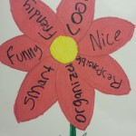 | Let’s Get Cooking!  Have fun with the Sesame Street characters in this interactive cooking game. There are 6 simple items to choose from. Make each virtually and then if you like, choose one to make in real life!  https://www.sesamestreet.org/games?id=26139  I can’t wait to see your creations! | Hand Print Keepsake  https://artsandbricks.com/family-handprint-art-for-lockdown-2020/  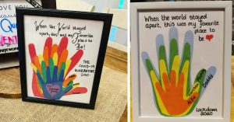
P3 and P4 | HOLIDAY! | Coping During the Pandemic Course for 7-12 year olds  https://lms.recoverycollegeonline.co.uk/course/view.php?id=375  This is a really useful course which helps to explain Coronavirus, how children might feel, tips for their mental health and how to look after themselves. There are some quick interactive activities and videos from reliable sources included. Work through this with your child/children and stop for discussion whenever you feel it’s needed. Don’t worry if you don’t want to do the whole course at once. Feel free to do a couple of sections each day. | Wellbeing Activity Page  Complete this activity page and I’m sure you will feel fab! If you can’t print it then do the activities on paper/in a notebook.  The link to download the document is my post about this Health and Wellbeing Grid. | Let’s Get Cooking!  You can spot rainbow pictures everywhere just now, so why not continue the theme and make a RAINBOW CHEESE TOASTIE!!  https://www.itv.com/thismorning/food/rainbow-cheese-toasties-juliet-sear-recipe  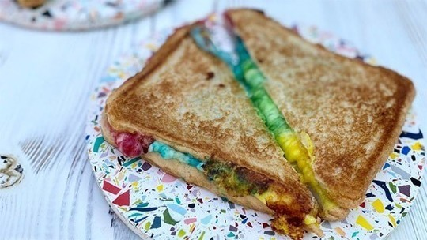 | Positivity Pebbles  Look for some pebbles in your garden or on your daily walk. Decorate them with positive words/messages/pictures. You can either keep them to cheer yourself up when you need it or spread the love and leave them in places around Blantyre for others to find.  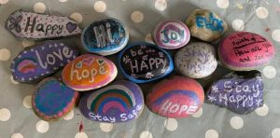
P5, P6 and P7 | HOLIDAY! | Coping During the Pandemic Course for 7-12 year olds  https://lms.recoverycollegeonline.co.uk/course/view.php?id=375  This is a really useful course which helps to explain Coronavirus, how children might feel, tips for their mental health and how to look after themselves. There are some quick interactive activities and videos from reliable sources included. Work through this with your child/children and stop for discussion whenever you feel it’s needed. Don’t worry if you don’t want to do the whole course at once. Feel free to do a couple of sections each day. | Express Yourself  It’s not good to keep your feelings bottled up. Even if you don’t feel like explaining them to someone else, it’s useful to get them down on paper.  Write about your feelings of lockdown. This could be through a diary entry, poem, song/rap – be as creative as you like!  If you feel comfortable sharing your work then I’d love for you to post it in the comments section of this post. | Let’s Get Cooking!  With all this extra time at home why not brush up on your cooking skills now that you’re getting older.  I know lots of you will be missing your chicken nuggets from McDonald’s so here’s a recipe from Jamie Oliver to make quick and healthy homemade nuggets. I think I might make this one myself!  If you don’t have a blender/food processor then to make the crumb you could put the ingredients in a freezer bag and give it a good old roll/bash with a rolling pin until it’s nice and fine.  https://www.youtube.com/watch?v=eW2hYfnCfXs&list=PLcpoB2VESJme7lSxXEcXyVtFPsMI78lcL&index=8&t=0s  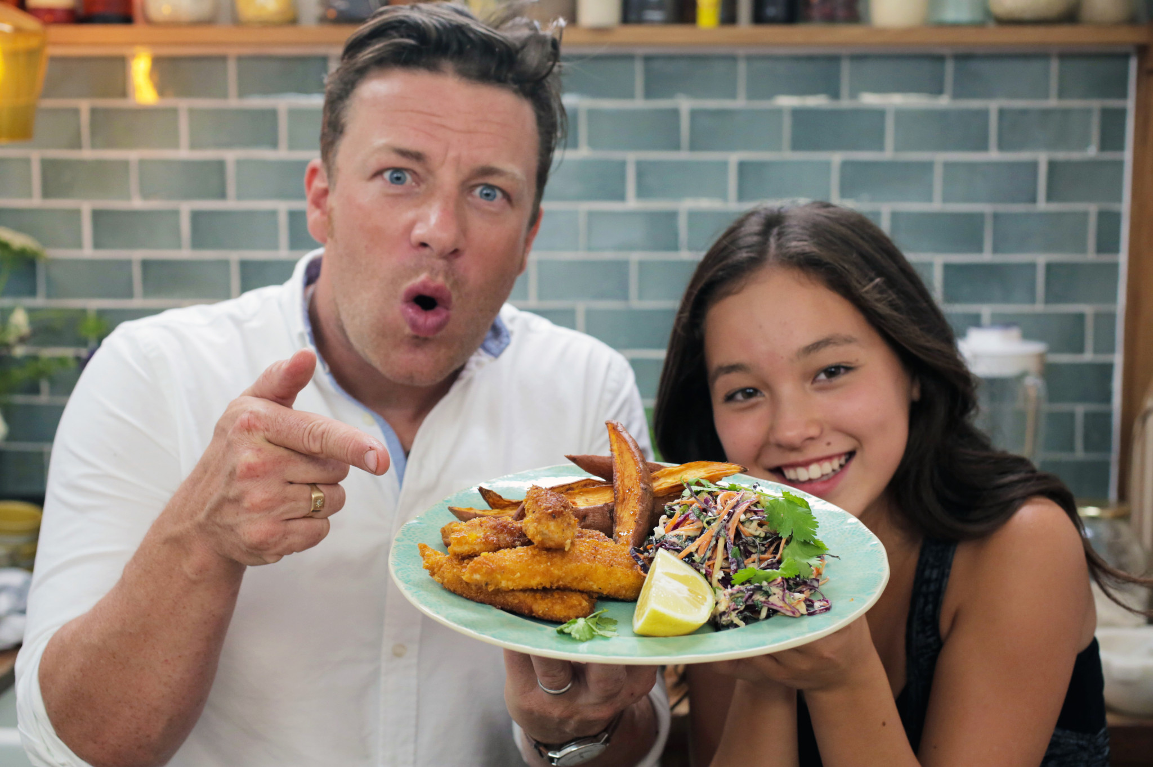 | Positive Quote Poster  Google positive quotes and use them to make a bright and colourful poster. Stick it up in your bedroom and read the quotes every day or whenever you need a wee positivity boost! If you know someone that needs cheering up, why not make them one too.  