Arrays Groups

3 x 6 = 18 6 x 3 = 18 3 x 6 = 18 6 x 3 = 18

Mental Multiplication Strategies

3 x 6 =
is the same as
6 x 3 =

Jumps Repeated Addition
3 x 6 = 18
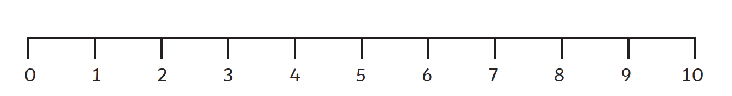
3 x 6 = 18
3 + 3 + 3 + 3 + 3 + 3 = 18
6 x 3 = 18 6 x 3 = 18
0 3 6 9 12 15 18
6 + 6 + 6 = 18
0 6 12 18

