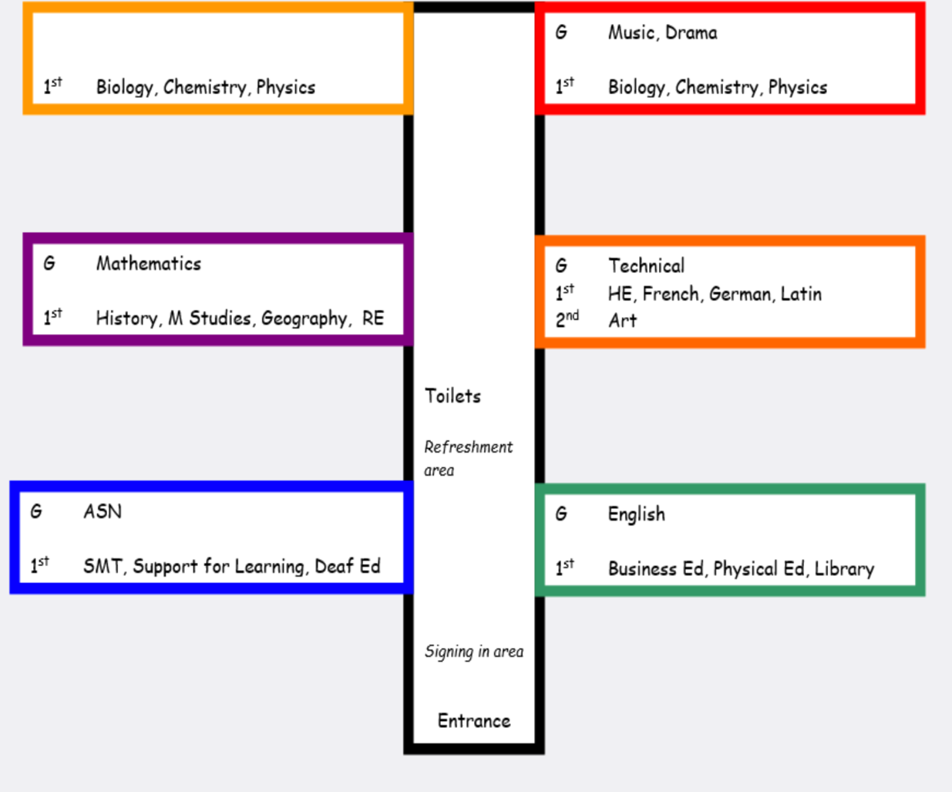
Primary 7 Transition Activity 1
D
P7 Transition Activity 1
Using the examples above, write where each room is:

B005 –
E106 –
C113 -
A007 -
F112 –
D110 –
E211 -

The letters in the boxes represent the wings of each department.

E014 – Wing E ground floor room 14
E214 – Wing E 2nd floor room 14
A
Ff
B
C
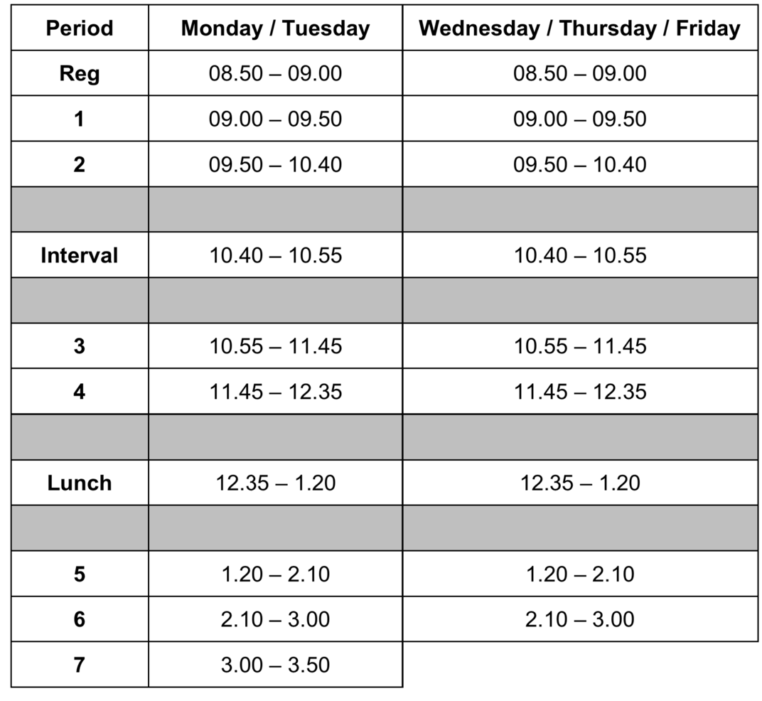
This is an illustrative example only and may not truly reflect the secondary school you will attend.
E

Use the timetable above to answer these questions:
- What time does registration begin?
- When does 5th period start?
- When does 2nd period end?
- When is lunch?
- What period will you be in at half past 11?
- How long is each period?
- What period will you be in at 3.15pm on Tuesday?
- What do you notice about period 7?
Write down the wing and floor of the following subjects:

Mathematics –
English –
Music –
Geography –
Physics –
Art –
German -

