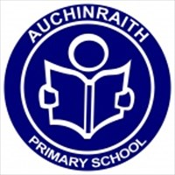

Reading Resource Pack
Level: Early Level – P1

Contents
- How To Guide: Reading Resource
- Fictional Question Bank
- Non-Fiction Question Bank
- Grammar Tasks
- Online Resources

Reading Resource Pack: Early Level – Primary 1
The purpose of this pack is to provide your child with a range of
reading tasks which can be used with any texts they may have at
home. You will find a section appropriate for fictional texts and a
section for non-fiction texts. You could also use the questions in
response to your favourite movie, T.V. show episode or Newsround
show! We hope you find this pack to be useful in continuing learning
at home.

Questions are based on the six key skills; remembering,
understanding, applying, analysing, evaluating and creating. Each
of the fiction/non-fiction question banks will follow this structure.

Fictional Question Bank
Remembering
- What is the Title?
- Who is the Author? Who is the Illustrator?
- What is the picture on the front Cover of the book?
- Can you think of something that happened in the story?
- What was your favourite part of the story?
- Did you notice any different types of print in the book instead of the words that tell the story?
- What were the illustrations like in your book?
- Can you describe your favourite illustration?
- Retell what happened in the story using your own words.
- Who were the main characters in the story?

Understanding
- Can you find some blending words in the book like c-a-t?
- Can you find some tricky words that you can’t blend?
- Can you find any words with a double sound you have learned? (Such as ie, ee, or, ai and oa).
- What happened in the beginning?
- What happened in the middle?
- What happened at the end?
- Come up with a different blurb for the story.
- Is the book a rhyming book? If so, can you find the rhyming words?

Applying
- Look at the front cover – what do you see? What do you think? What do you wonder?
- Look at the front cover and make a prediction about what is going to happen in the story?
- What can you use on the front cover to help you make your prediction?
- Can you think of any of your friends that would enjoy reading this story? Why would they enjoy it?

Analysing
- How have the illustrations helped you to understand the book better?
- Does the story teach us anything? / What lesson can you learn from it?
- Has anything like what happened in the story ever happened to you?
- Does the book/ programme remind you of anything else you’ve read or watched?
- What was your favourite part or the story? Why?
- Were there any parts of the story that you didn’t like? Why?
- Who was your favourite character? Why?
- Did you dislike any of the characters? Why?

Evaluating
- Overall, do you like or dislike the story? Why?
- How does the story make you feel? Why?
- What made you want to read/ watch this story?
- Was the story easy or difficult to read/watch? Why?
- Did any part of the story surprise you? Explain why?
- Why do you think the author gave the story its title?
- Have you read any other stories by this author? Are they similar?

Creating
- Can you think of a different ending for the story?
- What could have happened in the story to make it better?
- Can you think of another appropriate title for the story?
- Do you have a question you would like to ask the author about the story?
- Make up some information about one of the characters – do they have any pets? Who are there friends? Do they have any hobbies?
- Make up a quiz about the story for someone at home to see how many questions they get correct?

Non-Fiction Question Bank
Remembering
- What is the Title?
- Who is the Author?
- What is pictured on the front cover?
- Is there a contents page?
- Where is the contents page?
- What can you use the contents page for?
- Is there an Index?
- Where is the Index?
- What can you use the Index for?
- Does the book have pictures? If so, what were they like?
- Do you have a favourite picture?
- Tell me one piece of information you remember from the story?
- Did you notice any different types of print in the book? (eg: labels.)

Understanding
- What is the book/ programme about?
- Have you learned any new vocabulary words? What do they mean?
- What is a fact? Have you learned any from this book/ programme?
- Tell me the most interesting thing you have learned.
- How is this non-fiction story different to a fiction one?

Applying
- Who do you think would be interested in finding out information about this subject?
- How could the information you have learned help you in the real world?
- What do you still wonder about this topic?
- What else would you like to learn about this topic?
- Did the front cover give you any clues about the information you were going to find out?
- Would you recommend this book/ programme to a friend? Why or why not?
- If you could ask the author a question, what would you ask?

Analysing
- Are there any pictures? Do they help you understand the information better?
- Did the book/ programme change your view on this topic?
- Can you connect this with any fictional books/ programmes you have read/ watched?
- Does the book/ programme remind you of anything else you’ve read or watched?
- What was your favourite part? Why?
- Was there anything that you disliked finding out about? Why?
- What part did you find most interesting? Why?

Evaluating
- Have a discussion with someone in your house about what you have learned using this resource.
- Would you like to find out more information about this topic? Why/why not?
- Was there anything that surprised you when reading this text/watching this programme/documentary?
- Use the internet to check some of the facts that you have learned to make sure they are true. Find a source to back up this information.
- Would you like to learn more about this subject? Why/why not?
- How do you think the author of this book found out the information that he has included?
- Why do you think the author chose this title for the book?
- Did you find this non-fiction text/programme easy or difficult to understand? Why?
Creating
- Create a new front cover for the book. You could search online for some appropriate photographs to use.
- What could be an alternative title for this non-fiction book?
- If you were to create a sequel to this non-fiction book, what would it be called/be about?
- Create your own non-fiction book about a topic of your choice.
- Create a list of questions to ask the author of this non-fiction book. I wonder how he or she found out all of the facts?
- Choose a section of the book to create a factfile about. This could be about a particular area of interest.
- Does this book have a contents page? If not – create your own!
- Look in the index/glossary. Research the definition of some of the tricky words you can see.
- Use the index, glossary and subheadings to create your own sentences.
- If you have been watching a news programme or documentary, you could create a fact-file about what you have learned.
- Use a video camera to create your own news programme, detailing some of the facts you have learned to report about.
Grammar
It is expected that by the end of early level your child should be able to:-
- Ascribe meaning to mark making.
- Know that print has meaning.
- Know that English is read from left to right and top to bottom.
- Attempt to write things making phonetic attempts at words.
- Write own name with correct upper and lower case letters.
- Identify vowels and consonants.
- Form most letters correctly.
- Write simple regular common and CVC (Consonant, Vowel, Consonant) words.
- Understand that a sentence begins with a capital letter and a full stop.
- Recognise onomatopoeia (the formation of a word from a sound associated with what is named (e.g. cuckoo, sizzle).
- Show an understanding of different types of sentences.

Grammar tasks
A list of possible grammar activities have been compiled. They are designed to be used continuously on numerous occasions as many can be used with a different book or magazine. Regular revision of grammar activities will help your child to retain their learning. Lots of these activities include your child using a pencil and this will also assist with their handwriting.
Grammar Task 1
Write your name ten times. Try writing it different ways. You could use bubble writing, joined writing, rainbow writing or big/ small writing. Remember the first letter of your first name and surname needs a capital letter.
Grammar Task 2
Enjoy looking at any books that you have in your house and even if you are unable to read them make up a story using the pictures to help you.

Grammar Task 3
Create a comic strip of something you have done or a story that is in your head. Ask a grown up to help you write the story down.
Grammar Task 4
Draw a picture of anything you want. Tell a grown up all about your picture. Try to have a go at labelling your picture or writing a sentence on your own about it.
Grammar Task 5
Choose a book or magazine that you have in your house. Hand it to your grown up the correct way up to read. Whilst your grown up reads to you point to the words as they should read them. If you point to a common word that you know say it out loud.
Grammar Task 6
cat | rug | cog | pen
ring | ball | tie | bee
sand | bed | but | big
Above is a list of CVC words. Can you create a list of words that rhyme with these words?
Challenge – Make a matching game using pairs or rhyming words.
Grammar Task 7
it | as | a | I | at
an | has | had | did | is
in | and | us | on | the
no | so | go | his | of
to | if | not | can | my
by | into | tie | from | lie
or | see | for | went | with
Above is a list of common words. Ask a grown up to read the words one at a time and have a go at writing them.

Grammar Task 8
Use the common word list from Grammar Task 7. Choose a word and create a sentence with that word in it. Try to write the sentence remembering that your sentence needs a capital letter, finger spaces and a full stop.
Grammar Task 9
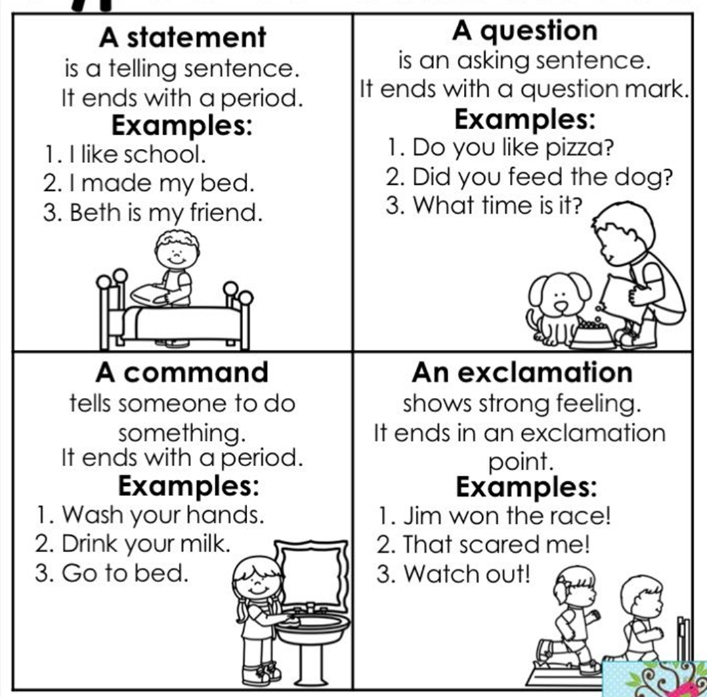
Above is an example of the different types of sentences. Try to create a sentence for each one. If a grown up gives you a sentence can you tell them what kind of sentence it is?

Online Resources
- https://www.doorwayonline.org.uk
A super resource for early phonics work and letter formation.

- https://www.education.com/stories/
Interactive stories that the children can listen to for enjoyment and can also become the basis of question and answer sessions.

- https://www.education.com/games/
lots of examples of early level literacy games.

- www.storylineonline.net
A variety of actors and authors reading story books.

- https://bbc.co.uk/bitesize
Activities based on each level of the curriculum. Ideas of stories to read and games to play.

- https://www.firstdiscoverers.co.uk/alistair-bryce-cleggs-5-phonics-games-activities/
Ideas for phonics games and activities

- www.twinkl.co.uk/.../early-years-reading
A wide range of phonics, reading and writing activities.

