The Café- Week Beginning 26/05/20
Help to set the table for dinner each night. You will need a plate/bowl, cutlery and a cup. | Can you write some instructions on how to make a sandwich?  Remember to include the ingredients and how to do it (method) | Go to www.topmarks.co.uk  In the search box type “money” and click on the first activity – Toy Shop Money Game. Initially try 1 coin up to 10p. Progress if it’s too easy! | After a grownup has been to the shops play a guessing game about how much the things cost.
Think about having your own café. With help from a grown-up, can you think of a good name for your café and make a sign?  “Welcome to…” | Design your own ice cream sundae. What would it look like? What flavours would it have? Would it have any toppings? Can you give it a fun name? | When preparing food, it is important that we wash our hands properly. Watch this video to help you to remember  https://www.youtube.com/watch?v=zxlQn7KaCNU | Visit http://archive.foodafactoflife.org.uk/QuickLinks.aspx?contentType=2  These games are all about healthy eating. Choose any of them to explore (the age 5-8 games if it specifies)
Think about what food you would sell in your café. Can you write a menu? Try to include some starters, main courses and desserts. | Talk to an adult about sharing pizza. If it is cut into 2 pieces, it is called half or halves. If it is cut into 4 pieces, it is called quarters. Can you make a pizza from playdoh or junk materials and cut it into halves and quarters? | We can use the “Healthy Plate” to show us how much of each food group we should eat every day. Use the healthy plate worksheet to write down something you like in each group and what variety of foods are in each group. | Can you try a new fruit or vegetable this week?  What did you try?
Watch this Mr Tumble clip about a café for some good ideas  https://www.dailymotion.com/video/x5ibgfh | Make a shop with food from your cupboards. Give them all a price tag from 1p-10p (keep this handy – you will need it in the next 2 weeks!!) | It is important to eat 5 fruits or vegetables a day to stay healthy. Write down what you and 1 other person in your house have had today. | Find a recipe you have never made before in a book on the internet. What did you make?  Did you like it?
Design your own Ice-Cream Sundae
Name of my sundae _____________________________________

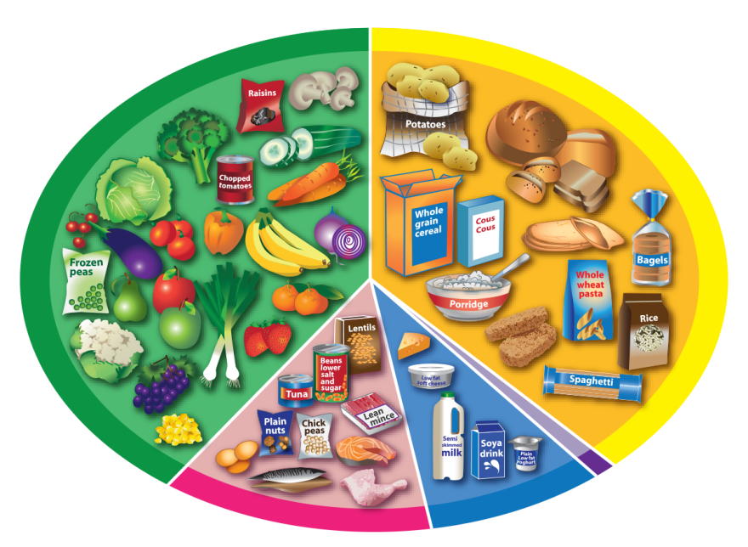
The Eatwell Guide

Fruit and vegetables
Potatoes, bread,
rice, pasta
and other starchy
carbohydrates

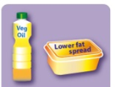
Oil and spreads
Dairy and
alternatives
Beans, pulses,
fish, eggs, meat
and other proteins
6-8
a day

