Primary 3-5 – Numeracy Home Learning

 | Jotter Work |  | Challenge
Tuesday  26th May | 1. Mental maths. | 2. Try counting on or back with helicopter rescue.  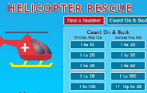  click here or google top marks helicopter rescue. | What is your house number? Let’s count on.  -Can you add 2 to that number?  -Can you add 12 or 22 or 222?
Wednesday  27th May | 1. Mental maths. | 2. Click on the picture and choose a counting game. You can count to 20, 100 or beyond.  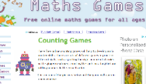  click here or google maths games counting. | Let’s do some counting!!  How many doors are there in your house?  Look at the ceiling or on tables, how many lights can you count in your house?
Thursday  28th May | 1. Mental maths. | 2. watch a clip on ordering numbers:  2-digit number  3-digit numbers | Have a look out of your window. Find 3 cars, write down the numbers on their registration plate and put them in order of smallest to largest.  Put the numbers together and create the largest number you can, read it out loud.
Friday  29th May | 1. Mental maths. | 2. Try some addition questions with karate cats.  click here or google BBC karate cats. | Use your dice to roll 2 numbers and add them together.  For an extra challenge roll 3 numbers and add them without writing them down.

