Look at the different learning tasks below. Try to complete one or two tasks each day.
Number
Practice counting in 1s, 2s, 5s and 10s. How high can you go?

Choose a one digit or two digit number. How many ways can you make that total? Example: 12 = 2+10, 6+6, 4+8 …
Try this for 5 different numbers.

Practice writing out your numbers 0-9. Make sure they are facing the right way and are not too big, not too small…just right!

Try out this place value game:

https://www.topmarks.co.uk/learning-to-count/place-value-basketball

Look at how many tens and units are on the screen, what number does it make? Click the correct basketball to score!
Example
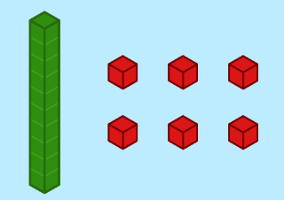

=

Beyond Number
Watch the first video on this website about measuring words.

https://www.bbc.co.uk/bitesize/articles/zf4vbdm

Can you find something long and short in your house? Can you describe them by using comparing words?
Try this game all about measuring words.

https://www.topmarks.co.uk/early-years/lets-compare

Try this game to test your problem-solving skills!

https://pbskids.org/peg/games/happy-camel

Problem Solving
Read the chilli challenges below. Choose the mild option for an easier challenge, and spicy to test yourself! Can you work out the answers?
Mild

Eric bakes these two trays of muffins.
He eats 2 muffins.
His dad eats 3 muffins.
His sister eats 4 muffins.
How many muffins does he have left?

Spicy

Lola buys this key ring.
Her mum gives her half of the money.
She pays for the rest herself.
How much does she pay herself?

