Look at the different learning tasks below. Choose one or two tasks to complete each day.
Handwriting
Write out the alphabet in lower and uppercase. Can you match the small letters with their big partner? If you are not sure you are forming your letters correctly, have a look on this website to show you:

https://www.doorwayonline.org.uk/activities/letterformation/

Spelling/Phonics
Use the word wall and phoneme grid from your last learning pack to practise spelling your common words and phoneme words. Use the spelling strategies grid below to help you choose a fun way to do this!

Ask an adult or older sibling to help you set up this game.
https://youtu.be/n4fBI-Kknzc

You can progress this from CVC words to using words from your phoneme grid! Just make sure you choose words that you can sound out fully.

Talking/Listening
Watch Newsround (new episode available on CCBC channel or iPlayer every morning and afternoon). Listen to the main stories. Talk to an adult or older sibling about how these stories make you feel, what is the most interesting story today?

Reading
Login to Oxford Owl and choose a story to read. An adult can help you look at the books and find one that looks like the reading book level you get home (between 1-6). Ask an adult to read you some of the questions below, you can answer these verbally first and then have a go at writing the answer. Can you challenge yourself to answer in a full sentence with a capital letter and punctuation mark?

Snuggle up and listen to one of these fabulous stories. Just click the link and then choose one of the stories. Is your favourite book there? Can you find something new?

https://www.youtube.com/playlist?list=PLB5TN0ac12P8-9uyI88NgfZv6I_zDYuxz
Writing
Choose a character from a story you have read this week. Can you act out their part of the story, either yourself or using some toys? You could even make some puppets using an old sock or some paper taped to a lolly stick, like this!

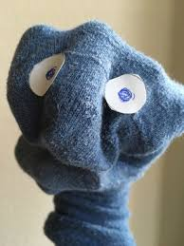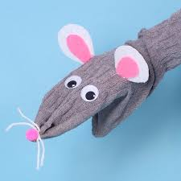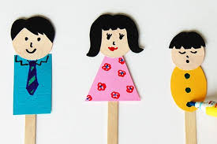

Once you have acted out the story, think about your character. How would you describe them? Talk about this with an adult or older sibling; who can come up with the best describing word?

Draw a picture of the character from memory, what are their most memorable features? Surround them with some of the words you have discussed (here’s some word to warm up your brain)

happy grumpy sad charming funny

lovely pretty ugly evil smart

kind scary wise moody polite

helpful honest shy cross curious

careful bold horrible mad unkind

Use your words to write a description of the character. Could you tell who it was without including their name?

Grammar
Try playing this game. Click the link and in Ernie’s section, try the punctuation full stop game, or the sentences game.
https://www.bbc.co.uk/games/embed/small-town-superheroes?exitGameUrl=http%3A%2F%2Fbbc.co.uk%2Fbitesize%2Farticles%2Fzncgvk7
Write out these sentences correctly. Underline your changes.
- 1. i think there should be capital letter at the start
- 2. the dog loved running in the field
- 3. you were meant to go over there
- 4. there are hundreds of rabbits in the field
- 5. the cat ran quickly
- 6. i could not believe my eyes
For extra challenge, can you extend the sentences to make them more interesting?
Example:
The dog ate his dinner.
The gruff, shaggy dog greedily scoffed his dinner and licked his lips.

