Primary 1a
Week beginning 26/05/20

Daily Numeracy activities

- Count forward and backwards using different voices – can you use a quiet voice, a loud voice or even a singing voice? Start quiet and get louder as you count forward, or start loud and make your voice quiet as you count backwards.
- Number Hunt – Look for numbers in your house, they could even be in a book or on the TV. Look for numbers when you are on a walk. Tell a grown up what numbers you have found. Pick a number and talk about it. Is it big? Is it small? What comes before and after that number? How can you add or subtract to make that number?

Weekly Numeracy activities

- Use the weekly activity grid and try to complete as many of the activities as possible throughout the week. If it is an activity that requires writing/ recording please use your numeracy jotter. Some of the activities can be completed more than once. The more you do them the easier they will be to complete.
 | Number | Addition/Subtraction | Beyond Number
Tuesday  26th May | Practise writing your numbers 0-10 in your jotter. Make sure all your numbers are facing the correct way.  A grown up can write them for you to copy underneath.  Challenge – write your numbers to 20. | Ask a grown up to give you a number between 0 and 10. Keep that number in your head and try to add 1 – use the counting on strategy.  Keep going to see how many times you can add 1 in your head.  Challenge – ask for a bigger number to keep in your head. | Time –  Practise saying the days of the week and months of the year in the correct order.  Order them online at  https://www.roythezebra.com/reading-games-high-frequency-words.html
Wednesday 27th May | Investigate numbers bigger than 10 with some help from the numberjacks.  Watch  https://www.youtube.com/watch?v=LtFwepiUIeU  Did you enjoy watching? Did you learn anything?  Have a chat with a grown up or leave me a comment on the blog. | Ask a grown up to give you a number between 0 and 10. Keep that number in your head and try to add 2 – use the counting on strategy.  Keep going to see how many times you can add 2 in your head.  Challenge – ask for a bigger number to keep in your head. | Measure -  Use your hands or feet to measure the length of various things in your house, the kitchen floor, a teddy, a doorway or a table.  Talk to a grown up or let me know what items were the longest and shortest.  Tip – Keep your hands or feet close together.
Thursday  28th May | Complete the number words worksheet below using your finger to match.  Challenge write the number words to ten in your numeracy jotter. A grown up can write these for you to copy underneath. | Ask a grown up to give you a number between 0 and 10. Keep that number in your head and try to subtract 1 – use the counting back strategy.  Keep going to see how many times you can subtract 1 in your head.  Challenge – ask for a bigger number to keep in your head. | Money-  Log onto  https://www.topmarks.co.uk/money/coins-game  Use the sorting and ordering features to work on your recognition of coins.  Challenge – Try the counting the coins feature up to 20p.
Friday  29th May | Log onto  https://www.topmarks.co.uk/learning-to-count/paint-the-squares  Select numbers 1-30, then  ask your grown up to ask you to paint a number a colour. Can you recognise the number? I’m going to start by asking you to paint number thirteen pink. Your grown up can now take over. | Ask a grown up to give you a number between 0 and 10. Keep that number in your head and try to subtract 2 – use the counting back strategy.  Keep going to see how many times you can subtract 2 in your head.  Challenge – ask for a bigger number to keep in your head. | Time –  Practise saying the days of the week and the months of the year in the correct order.  Can you write any of them in your jotter? A grown up can help by writing them for you and you can copy underneath.
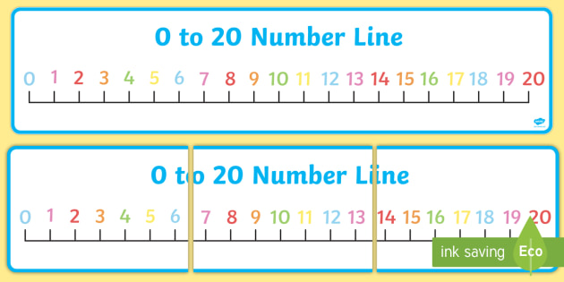
Use this number line to help with any addition subtraction tasks your child is finding tricky. This will help to build confidence with adding and subtracting mentally. (This resource can be printed, written into a jotter or used here.)

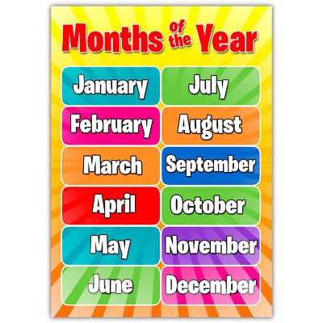
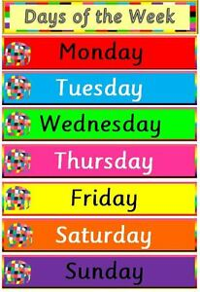

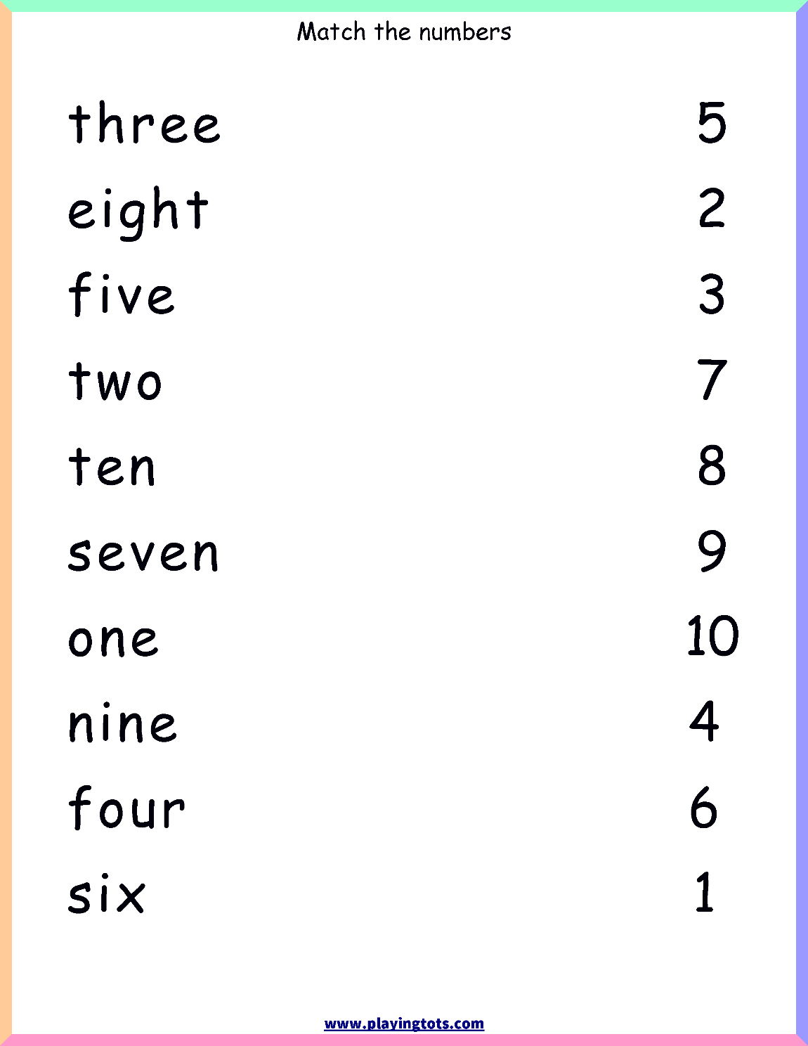
Worksheet for Number task on Thursday 28th May. (This can be printed or your grown up can copy it into your numeracy jotter.)

