Auchengray Primary School
Standards and Quality Report 2022/23
Context of the school:
Our School:
Auchengray Primary School serves the rural communities of Auchengray, Woolfords, Tarbrax and the surrounding areas. The school consists of two classes, a P1 – 3 and a P4 – 7. We started the session off with a roll of 24, which increased to 26 for part of the session and we ended the session with 23 pupils. The SIMD range from 4 to 7, with 8% of pupils FME.

Strong links continue to be developed within the local community, the Auchengray Church Centre, the WAT Group and WATIF. These community groups are very supportive of the school, both financially and in terms of activity within the school community.

The school is part of Biggar Learning Community and has strong links with all feeder primary schools. The learning community works closely on priorities identified in its own community improvement plan.

At Auchengray Primary we promote an ethos of respect across the whole school and wider community. We have high expectations in terms of behaviour, attitude and effort, with every child encouraged to be actively responsible for their learning.

We value; Respect; Creativity; Community; Nurture and Achievement. These values underpin everything we do within the school and wider community.

Vision
Our vision is to provide all our pupils with education and care of the highest quality which fosters confidence; cultivates personality and talents and develops skills for learning life and work, enduring they achieve their full potential in a safe, happy and motivating learning environment which is at the heart of our community.

Aims
We aim to have the highest quality teaching in order to promote the most effective learning in the core skills of Literacy, Numeracy and Health and Wellbeing. We strive to ensure that pupils are provided with stimulating opportunities and experiences to support their understanding of the world around them. We will endeavour to fully develop the key personal qualities of resilience, perseverance and a positive attitude to learning within all pupils whilst building the future generations of our community
Review of progress for session Aug 2022- June 2023
School priority 1: Curriculum Rationale
NIF Priority (select from drop down menus)  Closing the attainment gap between the most and least disadvantaged children and young people  NIF Driver  Curriculum and assessment  School Improvement | HGIOS?4 QIs (select from drop down menus)  1.3 Leadership of change  2.2 Curriculum  3.2 Raising attainment and achievement
Strategy
What did we set out to do?

Due to ongoing Covid restrictions and absences the Curriculum Rationale for Auchengray Primary School was not revisited in the session 2021/22, therefore was carried forward to session 2022/23 and its re-evaluation of what is important to our school community and curriculum has been addressed as a priority. In consultation with our parents’ we a reviewed of our Curriculum to ensure this was relevant to the context of Auchengray Primary school and that it addresses the needs of our learners.

Progress and Impact
What difference did we see? What did we achieve?

We have developed rolling programmes in almost all curricular areas which ensures all pupils benefit from a curriculum which is coherent, board, balanced and provides challenging learning opportunities. The school, along with parents identified the Expressive Arts as an area of the curriculum that did not adequately address the needs of our learners.

A detailed curriculum rationale has been developed with staff. It has a strong focus on developing the skills our pupils need learning, life and work, as well as taking account of learners’ entitlements; the four capacities and the four contexts for learning and reflects the uniqueness of Auchengray Primary School.

The Curriculum Rationale will be shared with all stakeholders in August 2023, with feedback being sought at this point.
Next Step(s) to inform SIP for 2023/2024:

The Expressive Arts will be a focus for curriculum development over the next three years, starting with music.

The curriculum rationale needs to be considered on a regular basis to ensure that it is fit for purpose and is relevant to context and needs of the school on an ongoing basis.

The curriculum rationale will be reviewed each session as part of the maintenance agenda and a full review to be carried out in 3 years (Session 2025/26).

School priority 2: Raising Attainment and Achievement
NIF Priority (select from drop down menus)  Closing the attainment gap between the most and least disadvantaged children and young people  NIF Driver  Performance information  Assessment of children's progress | HGIOS?4 QIs (select from drop down menus)  1.1 Self-evaluation for self-improvement  1.2 Leadership of learning  2.3 Learning, teaching and assessment
Strategy
What did we set out to do?

Although our data shows that our attainment in both writing and numeracy to be strong, our self-evaluation highlights the need for a more consistent approach across the school to the planning, teaching and assessment in these areas.

It also highlights the need for a greater number of opportunities for pupils to identify their strengths and next steps in writing and numeracy.

Progress and Impact
What difference did we see? What did we achieve?
Numeracy

Number Talks has been introduced across the school as our main approach to mental mathematics. Teachers received training as part of Inservice time and have developed a clearer understanding of the methodology of Number Talks. They have been introduced to the Number Talks Progression Pathway developed by SLC and provided with additional guidance that is age and stage appropriate. Teaching staff across the partnership have worked together to develop stage appropriate resources using examples from Number Talks book, such as ten frames, dot cards and counting on cards.

Number Talks takes place as part of daily numeracy lesson for P1 and P2 pupil and their confidence in mental maths has increased. Next Steps - Introduce additional strategies.

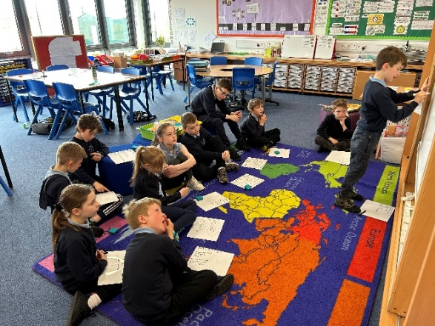
For Primary 3 and 4 pupils Number Talks implemented 2 or 3 times weekly up to Spring Break. Pupils have shown an increase confidence in the mental strategies taught and have been keen to share.
Next Steps – Reinforcement of known strategies and introduction of unknown strategies. Use older pupils to develop fluency in younger pupils

For the older pupils in P6 & 7, Number Talks principles are used 2 or 3 times weekly. Pupils have been taught all strategies and can use them to solve mental questions. Progressed on to using strategies to identify required calculation in word problems and identify which strategies can be used to solve these.

Maths Recovery training has not yet been accessed and this will sought during next session.

91% of all pupils are either on track or exceeding expected levels in Numeracy and Mathematics across the school and teachers report that almost all pupils are more confident in talking about number and most able to explain the strategies used. Teachers report that they are gaining in confidence in the use of Number Talks as a format for the teaching of mental mathematics and that they recognise the improvement in pupils’ ability to discuss number in general. Teachers also report becoming more confident in their professional judgement of pupils’ attainment of a level.

Literacy

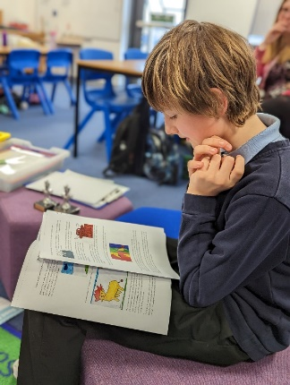
Staff have worked together to ensure that there is a shared understanding of the standards required to achieve a level from Early through to Second. They have created a criterion scale in line with SLC’s progression pathways. This will ensure that staff have a shared understanding of the levels within writing and will enable pupils to have a clear understanding of their own achievements in writing and enable them with support to set clear and meaningful targets.

Next Step(s) to inform SIP for 2023/2024:

Development of Number Talks will continue as part of the maintenance agenda to facilitate a complete academic year following the progression pathway and the guidance for each stage.
For P1 pupils the class teacher will introduce the strategy and SSA will work with the pupils in order to develop their capacity further.
The developed criterion scale will be trialled across writing assessments next session and pieces of writing will be moderated to ensure that there is a shared understanding in the achievement of a level across all teaching staff.

School priority 3: Personalised Support
NIF Priority (select from drop down menus)  Closing the attainment gap between the most and least disadvantaged children and young people  NIF Driver  Teacher and practitioner professionalism  Parental engagement | HGIOS?4 QIs (select from drop down menus)  2.3 Learning, teaching and assessment  2.4 Personalised support  3.1 Ensuring wellbeing, equality and inclusion
Strategy
What did we set out to do?

Raise attainment through a review of staged intervention processes and Literacy Profiling procedures in relation to our setting.

Progress and Impact
What difference did we see? What did we achieve?

All teaching staff undertook training by the Extended Community Team on the Literacy Consultation Profile and Planning tool. This enabled staff to develop their knowledge and skills and to be able to focus on the distinct area of literacy that are proving challenging for identified pupils.

Learners’ needs have been identified early through a range of reliable and valid assessment information. This session we had 8% of children identified as requiring additional support, however going forward we have identified 13% of pupils as requiring additional support.

Staff have become more familiar with the staged intervention process and have been able to use this to ensure that barriers to identified pupils’ learning have been reduced. Individual learners are being supported through well planned interventions, which are closely monitored and has led to positive outcomes for all identified pupils.

We have continued to build strong relationships with parents and carers and have worked effectively with them to ensure they are fully involved in decisions about the learning and the supports in place for their child/ren.

Next Step(s) to inform SIP for 2023/2024:

Continue to identify pupils who require support/interventions in order to achieve recommended levels across P1 – P7

Staff will continue to develop their knowledge and understanding of the Staged Intervention Process along with the South Lanarkshire Literacy Consultation Profile and Planning tool.

School priority 3: Increasing Creativity and Employability
NIF Priority (select from drop down menus)  Improvement in skills and sustained, positive school-leaver destinations for all young people  NIF Driver  School and ELC leadership  School Improvement | HGIOS?4 QIs (select from drop down menus)  1.2 Leadership of learning  2.2 Curriculum  3.3 Increasing creativity and employability
Strategy
What did we set out to do?

Pupils understand the need to develop their skills for learning, life and work across a range of contexts (including their digital skills)

Skills for life, learning and work will be developed across all stages.

Children demonstrate and apply skills and knowledge in a variety of contexts across learning.
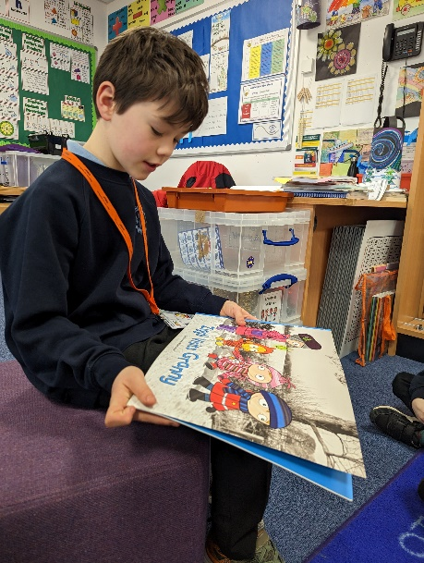
Progress and Impact
What difference did we see? What did we achieve?

All pupils have had opportunities to be involved in leadership activities. These include writing school assemblies; supporting pupils in a range of curricular activities such as reading, ICT and art; taking responsibility for the school growing garden; being involved in decision making as part of the Participatory Budget working group and taking part in organised leadership activities such as JRSO and SideKicks.
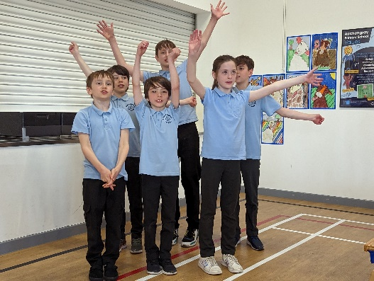

Pupils understand the need to develop their skills for learning, life and work across a range of contexts (including their digital skills) they are starting to identify the skills they are using in some more obvious tasks however the type of skills need to be unpicked and pupils’ knowledge and understanding of these deepened.
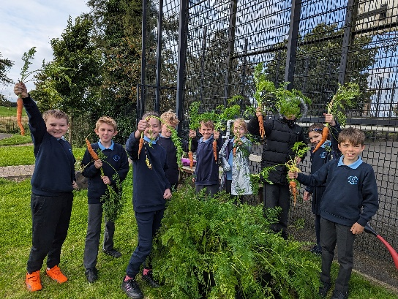

The three House Captains have demonstrated excellent leadership skills across the year. They have supported and encouraged the younger pupils and have been great role models to those pupils taking on these roles next session.
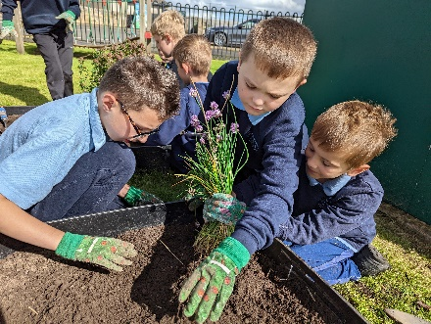

Next Step(s) to inform SIP for 2023/2024:

Develop a school action plan in line with the Biggar Learning Community Improvement Priority of Skills Development.

National priority: How we are ensuring Excellence and Equity?

Strategy
Brief commentary on context and identified barriers to learning which affect progress and attainment, key interventions undertaken.

Key Interventions Undertaken in 2022/2023 – Health and Wellbeing

Participatory Budget was used to help increase the attendance of targeted pupils. Targeted pupils were included in the PB working party who investigated the drivers for pupils’ attendance. This highlighted the playground as key to engagement in school. The PB was spent on developing activities in the playground. This has resulted in the targeted pupils are attendance increasing to 95.8%, which is very slightly higher the than the school average of 95.5%.

Wider Achievement. Our tracking of wider achievement shows that 65% of pupils have had achievements from outwith the school celebrated, this is a increase of 4% from last session, however none of our targeted pupils have had any wider achievements from outwith the school celebrated. This will continue to be a focus next session.
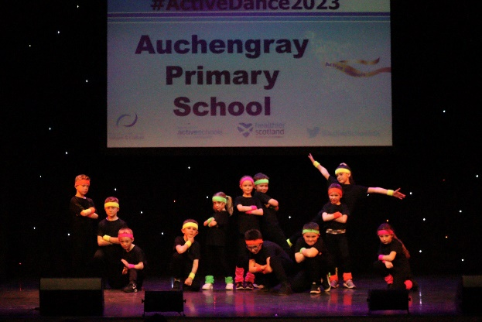

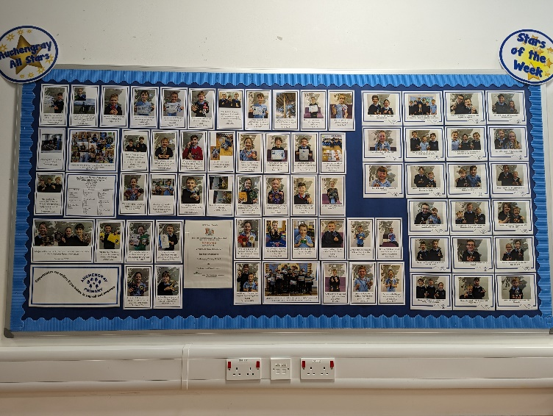
We invested Forest schools training Level 5, Forest Schools First Aid and resources to enhance the health and wellbeing of pupils.
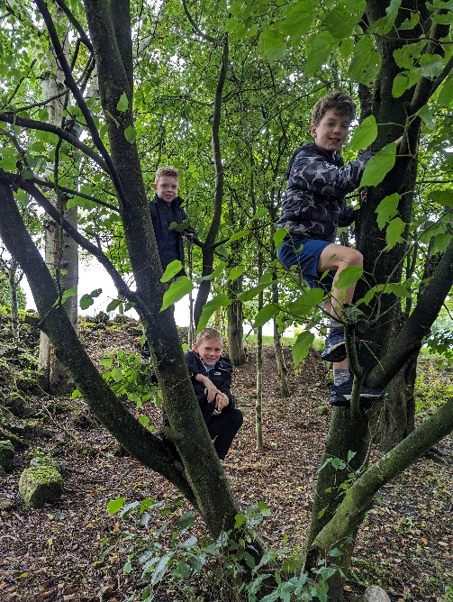
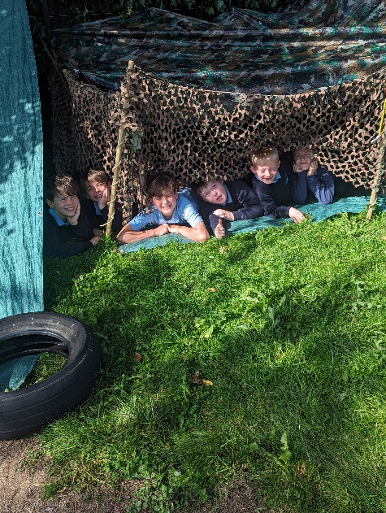

Key Interventions Undertaken in 2022/2023 – Cost of the School Day

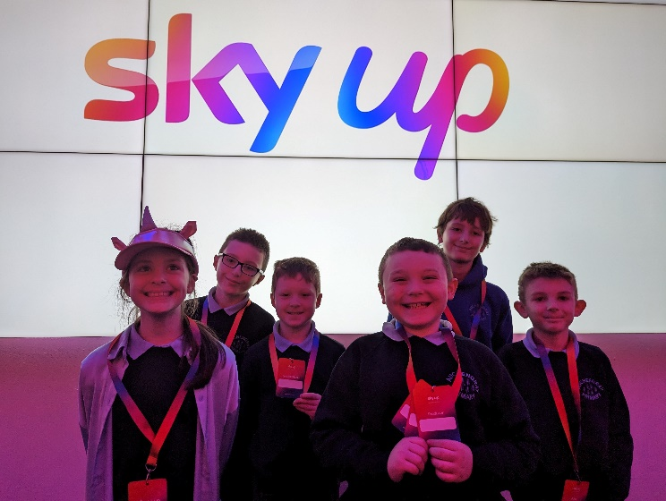
- Our preloved uniform rail is available during the school day and at any evening events. It is also available at the ‘Wee Café’ which is held every Thursday throughout the term in Auchengray Church Centre.
- We continued to participate in most of the activities provided by active schools, with no charge to parents.
- A number of school trips were undertaken, with no cost to parents.
- We continued to provide all stationary items for learning.
- We used the Winter Clothing allowance from SLC to provide a selection of wellington boots for use during the school day.

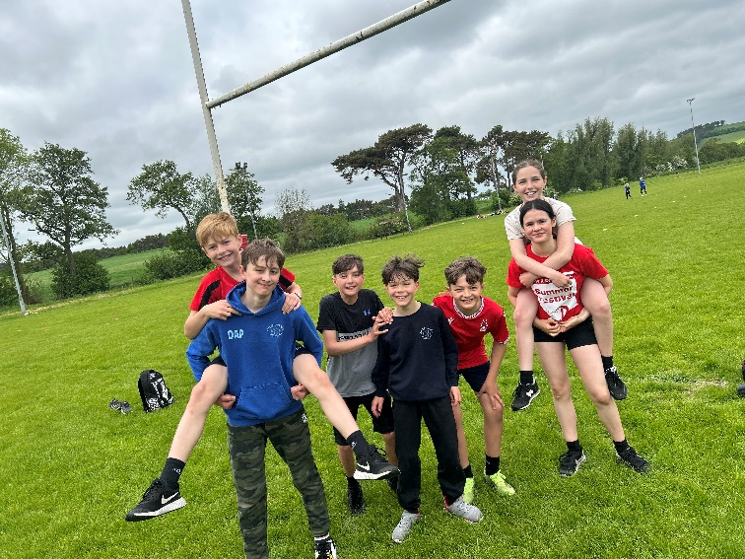
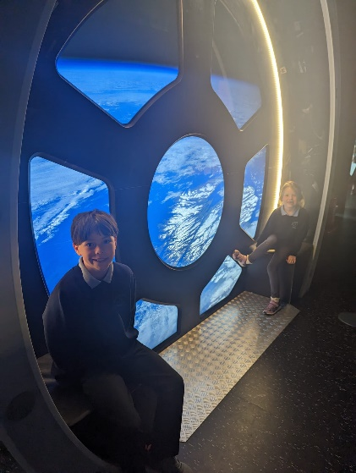

Next Step(s) to inform SIP/PEF Plan for 2023/2024:
- Promote the importance of wider achievement with parents.
- Continue to ensure pupils have opportunities for wider achievement across the school.
- Continue to look at ways in which to reduce the cost of the school day for all families.

