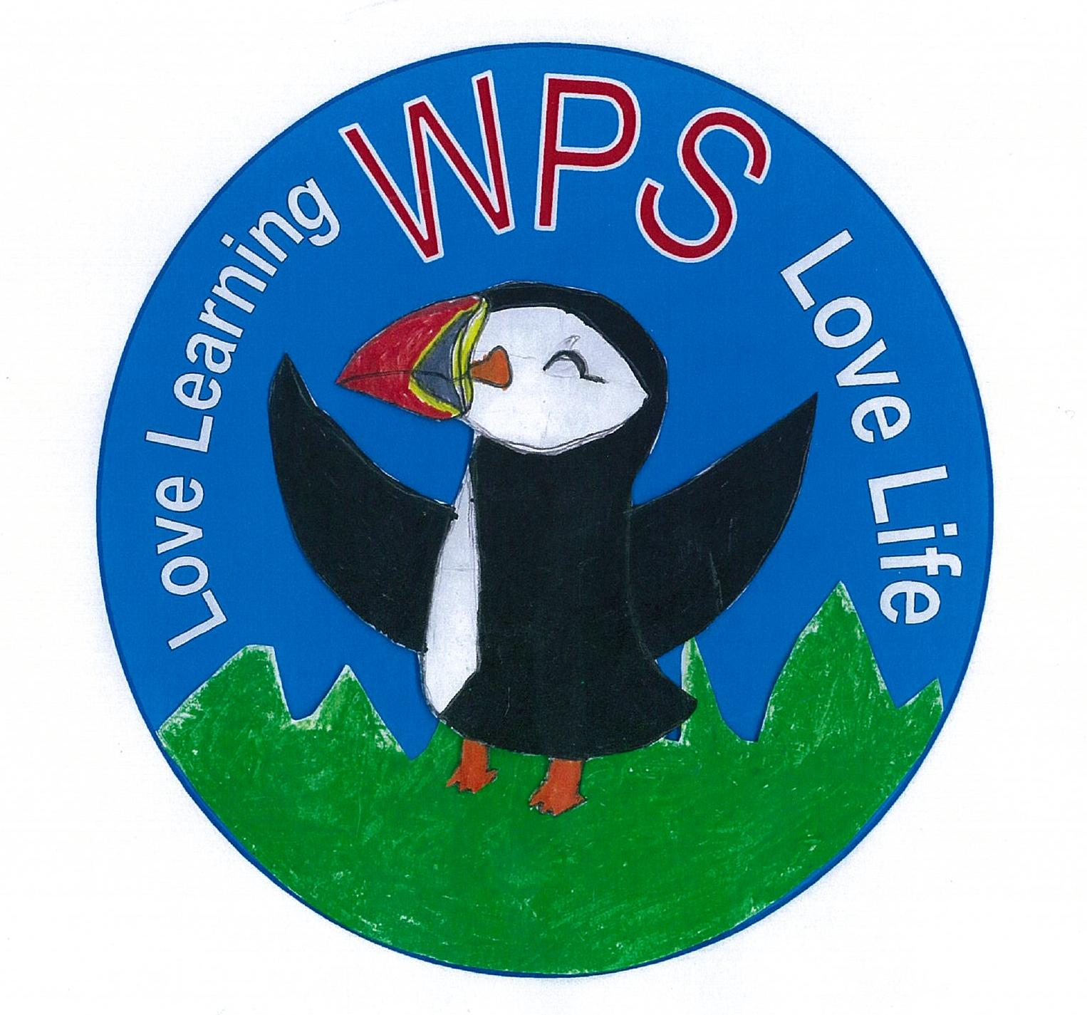


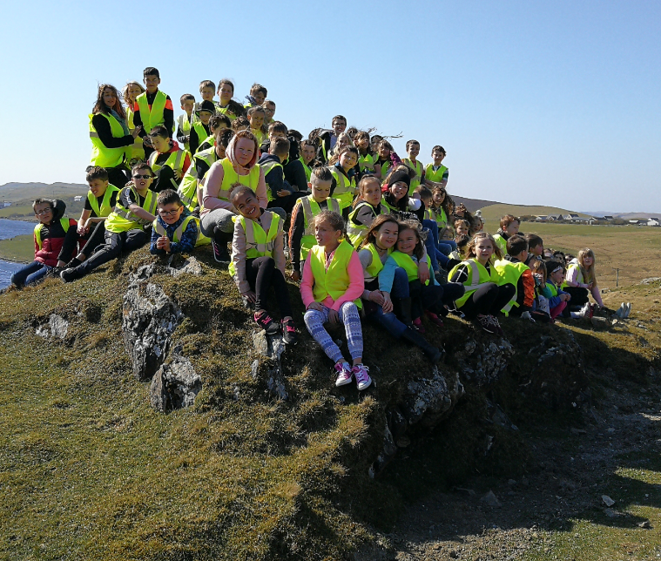
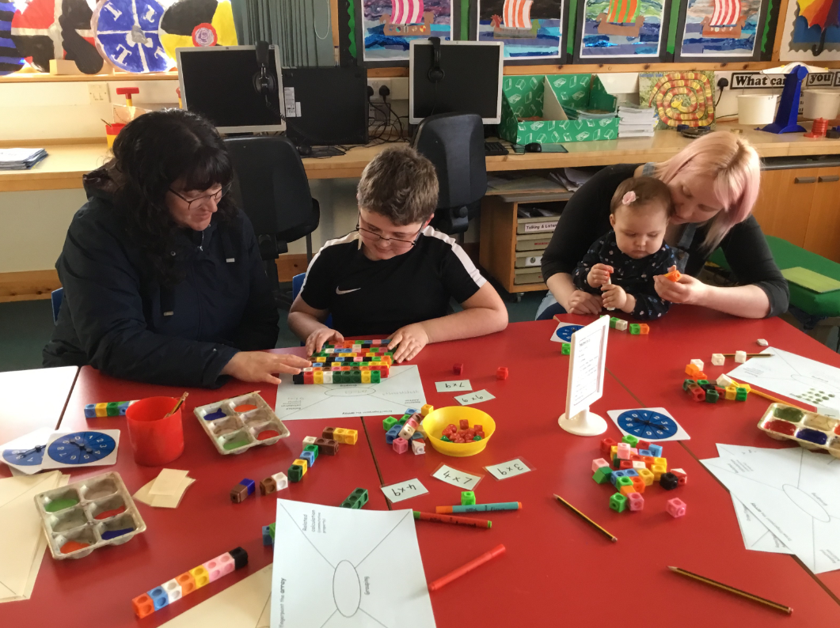
Whiteness Primary School Improvement Plan 2019 / 2020

School environment
Look at ways to improve our school environment.
Sharing responsibility to keep it calm, organised, inspiring and respected.

Curriculum development
Develop our Religious Moral Education (RME) learning progression through school.
Family Learning
Establish new ways to engage with parents.
Maintain our Bring a parent to School day for Primary Six.
Develop reading support in Primary One.
Establish Family days
Partnerships
Review our Promoting Positive Behaviour Policy, with a focus on building Positive relationships
Gather views and opinions from all staff, stakeholders, pupils, and parents.

