Snow Day – 14th March – P6/7
Literacy / Topic  - Write a character description.  - You can use any of the following pictures as a stimulus or chose a stimulus of your own.    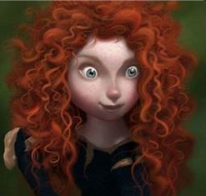      Additional  Euroquiz pupils- revision  Rest- Personal project research | Numeracy  All pupils - Practise times tables you want to improve on.  Introduction: The compass points and related angle turns.  All watch this video up to 9 minutes to give you a refresh and show you new learning ready for your activities.  Turns and 8- point Compass - Bing video  P6- I know the 8-point compass points and can relate this to angles. I can use them to describe directions and journeys.  Complete  P6 - 1- link-between-compass-points-and-angles  P6 - 2- SHM6 p109  P7-I know the link between the compass and angles (bearings). I can apply this to describe, follow and record directions, routes and journeys.  Compete  P7 - 1-Leckie 2b p192- read through and check you understanding  P7 - 2-Leckie 2b p193  Ext- Draw out the compass rose with 8 points and write in the degree turns for each 1/8 of a turn from north all the way round finishing at north again- 360 degrees. Remember a bearing always has 3 digits so numbers less than 100 start with a 0.  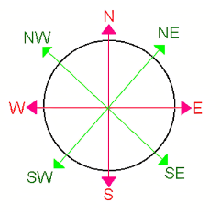 | Health and Wellbeing  What do you like to do to make you feel happy? Is it sport, drawing, listening to music, being out in nature, spending time with family? Or something else?  Spend some time doing the things you enjoy- build up your skills- e.g., a new trick with your football, a technique in drawing you want to perfect, finding that song you have been thinking about and learn the lyrics, exploring outside- discovering new things in your local environment, chatting to someone in your family.  If you want to- send me a photo at rachelcolclough@shetland.gov.uk  Have fun! And be happy

