Snow Day - 7th March – P6/7
Literacy / Topic  JRSO’s- please write a letter. We have many company vehicles driving too fast past the school when the 20mph lights are flashing. Please write an anonymised (ask parents) letter, that we can add a company name to, stating why you are writing and what you would like them to do- to keep children and families safe when crossing the road.  OR  JRSO’s- write a small piece for the Shetland Times, about what you have been doing to support parents to slow down traffic. Add in about your meeting with Lisa and the actions from it  - Letters to councillors, traffic engineer, police  - High profile out on road  - Letter to companies  - Hi Vis vests for all pupils who walk to school.  Euroquiz pupils- revision  Rest  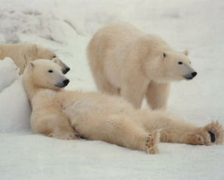  Write a short story (approximately 300-500 words) including dialogue about these three polar bears.  Remember VCOP | Numeracy  All pupils - Practise times tables you want to improve on.  Maths starter for P6- all  Go outside or around the house and take photos / draw any acute, obtuse and right angles you find.  P6- some  I know that complementary angles add up to 90 degrees and can create a missing angle quiz.  Create own complementary missing angle quiz. If you have a protractor draw your angles accurately. If you don’t have a protractor estimate your angle- be as accurate as you can- give the quiz to a parent / older sibling to complete.  P7- all  I know that supplementary angles add up to 180 degrees and can create a missing angle quiz.  Create own supplementary missing angle quiz. If you have a protractor draw your angles accurately. If you don’t have a protractor estimate your angle- be as accurate as you can- give the quiz to a parent / older sibling to complete.  P7 extension- some  I can demonstrate my understanding of naming angles and finding their sizes using my knowledge of the properties of a range of 2D shapes and the angle properties associated with intersecting and parallel lines.  Write / film / record your own guide on how to name angles. E.g.<ABC | Health and Wellbeing  Go outside, find some freshly fallen snow and see if you can find some animal tracks. Have a go at identifying them- Animal Tracks in Snow: Identify Animal Prints - Woodland Trust  Send me a photo at rachelcolclough@shetland.gov.uk  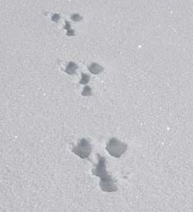  Have fun!

