Snow Day - 6th March – P6/7
Literacy / Topic  Euroquiz revision  or  Continue with your personal project research and write notes to bring back into school.  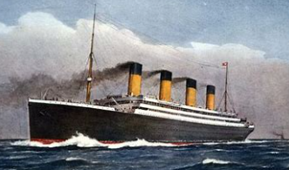 | Numeracy  All pupils - Practise times tables you want to improve on.  Maths starter for P6- all  What is an angle? - BBC Bitesize  P6- some  I know that complementary angles add up to 90 degrees and can calculate missing angles. Complete Complementary Angles sheet.  P7- all  I know that supplementary angles add up to 180 degrees and can calculate missing angles.  Complete Supplementary Angles sheet.  P7 extension- some  I can name angles and find their sizes using my knowledge of the properties of a range of 2D shapes and the angle properties associated with intersecting and parallel lines.  Watch this video: Angle Properties: Naming Angles with Letters Explained! - YouTube  Then complete Naming angles using three points worksheet | Health and Wellbeing    Go outside and enjoy the snow! Build a snowman/go sledging/make an igloo/snow angel. Send me a photo at rachelcolclough@shetland.gov.uk  Have fun!

