Creative 5 a Day

We should all be eating at least 5 portions of fruit and vegetables each day. Look at this website to find out what counts towards our 5 a day. https://www.nhs.uk/change4life/food-facts/five-a-day
Create an Art picture showing different types of fruit and vegetables in each rainbow colour. It can be digital, hand drawn and coloured or a photo using real life fruit and veg. The more creative the better.
We will put some pictures up in school for when we go back in August.

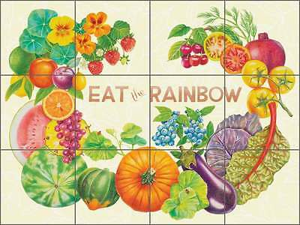
Here are some examples:

