Guess the Film

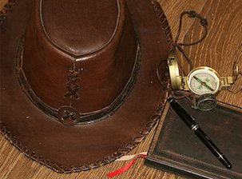
Can you guess the film from the picture clue below? (Answer at the bottom of the page.)

Time to get creative and busy with a camera. Think of a film of which could make a similar picture clue. Collect the items needed and getting snapping. Email your photo to the school. We hope to make a school quiz.

“Indiana Jones” - Did you guess it?

