Urafirth Early Years
Welcome Booklet and
Information

A

Warm Welcome
We would like to say a warm welcome you and your child to the
Early Years at Urafirth School.
Address: Urafirth Early Years, Urafirth Primary School,
Heylor, Shetland, ZE2 9RH, 01595 807460.
This handbook gives you information about your child’s time in our Early Years setting. All our staff are welcoming and we ensure that the setting is relaxed and comfortable to create nurturing learning experiences for your child.

We are a registered service with the Care Inspectorate
We are registered with the Care Inspectorate who look at the quality of care in Scotland to ensure it meets high standards. To view information from Inspections please see the link below for our most recent inspection report and details about the setting.
http://www.careinspectorate.com/index.php/care-services?detail=CS2003016129

We welcome your thoughts and ideas about how to add to the experiences that the children have. Please pass on any ideas or things that you wish to raise onto a member of staff.

The Nursery Team
Role | Person | Days in the Early Years
Head Teacher / Early Years Manager | Wendy Fraser | Monday - Friday
Early Years Senior Practitioner | Cheryl Ganson | Monday - Friday
Early Years Practitioner | Julie Willmore | Monday - Thursday
Early Years Worker | Becky Bird | Monday and Wednesday
Early Years Worker | Aileen Robertson | Tuesday, Thursday and Friday

Our Early Years Vision
Our vision for the Early Years is to have a place where children feel safe to express themselves and learn from their experiences. We have developed
‘Wir promise to wir peerie folk’ to reflect this.

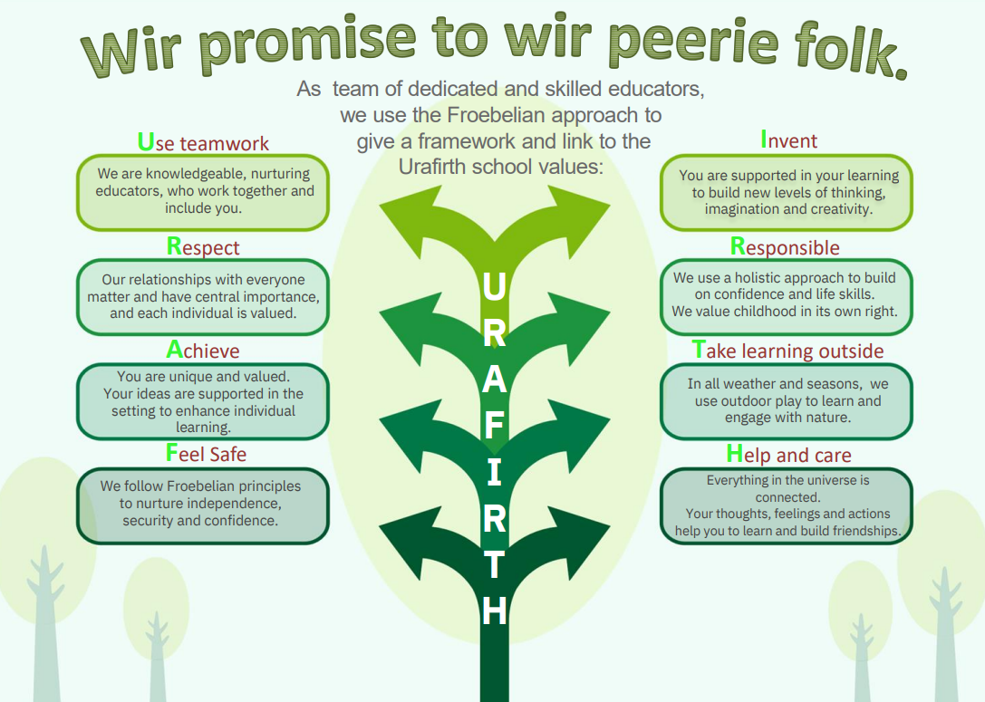

Starting Early Years
Prior to your child starting Early Years, the setting will contact you to arrange a visit day for you and your child. This gives you the opportunity to visit the setting with your child, meet the staff and children and to ask any questions. A letter will be sent to you before your child is due to join the Early Years setting.
New starts can begin attending in term 1, term 2 and term 3, depending upon when your child birthday falls. There is no new starts during term 4 (this is a Local Authority policy).
Parents/carers are welcome to stay until your child feels relaxed and happy in the setting.

Days and hours for your child attending Urafirth Early Years
Our setting offers up to 30 hours per week that your child can attend and we are open Monday to Friday term time, during the hours of 8.15am to 3.45pm, with a protected lunch time of 11.45am – 12.45pm (Meaning that there are no drop offs or collections during this time, to allow for calm and nurturing lunch time routine).
Adding to and changing times of attendance:
The days and / or hours your child attends can be changed through emailing the Early Years Team at Hayfield House in Lerwick.
Their email address is ELC@shetland.gov.uk

Snacks and lunches or packed lunch
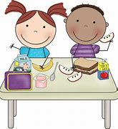
Snacks and lunches are provided and this paid for by the Scottish Government. We have our lunch in the Early Years room, creating a relaxed and homely experience eating together. The menu is the same as the primary school children (where a choice menu is given home to choose from and this operates on a four week rotation) or you can choose to provide a packed lunch.
Lunch time takes place from 11.45am – 12.45pm and we would ask parents to pick children up outside of these times.
Transportation of Children
Transport to and from Early Years is the parents’ responsibility. In the event that you are unable to collect your child yourself, please make Early Years staff aware of who will be collecting them (the person must be over 16 years of age).

Our Setting
The Early Years Setting accommodates up to 22 children.
The room has direct access to our secure outdoor play area and allows for free flow play from inside to outside. Children can choose from the wide range of equipment and resources available freely, encouraging independence and child-led learning.

Outdoor play
We encourage a balance between outdoor and indoor play, thus allowing children a wider variety of areas of discovery.
Outdoor play “encourages enquiry and invites discussion and exploration with interesting subjects to talk about and explore, stimulating curiosity.” (Building the Ambition - National Practice Guidance on Early Learning and Childcare).
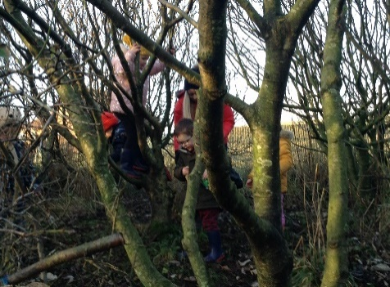
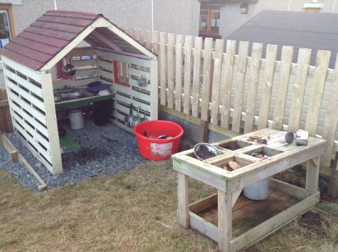

The Care Inspectorate highlight the benefits of outdoor play:
Through access to a range of outdoor activities we expect that children will:
- Participate in a wide range of activities that will support a healthy lifestyle
- Develop the skills to assess and manage risk
- Experience personal achievement and build confidence
- Explore and make choices
- Develop physical skills through movement and energetic play
Care Inspectorate (2016), My world outdoors, p.11

Learning through play
Learning through play is an important part for children’s learning and development and we recognise this in the way in which activities are set up., linking to the interests that the children have and taking on a child led approach. By being child led the children have full input into the daily activities on offer.
“Play is an intrinsic part of human nature and development. For babies and children, the essential role of play is well documented. Through play a child develops their cognitive, social, emotional and physical capacities”. (Realising the Ambition, 2020).
Physical activity also forms an integral part of our day, making use of the gym hall and the outdoor areas.

Play with open-ended materials
We make use of open ended materials. Staff will be encourage children to use their imagination by playing with resources including cardboard boxes, tyres, bread baskets, tarpaulins, wooden planks and plastic guttering. These are called ‘Open ended materials’.
They can be used in many different ways, allowing children to make anything from a boat or castle to an assault course or den. Using open ended materials in play allows children to:
- Play freely with friends
- Investigate
- Discover
- Explore
- Create
- Use lots of trial and error to learn for themselves
- Learn to make their own judgments about adventurous play and recognising safe limits
Please ensure your children are dressed for the weather so they can join in properly – they might need warm waterproof jackets, gloves or sunscreen, sun hats etc. depending on the weather (we provide wellies, warm waterproof trousers or oilskins for outdoor play).
Staff attend training to further support the children’s play using open ended materials and outdoor play.

Outdoor play and learning policy
As a team we have developed the use of an outdoor play and learning policy which links the use of the Froebelian approach in the setting.
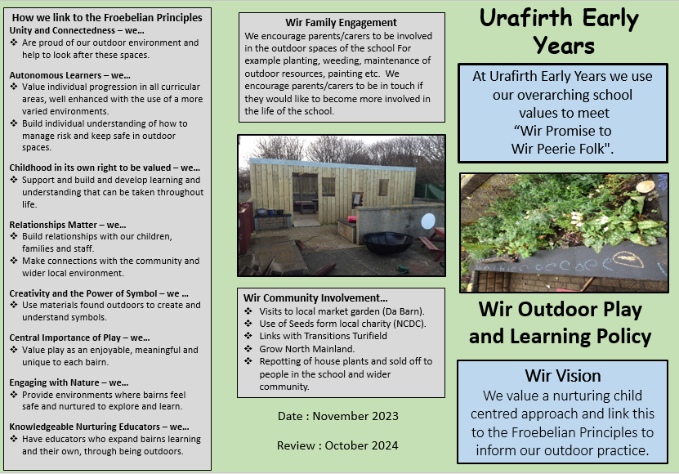
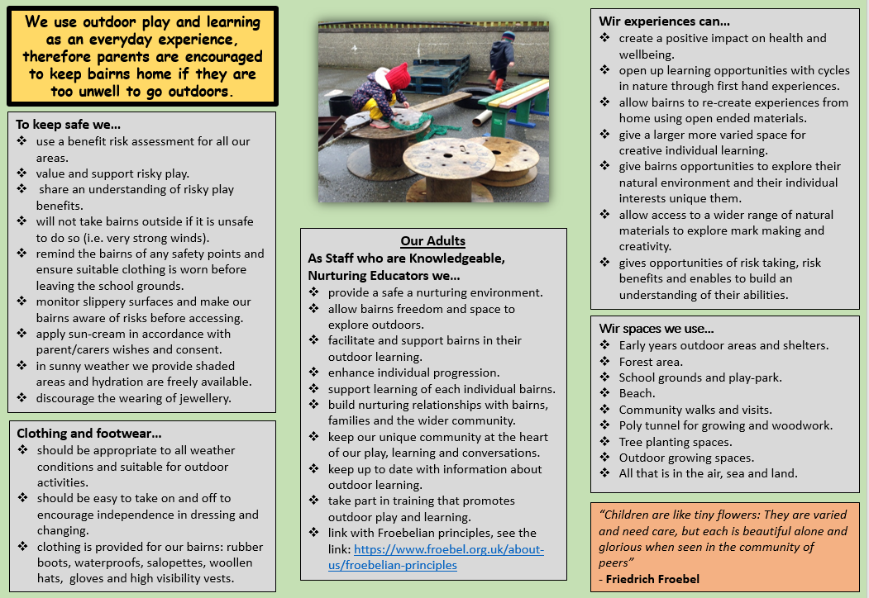

For further reading on the Froebel approach please see the website for more information:
https://www.froebel.org.uk

Numeracy and Literacy
Numeracy and literacy activities form an integral part of the day in Early Years, and the development of these skills are encouraged through songs, rhymes, stories and games. An example of this would be participation in one of the Book bug sessions.

Library and Reading
We encourage an interest in books and reading in Early Years. We have ‘Story Sacks’ to take home and enjoy with your family. We have a lovely library in the School which we use every day. By using books and reading this helps children with mark making and writing.
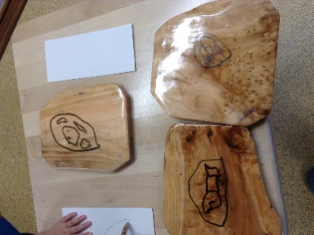

Sharing experience
We encourage children to bring toys/found objects from home. This can stimulate a great deal of discussion amongst the children, and can be the inspiration for much new learning.

Activities
Sometimes we have activities along with the Primary class. The activities are chosen to cover a wide range of skills and learning, often topic-related. This activity benefits primary and Early Years in social interaction, responsibility and collaborative work.

Birthdays
If your child’s birthday is on a nursery day we will be delighted to celebrate with them. We ask a child what they would like to have and we can bake or make cakes with healthy recipes. We have baked a big cake, baked cupcakes and we have even made a cake made from different fruit and vegetables.

Clothing
In the Early Years setting we provide the children with aprons for baking and messy play. We suggest that children don’t wear their best clothes as accidents can and do happen!
Children should bring a bag with a change of clothes in case it should be required. Outdoor waterproof clothing and wellies are provided here in the setting for messy outdoor play. Please dress your child appropriately to suit the weather, so they can enjoy the outdoor play. We provide sun cream (you can provide your own if you wish) and sunhats should be provided from home for hot days.

Tooth Brushing
The nursery children take part in the Childsmile Scheme, and enjoy regular visits from Clare Balfour, who helps show them how best to brush and look after their teeth. Your child is provided with his/her own toothbrush and is supervised in brushing his/her teeth after eating snack every day.

How we record and show progression in Learning and Development
Learning Journals
At the Urafirth Early Years, we use the Learning Journals Programme as a method to link with you for your child’s leaning and play experiences in the setting.
This programme is a great tool to share what your child is doing when they are at the Early Years. You can also share activities from home to show your child’s learning. It is quick and easily accessible online or by using the parent app which can be downloaded.
Please find the attached parent guide information for you to read or the link below to read / download:
https://learningjournals.co.uk/wp-content/uploads/2021/03/Parent-Guide-2021.pdf
For further information the developers of the Learning Journals have their webpage, which can be found at:
https://learningjournals.co.uk
They have also created this information video for parents to demonstrate how to use the Learning Journals. Please see the link below:
https://www.youtube.com/watch?v=KnJWq1cwgAw

Places where we show children’s learning and interests in the Early Years
The Early Years setting is follows the Curriculum for excellence from the Scottish Government in delivering a balance of play and learning. For progression we make use of the overviews for 3 and 4 year olds from The Highland Council.
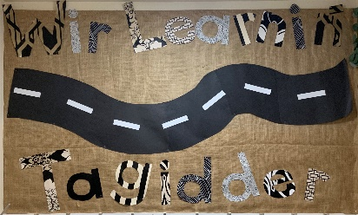
We develop our things to learn about as a group, through the interests of the children. This can be followed by checking the ‘Wir Learnin’ Tagidder’

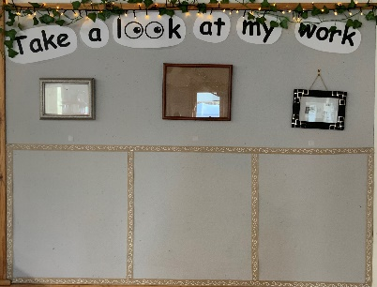
In displaying children’s individual work, each child chooses a space on our ‘Take a look at my work’ wall, where they can decide share their work for other to see. If they prefer not to share it with others they can put it into their individual ‘Take a look at my work book’ – a scrapbook for children to stick their work into.

How we share information and updates with parents
Facebook page: Search for Urafirth Early Years.
Emails sent from the school directly.
Letters sent out.
School website: https://blogs.glowscotland.org.uk/sh/urafirth/
Learning journals – log in regularly to check what we have been doing.
A chat at the gate.

Key documents that we link to
- The Early Years Framework (2008) sets out a vision for early years services in Scotland to ensure that children get ‘the best start in life’.
- Realising the Ambition: Being Me (2020) is the national practice guidance for early years in Scotland. The guidance covers the period from birth through early childhood into primary education.
- Curriculum for Excellence (CfE) builds on the solid foundations developed in the critical years pre-birth to three. Within CfE, children are entitled to a broad general education from age three until the end of S3. The early level of CfE for most children spans the period of time from age three until the end of Primary 1. It supports a smooth transition in learning between ELC and primary school.
- How good is our early learning and childcare? (2016) provides a suite of quality indicators. These support staff to look inwards, to scrutinise their work and evaluate what is working well for babies, toddlers and young children, and what could be better. The framework is designed to be used to support self-evaluation for self-improvement by practitioners at all levels.

Transition into Primary One
Our Early Years serves the Northmavine area and has close links with Urafirth Primary School, as well as North Roe Primary School and Ollaberry Primary School. Your child’s transition into primary school will be structured, with appropriate transfer of information. Visits by primary staff to Early Years, and by your child to their relevant primary school, take place in the summer term before your child moves into primary one. These visits aid the smooth transition your child will make into the primary school.

We look forward to supporting your child in their learning and
development and working with you.

