Urafirth Primary School

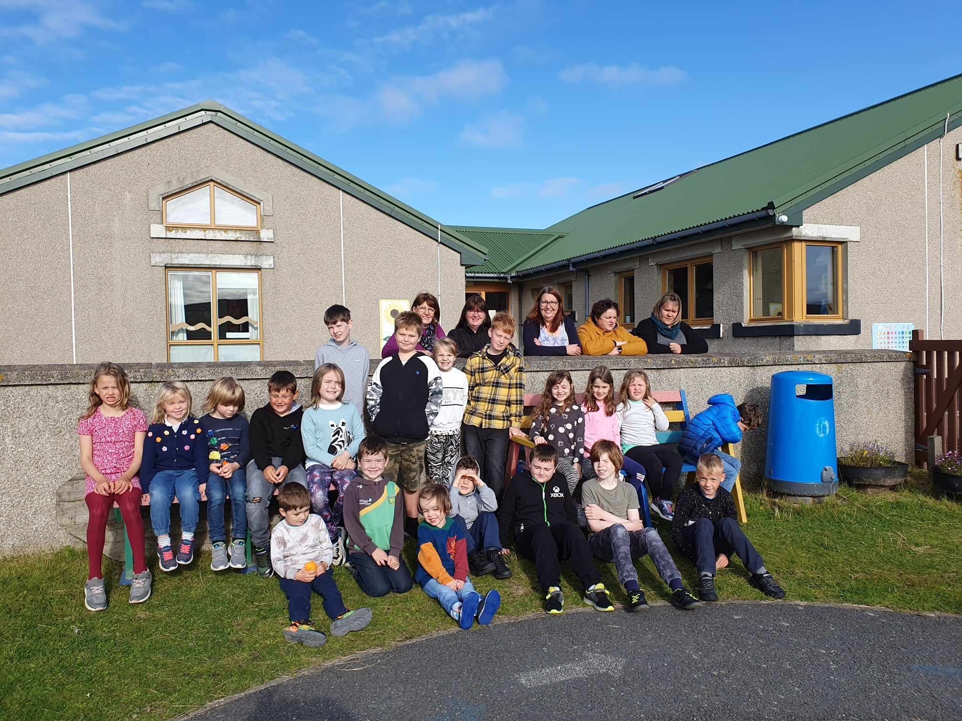

Standards & Quality Report
2022-23

and

School Improvement Plan
2023-24

Introduction

Shetland Islands Council is committed to delivering the best possible outcomes for children and young people so that they have the best start in life and are ready to succeed by following the principles of Curriculum for Excellence, the National Improvement Framework, Getting it Right for Every Child (GIRFEC), and Developing the Young Workforce.
We want to know how well we are doing this and how we can improve. We are continuously evaluating what we do and how it makes a difference to our learners. We have been asking ourselves – staff, pupils, parents/carers, and other partners – the questions contained in this Standards and Quality Report. Our self-evaluation – involving staff, pupils, parents/carers, and other partners – is in the pages that follow, along with our main improvement priorities for session 2023/24. This report is based on the quality indicators in How Good is Our School? 4th Edition (2015) and How Good is our Early Learning and Childcare? (2016) and on the priorities and drivers of the National Improvement Framework.

The current National Improvement Priorities are:
- Placing the human rights and needs of every child and young person at the centre of education
- Improvement in children and young people’s health and wellbeing
- Closing the attainment gap between the most and least disadvantaged children and young people
- Improvement in skills and sustained, positive school-leaver destinations for all young people
- Improvement in attainment, particularly in literacy and numeracy.

The National Improvement Drivers are:
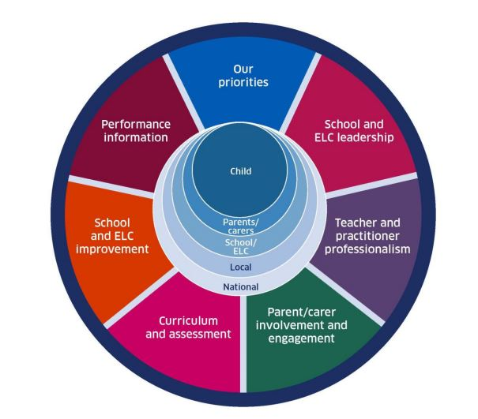

Contextual analysis of the school

Context of the School

Our Vision, Values and Aims
Urafirth is a community where we ‘engage and inspire our individual stars to shine brightly.’
We have developed school values in consultation with pupils, staff and parents. These values are used and pupils and staff on a daily basis to continue to foster the positive ethos that the school demonstrates.
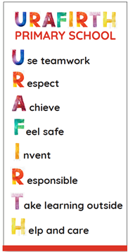

Local Contextual Issues
Urafirth Primary School is located in Northmavine adjacent to the main road between Urafirth and Hillswick, close to the shore. The school grounds boast a range of facilities which include a play park, mini-croft, cycle-track, forest, grass pitch and enclosed safe spaces, as well as access to the shore line. These are accessible out-with the school day. The school has primary and ELC shelters that facilitate outdoor learning in poor weather. The polytunnel includes a woodworking area.
We are surrounded by sea and croft land and Eshaness – which boasts a volcanic past, interesting geology, and spectacular scenery – is 6.5 miles from us. Shetland’s highest peak, Ronas Hill, is visible from the school. The school is 32 miles (45 minute drive) from Lerwick.
The school is lucky to be part of a close community that takes an interest in the school and provides active support. As Covid 19 mitigations have lessened we have been able to have parents’ evenings and other events in the school such as a ‘Soup and Sweet’ lunch. Parents have also played a major role in maintaining our outside area. The community is rural with crofting, tourism, salmon farming, the oil terminal and gas plant being major employers.
Feedback
- ‘There is a very positive and friendly atmosphere within the school. The strong focus on relationships is evident and it is clear you model that through your leadership’. – Term 2 school improvement visit feedback.
- ‘The children are so happy and keen to share the different things they do. There is a real sense of community with everyone supporting each other.’ School Improvement Visit Term 4.
- ‘The head teacher does a lot to move the school environment and the pupils’ learning forward’ – parent feedback
- ‘We are very happy with the indoor and outdoor environment, the learning opportunities and the staff’ – parent feedback
- ‘Thanks to all for their effort and hard work, because of it our bairns love school and get so much out of it’ – parent feedback
- ‘I like the school because it is fun and safe’ – pupil feedback

.
Collaboration and consultation with our stakeholders in session 2022/23

Who? | When and how? | What did we find out?  (bullet points on key themes)
Staff | The process has been ongoing over the past year with staff meetings, Teacher Meetings, ELC Meetings and PRD meetings | - Staff continued to feel included and valued  - There is a strong team spirit and everybody works together well for the vast majority of the time  - Staff feel they can speak about any health and wellbeing issues with the Head Teacher and there is good communication
Children and young people | Pupil Council - termly  Assemblies – at least termly  Questionnaire – Term 3  Class discussion  MS Forms | - Learning - most pupils now know what their next steps in learning are and how they are progressing  - School Values – almost all pupils are clear on the school values and are aware that adults also use the school values  - Environment – most pupils are aware of current school improvements and feel they have a say in their environment  - Pupils have a wish list that includes a frog pond, more time in the forest, more cooking and swimming.
Parent and Carers | Parent Council – termly  Questionnaire – Term 3  MS Forms  Social Media  Chatting with parents outside  Events such as ‘Soup and Sweet’ | Primary Parents  - 25% of parents responded to the survey and most parents would prefer to see homework for their children  - Parents are keen to see the library area developed  ELC Parents  - 25% of parents responded to the survey and all were extremely positive about all aspects of ELC and there were no suggestions.
Community and other stakeholders | Ongoing communications with local groups –  Northmavine Development Company  Northmavine Community Council  Northmavine Grow Local  Local Public Hall  Ability Shetland  Local government departments such as Active Schools  NHS including school nurse and school dental service  Brae High School Cluster  Anchor for Families  Local artist in residence | The school has recently been successful in obtaining a ‘food for thought’ grant of £1000 which will feed into our ELC outdoor development which was developed with local stakeholders.

Standards & Quality Report
2022-23

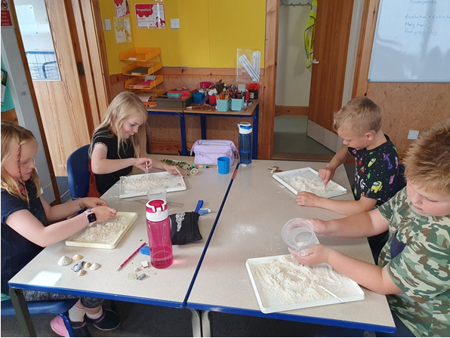

Progress made with the Priorities from our 2022-23 School Improvement Plan
NIF PRIORITIES  - Placing the human rights and needs of every child and young person at the centre of education.  - Improvement in children and young people’s health and wellbeing  - Closing the attainment gap between the most and least disadvantaged children and young people  - Improvement in skills and sustained, positive school-leaver destinations for all young people  - Improvement in attainment, particularly in literacy and numeracy.  (highlight as appropriate) | NIF DRIVERS  - School and ELC leadership  - Teacher and practitioner professionalism  - Parent/carer involvement and engagement  - Curriculum and assessment  - School and ELC improvement  - Performance information | 1.1 Self-evaluation for self-improvement  1.2 Leadership for learning  1.3 Leadership of change  1.4 Leadership and management of staff  1.5 Management of resources to promote equity | 2.1 Safeguarding and child protection  2.2 Curriculum  2.3 Learning, teaching and assessment  2.4 Personalised support  2.5 Family Learning  2.6 Transitions  2.7 Partnerships | 3.1 Ensuring wellbeing, equality and inclusion  3.2 Raising attainment and achievement/Securing children’s progress  3.3 Increasing creativity & employability/ Developing creativity & skills for life & learning

Priority 1: Continue to develop a play based pedagogy incorporating outdoor learning, woodwork and assessment techniques

What were our outcomes?  To use the Education Scotland Play Pedagogy Toolkit to enhance our understanding and inform next steps  To have woodwork area and pupils from ELC through to P7 will be having opportunities to learn woodwork.  To use clear methods of assessment will be used and understood by class teachers when using outdoor learning. | What did we do?  •We used the Play Pedagogy toolkit toolkit at the In service meeting 24.10.22  •We embedded woodworking in our whole school practice through an ELC Practitioner sharing her ongoing training with the whole school staff and acquiring additional resources to create the area required.  •We continued to be involved in the play –based pedagogy local authority group.  •We continued to develop our assessment techniques for outdoor Learning.  •P6 and P7 will got opportunities to interact and work with ELC children through a series of planned events. | What was the impact on learners?  All learners are getting opportunities to engage with woodwork and say ‘Can we have more times to go to the woodwork area to work with it?’  Play based pedagogy has become an accepted part of the school day throughout the school and the overall increase in HWB measured through the baseline survey helps to support this approach.  Parents have become more engaged in the life of the school through helping with the woodwork and this has added to learners’ expositive experience of the woodwork area. | What are the next steps and how do you plan to evidence the impact of further actions required?  Our maintenance plan will involve reaching our t to parents asking for helper volunteers and making a schedule to ensure all learners get a chance to have positive learning experiences in the woodworking zone.  Our maintenance plan will involve continuing with play based pedagogy approaches and attending meetings where possible.  We are developing a buddying system to ensure that learners get opportunities for leadership and enhance playtimes.  Teachers will continue to look for opportunities to teach and assess outdoor learning.

NIF PRIORITIES  - Placing the human rights and needs of every child and young person at the centre of education.  - Improvement in children and young people’s health and wellbeing  - Closing the attainment gap between the most and least disadvantaged children and young people  - Improvement in skills and sustained, positive school-leaver destinations for all young people  - Improvement in attainment, particularly in literacy and numeracy.  (highlight as appropriate) | NIF DRIVERS  - School and ELC leadership  - Teacher and practitioner professionalism  - Parent/carer involvement and engagement  - Curriculum and assessment  - School and ELC improvement  - Performance information | 1.1 Self-evaluation for self-improvement  1.2 Leadership for learning  1.3 Leadership of change  1.4 Leadership and management of staff  1.5 Management of resources to promote equity | 2.1 Safeguarding and child protection  2.2 Curriculum  2.3 Learning, teaching and assessment  2.4 Personalised support  2.5 Family Learning  2.6 Transitions  2.7 Partnerships | 3.1 Ensuring wellbeing, equality and inclusion  3.2 Raising attainment and achievement/Securing children’s progress  3.3 Increasing creativity & employability/ Developing creativity & skills for life & learning

Priority 2: To reinvigorate parental confidence and support family learning after the Covid Pandemic using PEEP family learning, zones of regulation, after-school clubs, development of a resource library and a review of homework provision.
What were our outcomes?  Starting to develop a resource library so that parents can borrow books, games etc.  Deliver 3 open afternoons where pupils can show parents what they are learning and doing in school and parents get the opportunity to feed back to the school in an informal matter.  Made further developments regarding the community input into Golden Time and after school clubs  To Implement Zones of Regulation in the Primary Department and be looking at its application in the ELC setting  PEEP family learning training to be undertaken by ELC staff and beginning implementation | What did we do?  •We carried out a homework consultation  •We organised sequence of Open Days  •We asked the Parent Council to support efforts to engage the Community in after school clubs and other Community activities.  •All staff received training on Zones of Regulation on 16.08.22 and the zones were put into practice in both primary classes  We rearranged Goldren Time to give more structured opportunities to children  ELC staff member undertook the PEEP family learning training. | What was the impact on learners?  - Learners in all primary classes receive weekly structured homework. There is a whole working week to hand the homework in and no homework is given over the weekend.  - Learners have been delighted to show guests around the school and share their learning at a number of event, leading to very positive comments about how the learners interact confidently and share their learning with pride.  - ‘The children are so happy and keen to share the different things they do. There is a real sense of community with everyone supporting each other.’ School Improvement Visit Term 4.  - Golden time opportunities for learning have increased with parents sharing their woodworking skills during this time. | What are the next steps and how do you plan to evidence the impact of further actions required?  This priority has been carried forward to the 2023-24 plan.

NIF PRIORITIES  - Placing the human rights and needs of every child and young person at the centre of education.  - Improvement in children and young people’s health and wellbeing  - Closing the attainment gap between the most and least disadvantaged children and young people  - Improvement in skills and sustained, positive school-leaver destinations for all young people  - Improvement in attainment, particularly in literacy and numeracy.  (highlight as appropriate) | NIF DRIVERS  - School and ELC leadership  - Teacher and practitioner professionalism  - Parent/carer involvement and engagement  - Curriculum and assessment  - School and ELC improvement  - Performance information | 1.1 Self-evaluation for self-improvement  1.2 Leadership for learning  1.3 Leadership of change  1.4 Leadership and management of staff  1.5 Management of resources to promote equity | 2.1 Safeguarding and child protection  2.2 Curriculum  2.3 Learning, teaching and assessment  2.4 Personalised support  2.5 Family Learning  2.6 Transitions  2.7 Partnerships | 3.1 Ensuring wellbeing, equality and inclusion  3.2 Raising attainment and achievement/Securing children’s progress  3.3 Increasing creativity & employability/ Developing creativity & skills for life & learning

Priority 3: Effective use of digital technology for literacy and numeracy.

What were our outcomes?  To use Clicker to support pupils in literacy tasks  To research the Education Endowment Foundation’s recommendations for improving literacy and have an action plan in place for the implementation of key findings.  To have a clear tracker for all aspects of digital literacy in place to help class teachers plan and track. | What did we do?  - Teaching staff engaged with Shetland’s CLPL sharepoint and the Clicker resources within  - Teachers researched EEF recommendations for using digital technology to improve learning with working group follow ups. This led to a recognition that an effective feedback could be given to pupils via using MS Teams function to assess reading skills.  - Shetland’s Digital Literacy and Computing Framework was used to make a tracker for each level. | What was the impact on learners?  Learners enjoyed the MS Teams reading assessment tool and responded well to the video feedback given.  90% of learners are on or above track in reading in the P5 – 7 class.  Learners have a targeted ICT programme based on the main sections of the tracker. Learners are becoming more computer literate and aware of the dangers of the internet and social media. | What are the next steps and how do you plan to evidence the impact of further actions required ?  To continue to use the MS Teams reading assessment tool with the P5 – 7 class as part of the maintenance plan.  To utilise the newly created digital literacy tracker to plan and execute ICT lessons alongside the Shetland Framework for Digital Literacy &  Computing Science
Pupil Equity Fund Reporting, 2022/23
Project/intervention: Continued focus on Health and Wellbeing including implementation of The Zones of Regulation and continued development of outdoor learning and our new outdoor classroom area and ELC garden area. Education Scotland’s Equity Toolkit will be utilised to inform future improvements in Literacy, Numeracy and Health and Wellbeing.
What was your gap? Urafirth Primary serves a remote rural community where parents may be unable to ensure access to all opportunities due to transport costs leading to isolation. Some pupils have low self-esteem and poor emotional/social wellbeing.
Interventions for Equity Interventions for Equity | Self-evaluation | National Improvement Hub (education.gov.scot)
(highlight the interventions that apply)
Early intervention and prevention | Social and Emotional Wellbeing |  |  | Promoting healthy lifestyles | Targeted approaches to literacy and numeracy | Promoting a high quality learning experience | Differentiated support
Use of Evidence and Data | Employability and Skills Development |  |  | Engaging beyond the school | Partnership working | Professional learning and leadership | Research and evaluation to monitor impact
Planned Outcome  Pupils will be further engaged in their outdoor environment with more opportunities for play-based learning.  We purchased a door for the outdoor shelter which made it even more flexible.  Outdoor blocks were purchased to encourage block play in the outdoor setting  An activity set was purchased to enrich playtimes and to be used for buddying.  The outdoor shelter area will be able to be used for after school clubs in order to give more opportunities for activities that are near at hand in this remote area.  Staff received zones of regulation training and started implementing the principles in class.  Kitbag introduced to staff as a means of helping pupils to listen to others and share their feelings and show empathy. |  |  | Measures of impact on learners  The Health and Wellbeing study carried out in November and June showed that learners perceived level of health and wellbeing increased or remained static over the time period. No learners displayed a decrease in perceived HWB during this time.  Learners fed back in pupil questionnaires regarding their appreciation for the outdoor areas  Zones of regulation implementation has meant that several pupils are now more able to understand their feelings and emotions giving them a greater sense of wellbeing and enabling them to approach their learning more positively.
Teaching and Learning |  | ✓
Leadership |  | ✓
Family and Community |  | ✓

School self-evaluation, 2022-23, and priorities for further improvement

Qualitative Data | Quantitative Data
Classroom observations, learning visits, learning walks, etc.  Focus group discussions  Feedback from online and face-to-face meetings  Conversations in staffrooms  Verbal feedback from learners and parents and carers  Questionnaires  Baseline and follow up HWB study | Attainment in the Broad General Education  Attendance, absence and late-coming  Measures of learner engagement, participation, inclusion and health and wellbeing  Tracking and Monitoring  Planning documentation  Curriculum rationale  Questionnaires and surveys with stakeholders and minutes of meetings with them  Child Protection referrals  Free School Meals data  PRDs  Professional learning records  Child’s Plans, CSPs and IEPs  School Improvement and Team Improvement reports  Education Scotland and Care Inspectorate inspection reports

All 100%; Almost All 91%-99%; Most 75%-90%; Majority 50%-74%; Minority/less than half 15%-49%; A few less than 15%
Leadership of Change (QI 1.3)

How well are you doing? What’s working well for your learners?
Staff take on leadership roles and train colleagues during staff development time. Staff are involved in self-evaluation processes using HGIOS 4 and challenge questions and always consider the impact of improvements on learners. The Head Teacher, Staff, parent and learners all work together to implement change and agree priorities. Leadership of change in recent years has impacted positively on children learning experiences in a number of key areas. Pupils play a role in leading parts of their learning. Pupils are involved in identifying and discussing the school’s priorities.

How do you know? What quantitative and qualitative evidence do you have of a positive impact on learners?
Questionnaires to pupils, staff and parents, staff meetings, assemblies, Parent Council meetings and minutes of meetings with them we are confident that we are achieving our goals. Other evidence comes in the form of tracking and monitoring, Child’s Plans, CSPs, school improvement reports and IEPs.

What are you going to do now? What are your improvement priorities in this area?
- Use the action plan and new school improvement priorities to further progress in this area.
- Promote the school vision and values and to produce a new school motto.
- Involve parent and learners in all aspects of school improvement.

Self-evaluation grade on the HGIOS?4 six-point scale: 4

Learning, teaching and assessment (QI 2.3)

How well are you doing? What’s working well for your learners?

Class teachers have a clear planning format and are well prepared. We now have the majority of the curriculum covered by learning progression frameworks to aid planning and assessment. Learners are enthusiastic and confident in the school learning environment. Assessment is recorded in folders and used to inform tracking and monitoring which in turn informs pupil progress, challenge and pace and next steps. Pupil voice is encouraged through Pupil Council, the new eco Committee and continuously throughout the school day. The Head Teacher monitors by having a programme of class visits, reviews of planning and assessment and by providing time for teachers to undertake moderation activities to help judge attainment and next steps.

How do you know? What quantitative and qualitative evidence do you have of positive impact on learners?

Staff are very clear on the needs of each individual pupil and through discussions with the Head Teacher, ASN teacher and Learning Support Workers every effort is made to meet those needs.
The Head Teacher holds regular assemblies where pupils can share their thoughts and ideas as well as give presentations of their learning.
We use the results of SNSA assessments and class assessments to inform our next steps. Other evidence comes in the form of tracking and monitoring, Child’s Plans, CSPs, school improvement reports and IEPs.

What are you going to do now? What are your improvement priorities in this area?
- Develop a clear assessment calendar to compliment the monitoring calendar
- Continue to track pupil progress
- Further develop the use of national benchmarks and progression frameworks to support assessment evidence.
- Head Teacher programme of visits and review of planning and assessment.
- Use teacher moderation activities to enhance understanding of the benchmarks and to accurately assess learners’achievements.
Self-evaluation grade on the HGIOS?4 six-point scale: 4

Ensuring wellbeing, equity and inclusion (QI 3.1)
How well are you doing? What’s working well for your learners?
Pupil wellbeing at the centre of all activities in the school. Transitions are carefully considered and enhanced transitions are provided if needed. We work with outside agencies to ensure the wellbeing, inclusion and equity of all pupils. We have embedded the rights of the child and staff are aware of these rights as well as pupils learning more about them at assemblies and in class. Outdoor learning is embedded in the school and this has given the pupils a sense of wellbeing.

How do you know? What quantitative and qualitative evidence do you have of positive impact on learners?
- The pupils are happy and communicate their needs and concerns freely with staff
- A whole school baseline assessment of the wellbeing indicators was conducted in November 2022 and then revisited in June 2023 to map changes.
- Feedback at assembly/ pupil council
- GIRFEC minutes and meetings
- Child protection procedures
- Attendance data
- SEEMIS
- Use of dyslexia toolkit
- Other evidence comes in the form of tracking and monitoring, Child’s Plans, CSPs, school improvement reports and IEPs.

What are you going to do now? What are your improvement priorities in this area?
- Set up a buddying system for playtimes that gives leadership opportunities as well as enhancing playtime for all
- Primary learners will help the ELC learners to grow food in their developing growing area
- Continue to ensure that ASN pupils have the opportunities afforded to others
- Continue to develop the outdoor area to enhance outdoor learning opportunities, using some of the PEF funds.
- Continue to embed the school values and the UN rights of the Child
- Continue to have an ethos of whole school inclusion that includes the ELC Department
- Continue to have ELC children mixing with primary children at suitable times
- Continue to work on ensuring pupil voice is heard in class and there is learner led opportunities
Self-evaluation grade on the HGIOS?4 six-point scale: 5

Raising attainment and achievement (QI 3.2)
How well are you doing? What’s working well for your learners?

- Whole school moderation exercise in June 2023 gives an accurate picture and one class will need extra support based on the results.
- SNSA results show that learners are on the whole performing above expectations with the exception of one class.
- Focussed tracking and monitoring and assessment means that the needs of individual learners are recognised and acted upon with individual and group support from the ASN teacher and Learning Support Workers as required.
- Attainment in literacy and numeracy continue to form the core of all work towards raising attainment and achievement.
- The Head Teachers monitoring programme ensures planning and classroom practice is continually under review.

How do you know? What quantitative and qualitative evidence do you have of positive impact on learners?

- A moderation event in June 2023 which assessed pupil levels in Numeracy, Reading, Writing and Health and Wellbeing
- Learners have opportunities to share their achievements with other though wall displays and assemblies as well as class discussions.
- Minutes of staff meetings, GIRFEC meetings and Parent and Pupil Council meetings.
- SNSA and other assessment results
- Questionnaires and surveys with stakeholders
- Other evidence comes in the form of tracking and monitoring, Child’s Plans, CSPs, school improvement reports and IEPs.

What are you going to do now? What are your improvement priorities in this area?
- To continue to focus on attainment in literacy and numeracy as the day to day backbone of the curriculum. Literacy will be the main priority following the results of the moderation exercise and SNSA results.

Self-evaluation grade on the HGIOS?4 six-point scale: 4

School Improvement Plan
2023-24

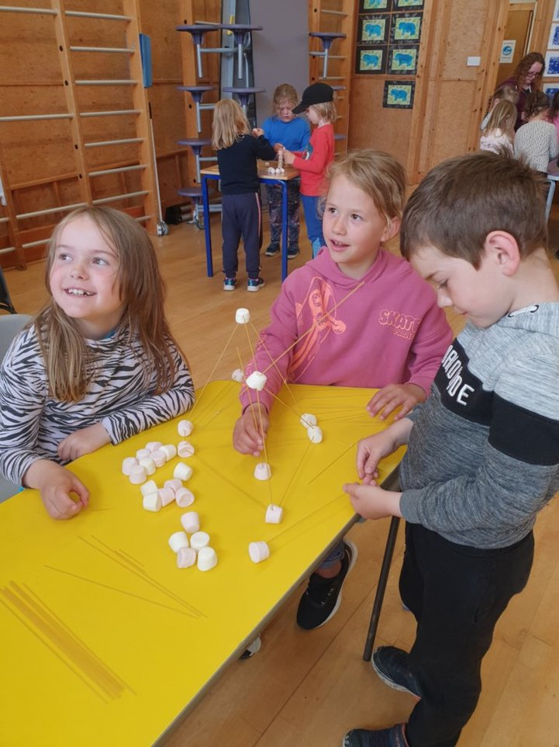

Factors Influencing the 2023/24 School Improvement Plan
Local authority factors  - Excellence and Equity for Shetlands’ learners  - Children’s Services, Recovery and Renewal Plan  - Children’s Services, Directorate Plan SIC Operational Guidance: School Improvement Planning and Standards and Quality Reporting  - SIC Strategy for Parental Involvement 2022 | National factors and drivers  - Curriculum for Excellence  - Realising the Ambition  - National Improvement Framework  - The Scottish Attainment Challenge  - Education Reform and Empowerment  - Getting It Right for Every Child  - Developing Young Workforce  - Digital Learning and Teaching Strategy  - The Equity Audit  - “Learning Together”: Scotland’s national action plan for parental involvement etc. 2018-2021

School factors

- Feedback from Parent Council, Learners and Staff
UNCRC  - We have a display with the Rights of the Child featured. Assemblies always reflect on this right and it is embedded in our practice with staff also made aware of the rights through staff meetings, being at assemblies and contributing to the school display. | Tacking Inequalities, Poverty Proofing and Cost of the School Day  - A school uniform swap system has been introduced for those who wish to have a school uniform without the expense.  - Continued provision from national government of digital devices.r.  - Supporting families to access financial entitlements with the support of Anchor  - Ensuring equal access to opportunities at school for all pupils including ASN pupils and removing barriers to learning and participation.

Improvement Priorities for 2023-24

NIF PRIORITIES  - Placing the human rights and needs of every child and young person at the centre of education.  - Improvement in children and young people’s health and wellbeing  - Closing the attainment gap between the most and least disadvantaged children and young people  - Improvement in skills and sustained, positive school-leaver destinations for all young people  - Improvement in attainment, particularly in literacy and numeracy.  (highlight as appropriate) | NIF DRIVERS  - School and ELC leadership  - Teacher and practitioner professionalism  - Parent/carer involvement and engagement  - Curriculum and assessment  - School and ELC improvement  - Performance information | 1.1 Self-evaluation for self-improvement  1.2 Leadership for learning  1.3 Leadership of change  1.4 Leadership and management of staff  1.5 Management of resources to promote equity | 2.1 Safeguarding and child protection  2.2 Curriculum  2.3 Learning, teaching and assessment  2.4 Personalised support  2.5 Family Learning  2.6 Transitions  2.7 Partnerships | 3.1 Ensuring wellbeing, equality and inclusion  3.2 Raising attainment and achievement/Securing children’s progress  3.3 Increasing creativity & employability/ Developing creativity & skills for life & learning

Priority 1: To improve attainment in literacy
Continuation from 2022/23? No
Data/evidence that informs this priority:  Tracking and monitoring shows that 20% of learners require additional support with reading and writing  SNSA results show that 75% of the P4 group last session were at band 4 for writing  Moderation of the current P5 class shows they are still working within the first level | Planned Outcome  To increaseoverall literacy outcomes from 71% to 74% in line with the Council’s stretch aim (The Ambition – Excellence and Equity for Shetland’s Learners)  To have achieved the Council’s spread aim of being part of the National Writing Programme by June 2024 | How exactly are we going to do it?  - Participating in the National Improving Writing Programme and begin to increase teacher confidence and knowledge by term 4  - To continue to develop high quality assessment as a result of the Writing Programme by term 4  - Develop the assessment calendar  - Address gaps in learning through assessment, moderation and tracking and plan interventions accordingly  - Ensure that the school has dyslexic friendly environmental print and signs throughout the building and ELC area  - Upgrade the library area to make a welcoming and inclusive environment for reading that is also accessible to ELC learners | Resources and Lead Person  - Head Teacher and Primary Teachers  - Head Teacher and Primary Teachers  - Head Teacher and Primary Teachers  - Head Teacher and Primary Teachers  - Learning Support Worker  - Head Teacher/ PEF funding | Monitoring the impact of the priority on learners  ACEL data in Writing  Tracking data  Completed moderation of writing – increased staff knowledge and more robust tracking  Observations of learning and teaching by Head Teacher  Quality Improvement Officer visits

Improvement Priorities for 2023-24

NIF PRIORITIES  - Placing the human rights and needs of every child and young person at the centre of education.  - Improvement in children and young people’s health and wellbeing  - Closing the attainment gap between the most and least disadvantaged children and young people  - Improvement in skills and sustained, positive school-leaver destinations for all young people  - Improvement in attainment, particularly in literacy and numeracy.  (highlight as appropriate) | NIF DRIVERS  - School and ELC leadership  - Teacher and practitioner professionalism  - Parent/carer involvement and engagement  - Curriculum and assessment  - School and ELC improvement  - Performance information | 1.1 Self-evaluation for self-improvement  1.2 Leadership for learning  1.3 Leadership of change  1.4 Leadership and management of staff  1.5 Management of resources to promote equity | 2.1 Safeguarding and child protection  2.2 Curriculum  2.3 Learning, teaching and assessment  2.4 Personalised support  2.5 Family Learning  2.6 Transitions  2.7 Partnerships | 3.1 Ensuring wellbeing, equality and inclusion  3.2 Raising attainment and achievement/Securing children’s progress  3.3 Increasing creativity & employability/ Developing creativity & skills for life & learning

Priority 2: To develop the ELC outdoor growing area to make a space where ELC and primary learners can come together to grow and prepare vegetables and fruit.
Continuation from 2022/23? No
Data/evidence that informs this priority:  HWB surveys conclude there is still some room for improvement particularly for being active, included and responsible in upper primary learners. | Planned Outcome  To create an ELC outdoor vegetable growing area. We will create a safe accessible area for vegetable planters with a boardwalk joining them. We will make links with local businesses and parents. We will use buddying to give leadership opportunities to P5 – 7 primary pupils and learn about healthy eating.  This will improve HWB outcomes for all. | How exactly are we going to do it?  - Purchase timber – term 1  - Build outdoor area T1 and T2  - Develop a series of activities and buddying system for ELC and P5 – 7  - Implement buddying lesson plans – T3 and T4  - Grow, harvest and eat the produce | Resources and Lead Person  Head teacher, Fundraising, Food for Thought and PEF resources  Head teacher, Fundraising, Food for Thought and PEF resources  P5 – 7 teacher and senior ELC practitioner  P5 – 7 teacher and senior ELC practitioner  ELC senior practitioner | Monitoring the impact of the priority on learners  Baseline HWB questionnaire for Primary and ELC learners in term 1 which will be revisited in term 4  Observation  Tracking data

Improvement Priorities for 2023-24
(A maximum of four priorities is recommended)
NIF PRIORITIES  - Placing the human rights and needs of every child and young person at the centre of education.  - Improvement in children and young people’s health and wellbeing  - Closing the attainment gap between the most and least disadvantaged children and young people  - Improvement in skills and sustained, positive school-leaver destinations for all young people  - Improvement in attainment, particularly in literacy and numeracy.  (highlight as appropriate) | NIF DRIVERS  - School and ELC leadership  - Teacher and practitioner professionalism  - Parent/carer involvement and engagement  - Curriculum and assessment  - School and ELC improvement  - Performance information | 1.1 Self-evaluation for self-improvement  1.2 Leadership for learning  1.3 Leadership of change  1.4 Leadership and management of staff  1.5 Management of resources to promote equity | 2.1 Safeguarding and child protection  2.2 Curriculum  2.3 Learning, teaching and assessment  2.4 Personalised support  2.5 Family Learning  2.6 Transitions  2.7 Partnerships | 3.1 Ensuring wellbeing, equality and inclusion  3.2 Raising attainment and achievement/Securing children’s progress  3.3 Increasing creativity & employability/ Developing creativity & skills for life & learning

Priority 3: To continue reinvigorate parental engagement and support family learning after the Covid Pandemic using PEEP family learning, zones of regulation, after-school clubs, development of a resource library and a review of homework provision.
Continuation from 2022/23? Yes
Data/evidence that informs this priority:  Parental engagement is still to return to pre-covid levels so it is important to continue with this priority.  Parental feedback through discussions, open days and questionnaires show that parents welcome endeavours to engage with them through open days, questionnaires, media and this focus needs to continue. | Planned Outcome  By the end of June 2024 we will  - have finished the library refurbishment which will mean more opportunities for parents to borrow books, games and other learning materials to promote family learning and engagement.  - have continued to arrange open afternoons where pupils can show parents what they are learning and doing in school and parents get the opportunity to feed back to the school in an informal matter.  - made further developments regarding the community input into Golden Time, reading volunteers and after school clubs  - investigated the role of zones of regulation within the ELC setting in the ELC setting  - Completed a programme of PEEP family learning in the ELC with newly trained staff | How exactly are we going to do it?  - Refurbishing library space by December 2023 and then acquiring new resources with the intent of sharing the space with parents through a resource library  - Using the school reporting calendar to continue with current events such as open afternoons but also engaging parents to find out what else they would like during term 1  - Have a volunteer appeal in the local community to find suitable volunteers for reading groups, after school clubs and Golden Time activities during term 1  - Review Zones of regulation as an ELC staff during staff development time during term 3  - Begin with the planned PEEP events and monitor engagement during term 1 and onwards | Resources and Lead Person  - Head teacher  PEF Funding  - Head Teacher  - Head Teacher and school secretary  - ELC senior practitioner and Head Teacher  - ELC senior practitioner and Head Teacher | Monitoring the impact of the priority on learners  Pupil feedback through various channels – assemblies, discussions, pupil council  Observations of learning and teaching by Head Teacher  Pupil questionnaires and MS Forms feedback  Existing Tracking and monitoring systems  Head teacher monitoring visits  Visits from Early Years Support Officer and Quality Improvement Officer  Parent Feedback at open days and other events

Pupil Equity Fund – Planning and Reporting
PEF Allocation 2023/24 |  |  |  |  | Carry forward from 2022/23:
Project/intervention: To increase attainment in literacy by using the Pupil Equity Fund to renovate the library, develop the ELC outdoor growing area and storage for outdoor blocks to free up existing storage and to make this valuable outdoor learning resource more accessible to learners.
What data/evidence informs this? Urafirth Primary serves a remote rural community where parents may be unable to ensure access to all opportunities due to transport costs leading to isolation. Tracking and monitoring shows that 20% of learners require additional support with reading and writing. SNSA results show that 75% of the P4 group last session were at band 4 for writing. Moderation of the current P5 class shows they are still working within the first level.
Interventions for Equity Interventions for Equity | Self-evaluation | National Improvement Hub (education.gov.scot) (highlight the interventions that apply)
Early intervention and prevention | Social and Emotional Wellbeing |  |  | Promoting healthy lifestyles | Targeted approaches to literacy and numeracy |  | Promoting a high quality learning experience |  | Differentiated support
Use of Evidence and Data | Employability and Skills Development |  |  | Engaging beyond the school | Partnership working |  | Professional learning and leadership |  | Research and evaluation to monitor impact
Planned Outcome  To provide learners with an accessible reading area where book are at the appropriate height and there are zones for reading and other tasks – links to priority 1  To help develop the ELC outdoor growing area to make a space where ELC and primary learners can come together to grow and prepare vegetables and fruit – links to priority 2 |  |  | Details of project/intervention:  - Consult with school community regarding library design – T1  - Engage staff and parents in building library space – T2  - Purchase binds and store – T2  - Build ELC outdoor area – T2  - Start planting and buddy plans for ELC area (T3 and 4) |  |  | Resources and Lead Person  - Head teacher  - Head teacher  PEF Funds £4000  - Head teacher, PEF funds £2000  - Head Teacher, Food for thought grant £1000, fundraising £1200, PEF funds £1000  - Head Teacher |  | Measures of impact on learners  ACEL data in reading and writing  Tracking data  Baseline HWB questionnaire for Primary and ELC learners in term 1 which will be revisited in term 4  Observation  Pupil questionnaires and MS Forms feedback  Parent Feedback at open days and other events
Teaching and Learning |  | ✓
Leadership |  | ✓
Family and Community |  | ✓

Urafirth School Working Time Agreement 2023-24

 | URAFIRTH PRIMARY SCHOOL (Based on 35 hour week)
School Session: | 2023/24
Item | Detail | Hours
Teaching and Learning
Class Teaching | Class contact based on 1.0FTE | 22.5
Personal preparation and correction | One third of class contact time | 7.5
Collegiate Time
Collegiate time (Annual) | 5 hours x 39 weeks. This does not include time within the In-Service days. | 195
Essential School Activities
Planning, Assessment & Moderation | Tracking and monitoring -6 hrs ( 1.5hrs x4) Focussed Assessment and Moderation - 8hrs (2hrsx4) Cluster Moderation Events - 6hrs (2hrs x3) Planning across curriculum.-30hrs (7.5hrsx4) | 50
Partnership with parents/carers | 12 x 30min (6hrs) parent appointments, report prep 12 x 2hrs (24hrs), website and facebook updates 8 x 1hr,newsletter 4hrs, curriculum info 4hrs,learning logs 4hrs | 50
Staff meetings/development | Whole staff meetings 6 x 1,5 (9hrs), teaching staff meetings 6 x 1hr (6hrs), Meeting with Early Years staff and ASN staff 39 x 15mins (9.75 hrs) | 24.75
PRD/Professional Update | PRD Meeting plus associated preparation and follow up admin. | 3
Liaison/Consultation/Review | Class teachers incl stage partner/ASN staff/ Specialist staff/SMT/ Support staff/outside agencies/Cluster colleagues - 19.5hrs (0.5hrsx39). Preparation and attendance of reviews - 10.5hrs. Transitions between stages in school -2hrs (0.5hr prep & 0.5hr meeting x2) | 32
Total | Time required for essential school operational activities | 159.75
Collegiate time remaining for development tasks |  | 35.25
School Improvement Plan Tasks | Time allocated for tasks to address priorities on School Improvement Plan | 24.5
Working Time Agreement Committee | Meetings and consultation. | 0.75
Flexibility | Distributed as and when needed this may include; whole school self-evaluation, pupil council, eco club, additional meetings, additional parent appointments due to family circumstances or concerns, unforeseen events as they arise, professional association meetings, etc | 10
Total | Time allocated to development tasks | 35.25
Total | Total collegiate time allocated | 195

Early learning and Childcare

Agreed use of additional staff time (1.5 weeks / 52.5 hours full time, pro-rata part time) for term time staff
Setting: Urafirth ELC

Activity | Approximate  hours | Frequency | Total hours | Notes/ Comments
All school Meetings | 1 | 4 | 4
General ELC Meetings | 0.5 | 16 | 8
Child Progression Meetings | 3.5 | 4 | 14
School Improvement Activities and Evaluation | 1.6 | 4 | 6.5
Cluster Meetings | 1.5 | 4 | 6
Flexibility (includes shopping, maintenance, fundraising etc) | 1 | 14 | 14
 |  | Total hours | 52.5

