Shetland Islands Council

Urafirth Primary School

Information Handbook

2019 - 20

Introduction

Urafirth Primary School is a two teacher primary school and Early Learning and Childcare (Nursery) setting in Northmavine, Shetland. The school sits in a picturesque location on the seashore, with views of Ronas Hill, Shetland’s highest peak. It is positioned midway between the villages of Urafirth and Hillswick, with the school catchment area stretching from Eshaness to Hamar and Heylor.
The Nursery operates extended hours (8am – 4pm), which serves the whole of the Northmavine area.

This handbook provides information for parents for the school year 2019-20. Although the information is believed to be correct, it is possible that changes will occur during the course of the year, that will affect the contents for this year or for the following school years.

For further information or clarification, please contact the school.

Throughout this handbook, links to websites are provided for further information. Free access to these pages can be gained at the Shetland Library Learning Centre and at Islesburgh Community Centre. Hard copies and different formats of the handbook (for example in Braille or large print) will be made available by request to the school.

Handbooks for all Shetland Islands Council’s schools can be found on the council’s website.
The direct link is:
http://www.shetland.gov.uk/education/SchoolHandbooks.asp
Contact Details

Name: Urafirth Primary School

Address: Heylor
Shetland
ZE2 9RH

Telephone: 01595 807460

Website: https://blogs.glowscotland.org.uk/sh/urafirth/

Email: urafirth@shetland.gov.uk

Stages of education: Early Years
Primary 1-3
Primary 4-7

Roll: Early Years 19 children
Primary 24 children

Denominational status: non-denominational

Headteacher: Mrs Wendy Fraser

Teachers: P1-3 Miss Anne Margaret Laurenson
P4-7 Mrs Elaine O’Neill/ Mrs Wendy Fraser

Office Admin: Mrs Valerie Peterson

Parent Council email: urafirth@shetland.gov.uk (we will forward on)

Facebook Group (closed): Urafirth Primary School Updates
Urafirth Early Years

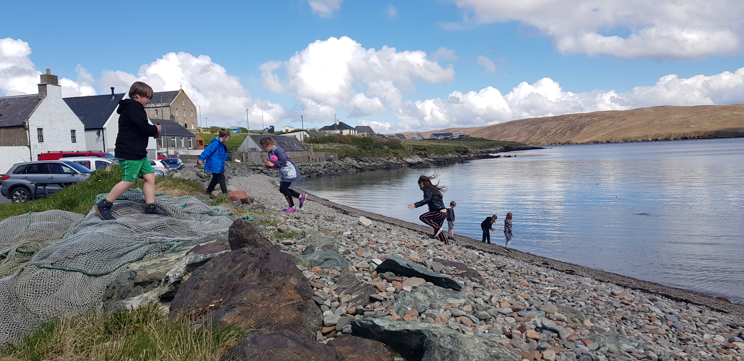
Concerns

We are keen to ensure that your child has a safe and positive school experience, and that you as a parent are supported. Should you have any concerns that you wish to share with us, or we with you, we are always happy to discuss these and to work together to find a solution. Homework diaries can be used as a means of communication, or alternatively you can contact Valerie in the school office to see if the relevant member of staff is free to speak with you either directly or via a suitable appointment.

Absence/Sickness

If your child is ill or if you think it is necessary for your child to be absent from school for any other reason, please contact the school with the details, as soon as possible.

The school can normally be reached by telephone from 8.30am. Alternatively we can be emailed. We understand that it may be difficult for you to contact us promptly if you or your child is unwell, but in order to ensure your child’s safety we will try to contact you if we have not been advised of the reason for your child’s absence by 9.30am.

For further information on school attendance, a guide for parents can be found on the Scottish Government’s website.
The direct link is:
http://www.scotland.gov.uk/Publications/2009/12/04134640/0

Complaints

Please direct a complaint to the Head Teacher in the first instance.

The School Complaints Procedure can be found on Shetland Islands Council’s website.
The direct link is:
http://www.shetland.gov.uk/education/hpc_complaints_procedure.asp

Visiting the school

You may wish to visit the school if your child has been offered a place or if you are seeking a place for your child. Please contact the school to make arrangements.

Communication

Communication regarding what’s going on is made through our school newsletter. The school also use the Urafirth Primary School Updates (closed) group on Facebook as a means of regularly communicating with parents, with reminders, clarification and sharing of appropriate information. If you are not already a group member, find us and ask to be added.

The school has a current up-to-date blog/website which can be found at https://blogs.glowscotland.org.uk/sh/urafirth/

Newsletters and other leaflets/handouts are normally issued on a “per family” basis, and will have pupil names written on paper copies (so that we know who has forgotten to take theirs!). Where possible we send via email however paper copies will continue to be available for anyone without email access or who prefers a paper copy.

We can be contacted for day-to-day enquiries either by telephone, email or face-to-face. We aim to answer the telephone promptly. A telephone relay system operates within the school, diverting calls to the classroom when the office is unmanned or the line is busy. It is not always possible to answer the telephone in the middle of teaching so should your call be urgent please redial (which will alert us) and we will call you back.

We endeavour to answer any email enquiries within 24 hours of receipt.

Mrs Fraser is normally available from 8.30 until 9.15am or from 3.15-4.30pm, should you wish to speak with her. Alternatively appointments to meet with her, or other members of teaching staff, can be arranged by speaking with Valerie in the school office.

Pupils are issued a plastic folder for homework/letter/etc at the beginning of the school year, along with a homework diary. These diaries are used by parents and staff as a regular form of home/school communication. All pupils have been issued with Number Notion pack to help with homework and to encourage family learning.

Pupils have individual access to www.sumdog.co.uk and we use GLOW for some of our class-work. We plan to use these, allowing pupils access to on-line learning both from school and home. This will be particularly useful for continuity of learning in the event of emergency school closures.

In the event of emergency school closure before the school day begins, we use a cascading communication tree to alert all staff and parents. Announcements are also made on SIBC, Radio Shetland and via the council website www.shetland.gov.uk.

In the event of emergency school closure during the course of the school day (e.g. if severe weather unexpectedly sets in) then we will alert all parents or emergency contacts of the situation and ensure safe return home of all pupils via school transport. Announcements will also be made on local radio and via www.shetland.gov.uk.
Parental Involvement

All parents of pupils enrolled in both Urafirth Primary and Urafirth Early Years are automatically members of the Parent Forum. The Parent Forum gives all parents a say in how the school operates. Interested parents form the Parent Council, which represents the views of the Parent Forum at termly Parent Council meetings.

There is also a very active fundraising (PSA) group who host a variety of events throughout the year e.g. Christmas Shopping Night and Summer Fayre. The money raised complements and supports the delivery of the curriculum.

We work in partnership with parents to support pupil development. Parents are invited into school throughout the year for both formal and informal events e.g. Open afternoons and evenings.

We will also offer monthly Play Sessions to parents of Under 5s, led by Early Years staff. These will support parents in early literacy development with their child and focus on oral language, story, song and rhyme in play.

At times throughout the school year we seek and takes account of parental views on the education we provide and we involve staff, parents and pupils in evaluating the school’s performance (e.g. through audits, questionnaires, open events).

For further information and resources regarding getting involved with your child’s learning, please contact the school and/or take a look at Parentzone on Education Scotland’s website.
The direct link is: http://www.educationscotland.gov.uk/parentzone/index.asp

You may wish to learn more about the role of the Parent Council in representing your views on education matters. You can contact the school’s Parent Council directly and/or access information on Education Scotland’s website.
The direct link is:
http://www.educationscotland.gov.uk/parentzone/getinvolved/parentcouncils/index.asp

The Joint Chairs of the school’s Parent Council is currently: Mr Craig Nicol and Mrs Charlene Johnston
Our School Ethos

Inspire our individual stars to shine brightly!

How do we do this?
- Working in partnership with pupils, parents and the wider community
- Providing a top quality, challenging and fun education
- Recognising and celebrating all the achievements of our bairns
- Nurturing and promoting a culture of respect for ourselves and others
- Fostering positive relationships and encouraging effective teamwork
- Inspiring creativity
- Securing a caring, safe and stable environment where the health and wellbeing of all members of our school community is prioritised
- Utilising our outdoor environment to promote positive attitudes towards our wider world

The pupils, staff and Parent Council have worked to develop our school values. These are being used as a basis for behaviour management and at assemblies to reinforce the school ethos.

Our School Values

URAFIRTH

Use teamwork
Respect
Achieve
Feel safe
Invent
Responsible
Take learning outside
Help and Care

Our values help with our thoughts, words and actions.

Our values are important because they help us to grow and develop.

Why values, not rules?
- Our aim: Children taking responsibility for their behaviour and their actions, through the values chosen by them and by the school community.
- Values provide greater aspirations than rules
- Rules require remembering. Values require thinking.
- You can ‘bend the rules’. You can’t bend values!

Urafirth Primary School and Nursery is at the very heart of this small but thriving community.

A monthly inclusive Urafirth Primary/Ability Shetland Youth Club will continue to run this year. Pupils also attend a monthly Youth Club held at Hillswick Public Hall. The facilities are regularly used for a variety of adult learning classes. We have close links with local businesses and business people who support us in a wide variety of ways throughout the school year.

Parents, extended family and local “experts” often have valuable skills, experiences and insights, and are supported in visiting the school to share these with pupils.

As a small school we try to make the most of all opportunities provided by Active Schools and Shetland Arts, which allow us to benefit from working in partnership with other schools throughout the academic year.

The Childsmile team visits throughout the year. Local representatives from SSPCA, Coastguard, Community Police, Dogs Against Drugs team, Peerie Makkers, Shetlandfirwirds and a host of other bodies also support us.

Events hosted by the school are advertised locally in the Hillswick shop, hotel and surgery, as well as in the local newspaper.

Pupils have moved on from setting school rules and now we think about our behaviour in term of the school’s values. Pupils are responding well to this approach. In our small school we have a well developed shared ethos where positive behaviour is the expectation of everyone, staff, parents and pupils alike. Where conflict/difficulty does arise we work together to find satisfactory solutions. Pupils earn Golden Time through their hard work and good behaviour.

The Health and Wellbeing of pupils is very important to us. We use SHANARRI and our school values for all learners to identify common development themes and identify individual needs.

We are proud of our commitment to the environment and make regular use of our outdoors facilities, which local people support us in developing and maintaining. We actively support community projects like Da Voar Redd Up.

The school, with support from the local community, are very good at supporting charities e.g. CLAN, Barnardos, CRUK, Hillswick Wildlife Sanctuary and JDRF.

Pupils are encouraged to share their achievements made outside of school during newstime/show and tell. Achievements in school are acknowledged verbally, through the achievements wall, and via comments written in homework diaries and in jotters. Certificates are periodically given out, as are Headteacher Award Stickers. We highlight our school achievements through the local media.

Curriculum – overview

Curriculum for Excellence is designed to provide a coherent, flexible and enriched curriculum throughout a child’s life from 3 to 18 years old.

The curriculum aims to ensure that all children and young people in Scotland develop the knowledge, skills and attributes they will need if they are to flourish in life, learning and work.

Curriculum for Excellence defines five levels of learning. The first four levels provide a broad general education, with progression to qualifications described under a fifth level, the senior phase.

Level | Stage
Early | The pre-school years and P1, or later for some.
First | To the end of P4, but earlier or later for some.
Second | To the end of P7, but earlier or later for some.
Third and Fourth | S1 to S3, but earlier for some. The fourth level broadly equates to Scottish Credit and Qualifications Framework level 4.  The fourth level experiences and outcomes are intended to provide possibilities for choice and young people's programmes will not include all of the fourth level outcomes.
Senior phase | S4 to S6, and college or other means of study.

Teachers and practitioners will share information to plan a child’s “learning journey” from 3-18, helping their progression from nursery to primary, primary to secondary and beyond. This will ensure children continue to work at a pace they can cope with and be provided with challenge they can thrive on.

Detailed information about Curriculum for Excellence can be found on Education Scotland’s website. This includes:
- how the curriculum is organised
- the entitlements of every child
- how progress is assessed.
The direct link is: http://www.educationscotland.gov.uk/thecurriculum/index.asp
Curriculum

In 2019/20 we have two primary classes; P1-3 with 12 pupils and P4-7 with 12 pupils. Learning is carried out in a variety of ways including age/stage specific individual, pair and group work and collaborative group work across the age ranges.

Under Curriculum for Excellence, everyone involved in education has a responsibility to develop young people’s literacy, numeracy and health and well-being skills across all areas of their learning. Much of our learning is done through interdisciplinary topics, where these skills are tackled through meaningful science, social studies or technologies contexts.

Pupils learn French from P1 upwards. We have visiting specialist art, music and PE teachers who work in partnership with school staff to ensure coherent programmes of study. Swimming lessons are usually provided in a 6 week block annually. A six week block of Shetland Dance instruction may also be provided, depending on cost. The opportunity for individual Fiddle instruction and piano instruction is offered to older pupils (P5 and above).

School outings, outdoor education days and residential trips within the local community and across Shetland, and P5-7 residential trips to mainland Scotland may all take place to allow pupils a wide and varied range of experiences and to promote opportunities for personal development.

The positive ethos of the school encourages pupils to become successful learners, confident individuals, effective contributors and responsible citizens and there are many opportunities to see this in action both within and outwith school e.g. JRSOs speaking to nursery pupils and presenting at the Town Hall, individuals keen to take on personal challenges for charities etc.

Pupils are regularly consulted about the contexts for learning which interest them. Pupils are also encouraged to engage in personal projects linked to the interdisciplinary topic or their own personal interests and to share these with their peers.

Pupils are involved in setting their own learning targets, in consultation with staff, through reflection on their own and others work. They have opportunities to assume a variety of roles within a group, developing skills in managing themselves and others, resources and time. They regularly plan activities and tasks within a group and assess against success criteria they have helped set.

We realise that there are many knowledgeable/artistic/practical parents in our community and welcome your involvement in school. If you have a skill you would like to share or some spare time that could be used productively, please contact Valerie in the office.

When we plan to deliver sensitive aspects of the curriculum, e.g. Sex Education, you will be given advance notice and the opportunity to view and comment on materials which your child will use.

In class pupils learn about religions from all around the world as part of their Religious and Moral Education; about special places, people, books, festivals etc.
Whole School Assembly may be informational, moral or religious. Children are invited to listen and to ask questions regarding what they have heard, and are encouraged to express their considered opinions. Pupils may be invited to take part in the singing of songs, hymns and carols. We celebrate Christmas annually with the local community by hosting a well-attended Christmas Show. Parents and families are warmly welcome to attend our Assemblies.

Should you wish to withdraw your child from such activities your views will be respected.

Our Curriculum Rationale
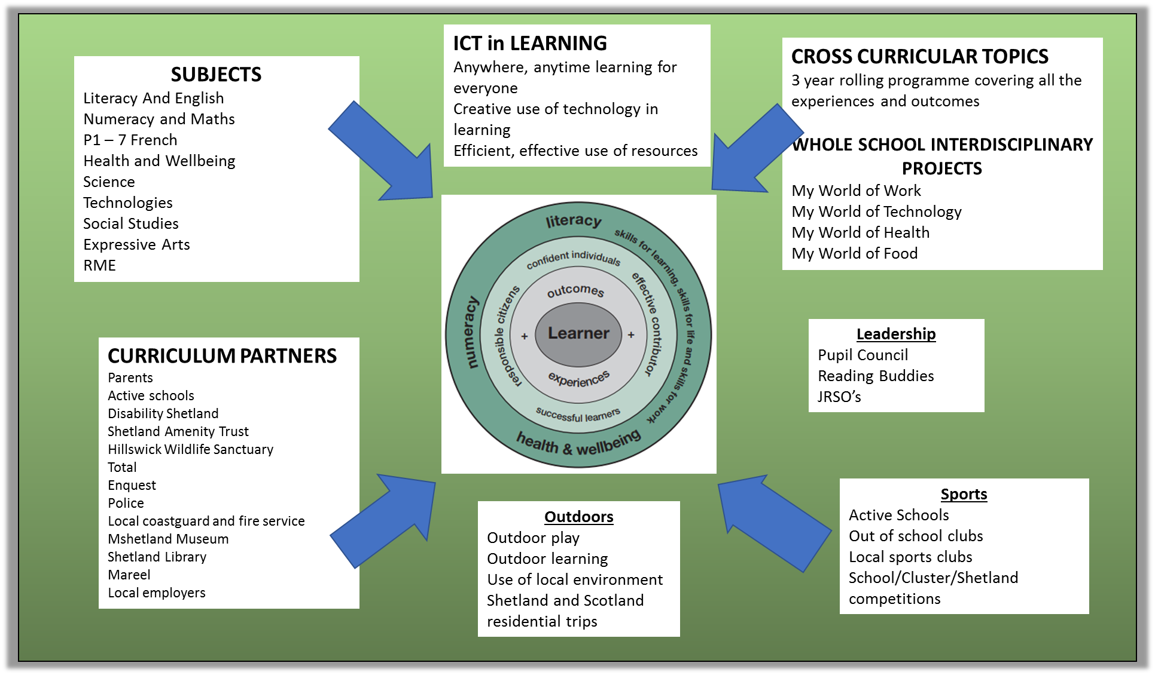

 | Open sessions/ daytime/ evening | Parent Interviews | Tracking and Monitoring | Pupil Presentations | Targets/ e-portfolios/ Learning Logs etc | Written Reports | OTHER
Term 1 | Open day – 03.10.19 | P1 settling in interviews  P4/5 settling in interviews | Northern Alliance data | Upper led assembly | 1 piece of work in pupil folder – literacy, numeracy and HWB. Level achieved noted. | Standards and Quality Report  School Improvement Plan | Parent Council  Website  Facebook  Newsletter
Term 2 | Xmas show  Shopping night |  | Northern Alliance data  T & M joint meeting with HT  PEF numeracy update | Lower led assembly | 1 piece of work in pupil folder – literacy, numeracy and HWB. Level achieved noted.  My Learning Journey Folder home - nursery | School Handbook updated | Parent Council  Website  Facebook  Newsletter
Term 3 | Open day Literacy focus  03.03.20 |  | Northern Alliance data  SNSA results  T & M joint meeting with HT | Nursery led assembly | 2 pieces of work in pupil folder – literacy, numeracy and HWB. Level achieved noted.  My Learning Journey Folder home - nursery |  | Parent Council  Website  Facebook  Newsletter
Term 4 | HWB focus  during Health week | May – discuss reports | Northern Alliance data  T & M joint meeting with HT  PEF numeracy update | Whole school assembly | 2 pieces of work in pupil folder – literacy, numeracy and HWB. Level achieved noted.  My Learning Journey Folder home - nursery | Annual written pupil reports (May) | Parent Council  Website  Facebook  Newsletter
Assessment and Reporting

Parents are welcome to speak with us at any time throughout the year to discuss pupil progress and any issues as they arise.

We follow reporting guidance issues by the local authority in 2017/18.

The Scottish National Standardised Assessments in numeracy and literacy are used as part of the school assessment process.

Further information on achievement, reporting and profiling can be found on Education Scotland’s website.
The direct link is: http://www.educationscotland.gov.uk/learningteachingandassessment/assessment/achievement/index.asp

Reporting Calendar 2019 / 20
Transitions

Transitions occur at key points in a child’s education when they move on to a different stage of learning. Transitions can include moving to the stage of primary education, moving from primary to secondary school, moving to the senior phase of Curriculum for Excellence and then post-school learning, training or work. Transitions can also include any changes in a pupil’s learning journey, for example when a pupil changes school or when learning is interrupted.

We have links with the Under 5s group and have established effective procedures to assist young children and their parents with transitioning into the Early Years setting. Any queries regarding these procedures can be made via the school office on 01595 807460.

Currently pupils transitioning from Early Years into Primary 1 at Urafirth Primary will be familiar with the building, the staff, the visitors and the pupils. They will have experienced working together with the primary pupils on many occasions. In addition to this there will be at least 3 planned transition visits where new P1s will visit “the big class” for extended periods of time. For those children transitioning to North Roe or Ollaberry Schools planned transition days are set up in the spring/summer terms to allow the children to visit their new schools. The headteachers from each school may also visit the Early Years to consult with staff and meet/observe pupils prior to visits. You can help the process by speaking with nursery staff about any worries you may have, as well as encouraging your child’s independence in different tasks and activities, such as putting on/taking off outdoor clothing, washing/drying hands, tidying up after a game or activity. Alternatively you may contact the receiving school directly:

North Roe Primary Miss Hannah Irvine 01595 745685
Ollaberry Primary Mrs Marianne Raikes 01595 807270

Primary 7 pupils from Urafirth Primary move on to Brae High School. There are a number of transition days/events held in the summer term, where pupils have the opportunity to meet with other P7 pupils from the other feeder schools (Urafirth, North Roe, Ollaberry, Mossbank, Brae and Lunnasting). In addition, pupils experience a 2 day visit to Brae High School, travelling on pupil transport, where a sample timetable is followed, with older pupils from the High School acting as mentors and guides. You can help the process by speaking with teaching/support staff about any worries you or your child may have, as well as encouraging your child to read widely, make sure they know times tables, that they maintain a good attitude towards completing homework tasks, and taking on some extra responsibility for the day to day management of their lives. Alternatively you may contact the receiving school directly:

Brae High School 01595 745600

National organisations, such as Parenting Across Scotland, provide advice to parents on supporting their child’s transitions.
The direct link to Parenting Across Scotland is:
http://www.parentingacrossscotland.org/

Regarding transition into adult life, more information can be found on Shetland Islands Council’s website.
The direct link is:
http://www.shetland.gov.uk/education/transition_into_adult_life.asp

We recognise that children with additional support needs may need transition arrangements that are additional to those made for their peers. Information sharing and planning will take place in advance of each transition. Further details can be found on Shetland Islands Council’s website.
The direct link is:
http://www.shetland.gov.uk/education/documents/TransitionAdmissionsandPlacingRequestsInformationForParents.pdf

Placing Requests

If you do not wish for your child to attend the catchment area school, you can place a request with Shetland Islands Council that your child attend another school. Details of how to make a placing request can be found in Shetland Islands Council, Children’s Services, Admissions Policy. The policy can be found at: http://www.shetland.gov.uk/education/documents/AdmissionsPolicyFINAL.pdf

Please make your Placing Request in writing to:

Director of Children’s Services
Children’s Services
Hayfield House
Hayfield Lane
Lerwick ZE1 0QD
To help you, the Scottish Government has published a guide for parents on choosing a school and the placing request system. It is available on the Scottish Government’s website.
The direct link is:
http://www.scotland.gov.uk/Publications/2010/11/10093528/0

Support for Pupils

Most pupils will be given the support they need to fully access the curriculum in the general course of their education. There will be times when some pupils will need additional support. This could be on a long-term basis with the amount of support varying according to the needs of the pupil as progress is made through school or as a temporary support when a need arises.

Information on how pupils’ additional support needs are identified and addressed can be found on Shetland Islands Council’s website. The website also provides information on mediation and dispute resolution services, links to the NHS and other agencies or organisations that can provide further support, information and advice about support and advocacy.
The direct link is:
http://www.shetland.gov.uk/education/asn_home.asp

We currently have an ASN teacher 1day per week and a Learning Support Worker for 4 days per week, supporting both the Primary and the Early Years setting.

If you think that your child needs additional support then please contact either Mrs Fraser (head teacher) or Mrs Stevenson (ASN teacher) to discuss your concerns.

It is our aim to be as inclusive as possible and as such additional support is provided through teamwork in a variety of ways. This includes team teaching, small group work and individual work, which may take place with any member of the teaching/support staff. You are encouraged to arrange to speak with any of the teaching or support staff directly to help us understand your child’s needs and responses and to allow us to support your child and the school in best meeting your child’s needs.

Other useful information and advice regarding additional support for learning can be found on Enquire’s website.
The direct link is:
http://www.enquire.org.uk/

ASN information – Information on how pupils’ additional support needs are identified and addressed can be found on the SIC website. The website also provides information on mediation and dispute resolution services, links to the NHS and other agencies or organisations that can provide further support and advocacy. The direct link is http://www.shetland.gov.uk/education/asn_home.asp

Pupils with additional support needs are reviewed and updated each term by the ASN teacher and Early Years staff. Please ask the Head Teacher if you wish for more information

Enquire also provide a wide range of clear and easy-to-read guides and factsheets explaining everything from 'additional support in the early years' to 'what planning should take place for moving on from school'.
See The Parents' Guide to Additional Support for Learning

In Shetland, we have two special Additional Support Needs departments (attached to Bells Brae School and Anderson High School). A request for a child to access a place in one of these special departments is at the discretion of Children’s Services. Further information can be found on Shetland Islands Council’s website - the direct link is:
http://www.shetland.gov.uk/education/documents/TransitionAdmissionsandPlacingRequestsInformationForParents.pdf. and in Shetland Islands Council’s Children’s Services Admissions Policy. The policy can be found at: http://www.shetland.gov.uk/education/documents/AdmissionsPolicyFINAL.pdf

Getting It Right For Every Child (GIRFEC)
In Shetland, we believe that children can be better supported by adults working closely together and sharing important information with each other. This process is known as GIRFEC: getting it right for every child.
Before GIRFEC can be used, consent from the parent of the child and/or the child (depending on the age of the child) is required. The staff asking permission will explain more about what GIRFEC means. Detailed information about the process can be found on Shetland Islands Council’s website.
The direct link is: http://www.shetland.gov.uk/children_and_families/GIRFEC.asp

Child Protection
It is every child’s right to be cared for and protected from harm. It is every person’s responsibility to make sure that happens. The Shetland Child Protection Committee provides help when there is a need. Their website gives information on how to access that help.
The direct link is: http://www.childprotectionshetland.com

Shetland Islands Council’s website also provides information on our responsibilities towards children and includes where to find help and support.
The direct link is:
http://www.shetland.gov.uk/children_and_families/child_protection.asp
School Improvement

A copy of the improvement plan is available in school.

Our main focus for 2019/20 session is:

Priority 1: Closing the gaps in numeracy attainment. (Pupil Equity Funding Priority)
Priority 2: Development of outdoor learning as a routine teaching method
Priority 3: Developing digital learning (linking to priority 1 and PEF spend)
Priority 4: Taking a whole school approach to emerging literacy

We will also further address planning to ensure a more structured approach quality learning across all Curriculum for Excellence Experiences and Outcomes

Information about the school’s performance at national level can be found on the Scottish Government’s website and on the Education Scotland’s Scottish Schools Online website which also includes HMIe Inspection Reports.
Direct links are:
http://www.scotland.gov.uk/Topics/Statistics/Browse/School-Education

HMIe Inspection reports and School Consultation reports can be accessed directly on Education Scotland’s Reports webpage.

Other useful websites
Information on the following websites may also be of interest to you:

Scottish Qualifications Authority
http://www.sqa.org.uk/sqa/41292.html

Scottish Credit and Qualifications Framework
https://scqf.org.uk/interactive-framework/

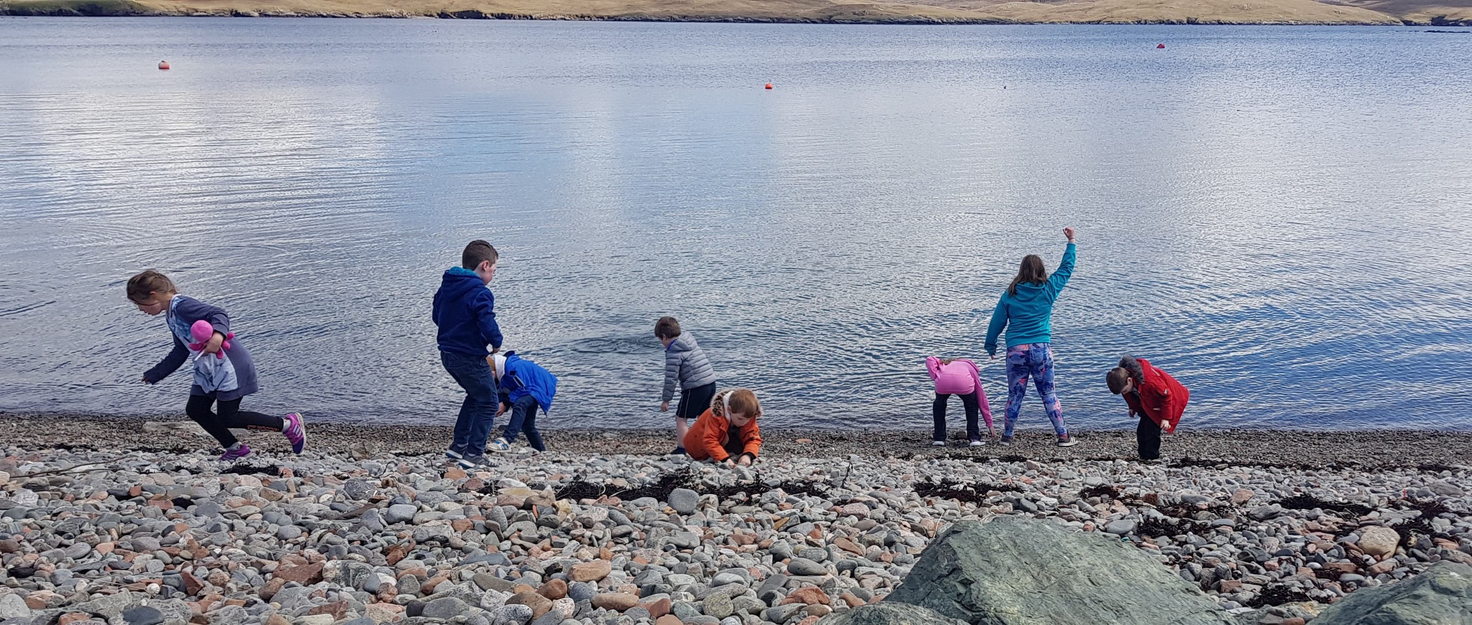
School Policies and Practical Information

School policies can be accessed on request via the school office.

Policies applicable to all schools across Shetland can be found on Shetland Islands Council’s website. The policies include:
- healthy eating
- bullying
- exclusion
- school trips
- equality and diversity
- adverse weather.
The direct link is:
http://www.shetland.gov.uk/education/policies_guidelines_and_forms.asp

We ask that a blanket permission form is completed at the beginning of the school year for trips in and around the local area. This is done on the understanding that we advise you, via the school newsletter or a leaflet, in advance of any trips, as well as activities and clubs as they become available throughout the school year. You will be asked for additional permissions as appropriate.

Shetland Island Council’s website provides information on Instrument Instruction along with other creative learning opportunities.
The direct link is:
http://www.shetland.gov.uk/education/creative_learning.asp

All pupils are members of the Pupil Council, where they are involved in decision making regarding their school and what happens in it. Pupils from P2 and up are elected annually onto the Pupil Council and they meet at least termly with the head teacher to take forward initiatives decided by the pupils. We have 2 P6 Junior Road Safety Officers. Each group meets, makes decisions and carries out an action plan, making a positive contribution to the development of the school.

School meals are made in Urafirth Primary and are currently available free of charge to P1-3 pupils and at a cost of £2.20 per day for P4-7 pupils and £1.80 for nursery children. Alternatively healthy packed lunches can be brought from home. Milk costs 90p per week for P1-7. Nursery snack/donation currently costs 60p per day.

Those in receipt of certain benefits may be eligible for free school meals & milk. Should you wish to apply for free school meals then please contact Valerie in the office for the relevant paperwork.

Milk and water are available to drink daily and fresh fruit is available most days. We also operate a healthy tuck shop.

School Winter Transport is provided for all our current primary pupils from after the October holidays until the Easter holidays. Outwith these times local pupils are encouraged to walk, cycle or car share, whilst those living further afield are provided transport year round. For further details see SIC Transport Policy –http://www.shetland.gov.uk/education/documents/SchoolTransportPolicy_001.pdf

Financial Help for Parents

Grants are available for school meals and clothing. Guidance and an application form can be found on Shetland Islands Council’s website.
The direct link is:
http://www.shetland.gov.uk/education/hpc_clothing_grants_and_free_school_meals.asp

Information on the provision and finance of transport can be found on Shetland Island Council’s website.
The direct link is:
http://www.shetland.gov.uk/education/hpc_school_transport.asp

.
The School Day

Urafirth Primary Classes

The school day begins at 9.15am and ends at 3.15pm.
We have supervised break-time from 10.40am till 11am.
Supervised lunchtimes are from 12.30pm till 1.15pm.
We offer a breakfast club from 8am at a cost of 50p daily.

Urafirth Early Years
Early Years operates from 8am – 4pm
Breakfast is available for 50p from 8 – 8.30 am
Lunches are served from 12 – 12.30pm

Term dates for the following school year can be found on Shetland Islands Council’s website.
The direct link is:
http://www.shetland.gov.uk/education/term_dates.asp
Calendar of (known) Events

Term 1 August 2019
Date | Event | Time
19th Aug 2019 | In Service
20th Aug 2019 | In Service
21st Aug 2019 | Welcome back assembly for Primary Pupils | am
28th Aug | Under 5’s Literacy morning | 9.45 – 10.45am
w/b 2nd Sept 2019 | World of work week
3rd Sept | Teachers Staff Meeting | 3.30pm
w/b 16th Sept 2019 | Peer observations
17th Sept 2019 | Whole staff meeting | 3.30 – 5.00pm
25th Sept 2019 | Under 5’s Literacy morning | 9.30 – 10.30am
25th Sept 2019 | CLAN Coffee Morning | 10.30 – 11.30am
25th Sept 2019 | Parent Council Meeting | 7pm
3rd Oct 2019 | After School Learner event for parents

Term 2 October 2019
Date | Event | Time
28th October 2019 | In Service
29th October 2019 | In Service
5th Nov 2019 | Teachers Staff Meeting | 3.30pm
6th Nov 2019 | Parent Council Meeting | 7pm
7th Nov 2019 | Shopping Night | 6.30pm
12th Nov 2019 | STEM P4-7 class visit
13th Nov 2019 | Whole staff meeting | 3.30 – 5.00pm
15th Nov 2019 | Children in Need and Assembly | Am
19th Nov 2019 | STEM P4-7 class visit
26th Nov 2019 | STEM P4-7 class visit
27th Nov 2019 | Under 5’s Literacy morning | 9.45 – 10.45am
28th Nov 2019 | Teachers Staff Meeting | 3.30pm
11th Dec 2019 | Xmas concert day & evening | Am & pm
12th Dec 2019 | Care Centre visit | Pm
13th Dec 2019 | Xmas Assembly | Am
16th Dec 2019 | Xmas lunch | Lunch time

Term 3 January 2020
Date | Event | Time
6th Jan 2020 | In Service
7th Jan 2020 | In Service
8th Jan 2020 | First day back for pupils
10th Jan 2020 | New Year assembly
15th Jan 2020 | Parent Council | 7pm
15th Jan 2020 | Teachers Staff meeting | 3.30pm
29th Jan 2020 | Occasional holiday
17th Feb 2020 | Peer observations week
18th Feb 2020 | Teachers Staff meeting | 3.30pm
20th Feb 2020 | In Service
21st Feb 2020 | Occasional holiday
21st Feb 2020 | Northmavine Up Helly Aa
24th Feb 2020 | Occasional holiday
27th Feb 2020 | Whole Staff meeting | 3.30 – 5.00pm
3rd March 2020 | Open Day
5th March 2020 | World Book Day H.T. Assembly
w/b 18th March 2020 | SNSA week
25th March 2020 | Garden tidy up | pm
27th March 2020 | Last day of term
Term 4 April 2020
13th April 2020 | Occasional holiday
14th April 2020 | First day back for pupils
17th April 2020 | Report deadline
24th April 2020 | Bingo night
1st May 2020 | Parent Council meeting | 7pm
13th May 2020 | Parents’ evening
14th May 2020 | Parents’ evening
18th May 2020 | H.T. classroom observations
19th May 2020 | Teachers Staff meeting | 3.30pm
w/b 25th May 2020 | Staff review week
w/b 1st June 2020 | Health week
4th June 2020 | Whole Staff meeting | 3.30 – 5.00pm
6th June 2020 | Pitch In day | 10.30am
23rd June 2020 | Teachers Staff meeting | 3.30pm
3rd July 2020 | Last day of term.

Additional Information

Online Protection
For information about online protection for your child, you may like to look at the Child Exploitation and Online Protection Centre’s website.
The direct link is:
http://www.thinkuknow.co.uk

What you can do to help in the event of school closure/unexpected days off school:
- Encourage your children to read – e.g. comics, novels, much loved books, magazines, newspapers, BBC Newsround website.
- Have them help around the house/take on extra responsibilities that they can report back about in school
- Have them log into GLOW and find out if there is a task to complete, discussion to add to, or a blog they can write about something they have achieved.
- Practice times tables and spelling
- Do a mini personal project together
- Bake/cook, using practical maths skills
- Get them to summarise a programme they have watched
- Draw a picture of the view from a window

