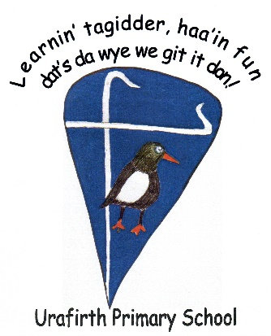

Urafirth Primary School

Curriculum Rationale

**Urafirth Primary School is a vibrant if remote School in the north mainland of Shetland. As part of our school improvement journey we have updated our vision and aims and these have fed in to our Curriculum Rationale document. This document explains what the school community wants to achieve for the children in the school, providing a high quality education for all learners.**

** Our Vision**

Urafirth is a community where we engage and inspire our individual stars to shine brightly

*How do we do this?*

* Working in partnership with pupils, parents and the wider community
* Providing a top quality, challenging and fun education
* Recognising and celebrating all the achievements of our bairns
* Nurturing and promoting a culture of respect for ourselves and others
* Fostering positive relationships and encouraging effective teamwork
* Inspiring creativity
* Securing a caring, safe and stable environment where the health and wellbeing of all members of our school community is prioritised
* Utilising our outdoor environment to promote positive attitudes towards our wider world

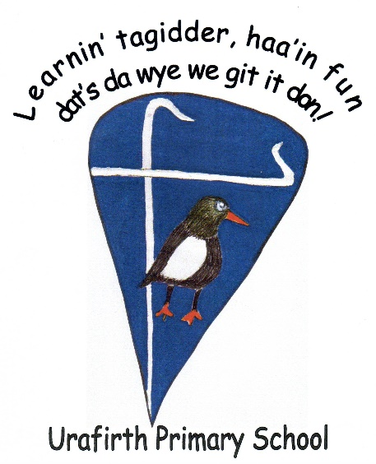

Urafirth Primary School is unique. There may be other schools with similar ethos, in similar locations, with similar opportunities and challenges, but that is all they are – similar.

What makes us unique is our location, our community and our people!

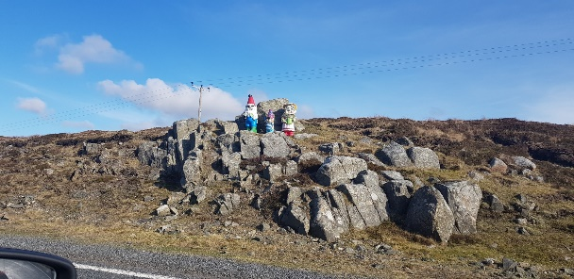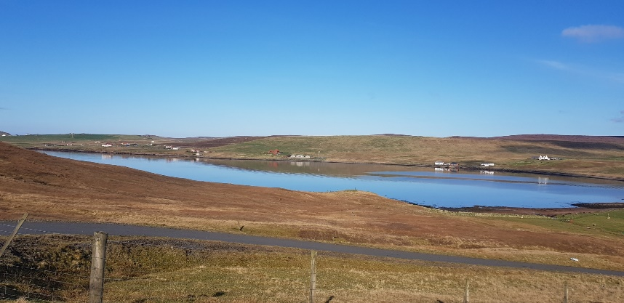Pictures

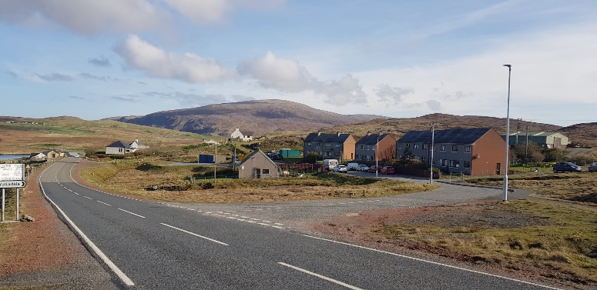

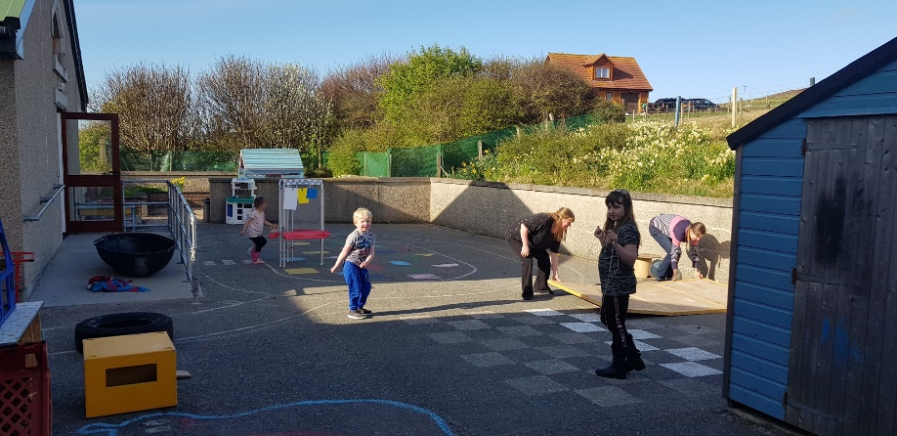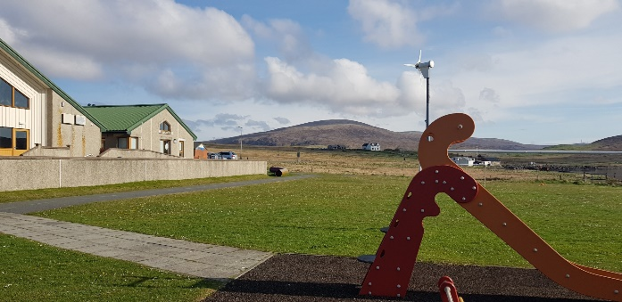

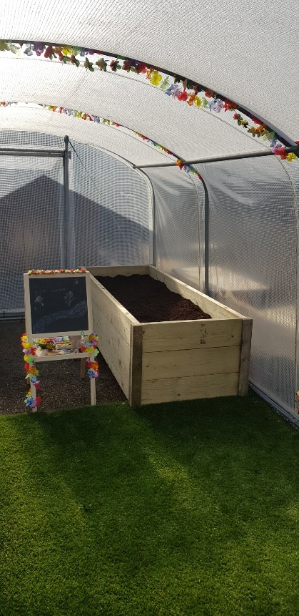

Our Location

It is safe to say, we are a remote rural school.

**Shetland** - An archipelago made up of more than 100 islands, 15 of which are inhabited, situated closer to Norway than mainland Scotland. We are located on the largest island, Mainland, in an area known as Northmavine. We are situated off the main road (single track) between Urafirth and Hillswick, close to the shore.

The school grounds boast a range of facilities which include a play park, mini-croft, poly tunnel, cycle-track, “magic forest”, grass pitch and enclosed safe spaces, as well as access to the shore line. These are accessible out-with the school day. We are surrounded by sea and crofted land.

Eshaness – which boasts a volcanic past, interesting geology, and spectacular scenery – is 6.5 miles from us. Shetland’s highest peak, Ronas Hill, is visible from the school.

We are 32 miles (45 minute drive) from Lerwick, Shetland’s main town and commercial area. Edinburgh is 380 miles away and is accessible by plane or ferry. A journey by plane involves a 1 hour 30 minute drive to Sumburgh Airport and a 1 hour 20 minute flight to Edinburgh Airport. The ferry journey involves a drive to Lerwick, a 12 or 14 hour sailing to Aberdeen, followed by a 2-3 hour onward trip by car, bus or train to Edinburgh.

Recently installed fibre broadband has improved our capacity to engage more fully online.

*We are remote. We are resilient. We are connected.*

Our Community

We are a vibrant, inclusive school, central to the welcoming community which we serve.

The community has a strong history of whaling, fishing, crofting, knitting, fiddle and accordion, dialect and tourism. Our connections with the land and the sea are important to us.

Our community works with us and for us, and we reciprocate. Local people, retained by the coastguard and fire service, support our curriculum, as does Hillswick Wildlife Sanctuary and Tangwick Haa Museum. The Hillswick Shop, Hillswick Health Centre, St Magnus Bay Hotel and Braewick Café all contribute to the life of the school. Local people help us deliver and broaden our curriculum. Active Schools and Disability Shetland support school staff and parent volunteers in providing out of school clubs. We host information, learning, fundraising and social events to which the whole community is invited, including our local Up-Helly-Aa.

We engage with our wider community too: Our cluster of schools which feed into Brae High School; Total and Sullom Voe Terminal; Sporting events; Shetland Arts; STEM; Shetland Amenity Trust

*We belong we include we involve*

Our People

Our staff are awesome! Many of them have (or have had) children, nieces, nephews or grandchildren attending this school so they have a vested interest in ensuring a top quality education for the bairns who come here. Everyone works to foster and develop positive relationships with each other, parents, pupils, support services and our community. Our staff are an integral part of the community in which they work. Supportive of each other, willing to try new things, and engage in continued development opportunities.

*We’re family, we’re educators we’re learners*

What we do

* Inspire creativity
* Secure a caring, safe and stable environment where the health and wellbeing of all members of our school community is prioritised
* Utilise our outdoor environment to promote positive attitudes towards our wider world
* Provide a top quality, challenging and fun education
* Indoor and outdoor learning opportunities
* Interdisciplinary learning that links to pupils ideas and the environment around them
* Tracking and monitoring of pupil progress that helps us understand best next steps for each individual learning
* Recognise and celebrate all the achievements of our bairns
* Nurture and promote a culture of respect for ourselves and others
* Foster positive relationships and encouraging effective teamwork