Urafirth Primary School

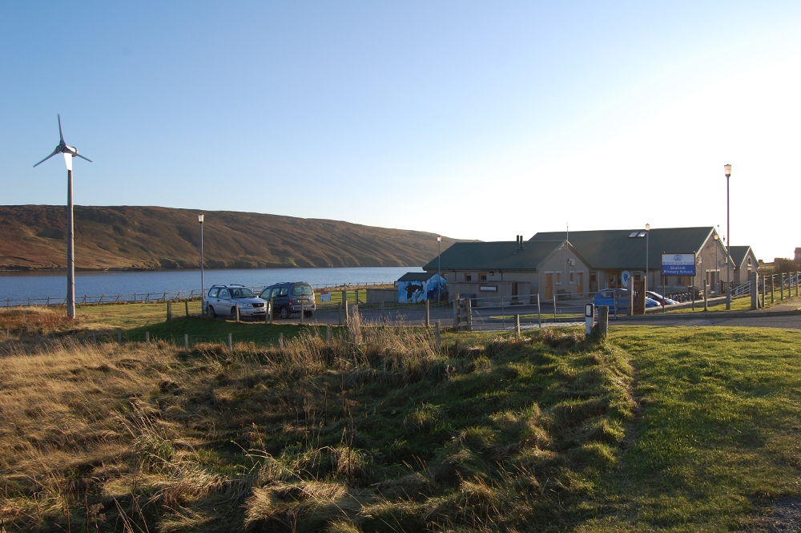

Standards & Quality Report
and
School Improvement Plan

Session 2018/19

Introduction

Shetland Islands Council is committed to delivering the best possible outcomes for children and young people so that they have the best start in life and are ready to succeed by following the principles of Curriculum for Excellence and Getting it Right for Every Child (GIRFEC).
Within Curriculum for Excellence, every child and young person is entitled to experience a curriculum which is coherent from 3-18. Those planning the curriculum have a responsibility to work in partnership with others to enable children and young people to make transitions smoothly, building on prior learning and achievement in a manner appropriate to their individual learning needs. This should ensure that young people are well placed to move to positive destinations on leaving school and entering adult life.
We want to know how well we are doing this and how we can improve. We are continuously evaluating what we do and how it makes a difference to our learners. We have been asking ourselves – staff, pupils, parents/carers, and other partners – the questions contained in this Standards and Quality Report. Our self-evaluation is in the pages that follow, along with our main areas for development for session 2018/19. This report is based on the quality indicators in How Good is Our School? 4th Edition (2015) and How Good is our Early Learning and Childcare? (2016)

Context of the School
Urafirth Primary is one of three remote rural schools in Northmavine, Shetland and has a roll of 24 pupils in session 2018-19. We have 2 multi-composite classes, P1-4 and P5-7 with 12 pupils in each. The school also has an Early Years Class which, following a successful Scottish Government funded trial, offers 1140hours of free Early Learning and Child Care for 3 and 4 year olds (term time only) to children from across Northmavine. We have a current role of 18 in the nursery, rising to 25 by the end of session 2018/2019. Our operating capacity is 22.
Urafirth Primary is at the centre of a community where many of the children’s home lives revolve around the crofting calendar, seasonal tourism, fishing and the oil industry. Shetland dialect is the ‘mother tongue’ of a significant proportion of pupils, families and staff. SIMD data is not a true reflection of need within the school: Many families face challenges associated with rural poverty, we have a significant level (20% of total roll) of identified additional support needs and have families in receipt of Free School Meals (we are certain more would be entitled). We have no Pupil Equity Funding but received additional funding of £1200 last session from the local authority to allow us to target “closing the attainment gap”. We used this to help improve writing, including moderation activity within the Brae High School cluster. A further £1200 has been allocated for this session.
Due to the size of the school reporting of statistics regarding pupil attainment can result in individual pupils being identified, so have been avoided in this report. We continue to refer closely to our own teacher judgement data, SNSA data, the local and national achievement of a level data. On the whole the school continues to make good progress in supporting the individual needs of all pupils in their attainment and achievement, as evidenced in tracking & monitoring data and assessments.
The school benefitted hugely from the installation of high speed fibre broadband. This allowed pupils and staff to access GLOW and work with a wide range of tools available within it, as well as improving office links to the council’s intranet and associated systems. Training and support from colleagues and pupils within the authority has been welcomed.

School Aims
“See our individual stars shining brightly!”
by

In partnership with pupils, their families and the wider community, providing a quality, challenging and fun education, which embraces Curriculum for Excellence and which recognises and celebrates the achievements of our bairns.

Developing and maintaining a culture of respect for ourselves and others, fostering positive relationships and promotes effective teamwork.

Doing this within a caring, stable environment where the health and well-being of all members of our school community is nurtured and supported.
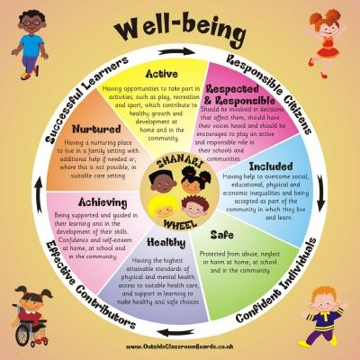
This was created in 2009/10, reviewed by Parent Council in 2015/16 and will be updated during this session 2018/19
Participants | Engagement details
Pupils | Pupil Council meetings held throughout the school year, once per term.  Pupil Co-operative Learning activity , traffic lighting How Good We Are to identify priorities  Class meetings to discuss and agree contexts for learning for the year ahead
Parents | How Good Is our School questionnaire – SIP priorities  Parent Council meetings termly throughout the school year – staffing, budget, governance, School Improvement, community engagement, communication, fundraising, car parking
Volunteers/3rd Parties | Disability Shetland/Urafirth Primary Youth Club  Active Schools – SportsScotland Award
Teachers and other staff | In-service – presenting the SIP for 2017/18  Collegiate sessions – planning “non-PEF” funding spend  Staff discussions re: governance review  Collegiate sessions – using benchmarks/achievement of a level  Collegiate session – evaluating non-PEF intervention  Collegiate sessions – new authority planning  Collegiate sessions – new authority tracking and monitoring  Collegiate session – SIP review of progress  Collegiate session – SIP priorities 2018/19  Collegiate sessions – Early Years self-evaluation
Other partners | Northern Alliance: Emerging Literacy network sessions  Quality Improvement Officer professional dialogue
Brae High School Cluster | Collegiate sessions – moderation  Collegiate session - NURTURE

What have we done to…

Make Improvement in attainment, particularly in literacy and numeracy?
Implemented Northern Alliance Development Approach to Emerging Literacy at Early Level (Early Years and Primary)
Introduced Highland Numeracy Framework at Early Level (Early Years)
Resourced and implemented the introduction of SEAL maths at Early Level and beyond (Primary), whilst awaiting Northern Alliance Progression Framework.
SNSA and teacher judgements regarding achievement of a level

Close the attainment gap between the most and least disadvantaged children?
Used an array of criteria, relating to rural poverty and the Shetland context, to identify “disadvantage” within our setting.
Engaged with allied professionals and worked well with families in specific interventions for identified children (P1 vocabulary)
Targeted literacy and numeracy development at Early level, with engagement into First level.
P7s have engaged in Social Fitness with cluster schools, to develop peer relationships prior to high school transition.
A lot of work has been done in pre-school, encouraging parents to read at home through Education Scotland’s ‘Three Read Approach’
New writing resources have been sourced
The Early Years successfully trialled then implemented 1140hours of free Early Learning and Child Care (increased hours funded by Scottish Government till April 2018, then SIC funded)

Improve children and young people’s health and wellbeing?
Ensured 2 hours of quality PE is available to all primary pupils across the school week.
Attempted to use SHANARRI to address individual needs of all.
Worked with Active Schools and Disability Shetland to provide out-of-school Clubs, with a focus on being active and developing general health and well-being of all.
Completed on-line self-evaluation with SportScotland, with eligibility for Bronze level award.

Improve employability skills and sustained, positive school leaver destinations for all young people?
Hosted a My World of Work Week, with input from: Jenny Wink, Total
Andrea Manson, Councillor and Hotel Owner
Christina, Braewick Café
Site visit to Total at Sullom Voe Terminal
Focus on importance of literacy and numeracy skills now, and in the future.
Key messages from recent self-evaluation:
Children and young people:
- Children asked for a greater focus on Developing Young Workforce. The school already devotes a week each year for local employers to come in and discuss their jobs. The school will look at developing the DYW agenda and careers education in topic work and through interdisciplinary learning.
- Engaging reluctant learners remains a challenge – more pupil input into what is learned, when and how it should be assessed. Digital technology will support in this area (including Glow) with better connectivity now in place in the school.

Staff:
- There has been discussion about curriculum design in the school – there is a need for a balance between pupil led and a planned rolling programme of topics.
- Increased confidence needed in using new local authority planning formats and benchmark tracking
- Positive professional development experiences, particularly with NA Emerging Literacy and SSERC
- Staff are keen to develop the Science curriculum following recent SSERC input.
- Early Years staff report positively on their engagement in the extended hours trial and are positive about their ongoing learning

Parents and Carers:
- Would like to know more about the curriculum and progression pathways on offer in the school.
- The school is keen to engage parents more with the principles of emerging literacy and SEAL numeracy.
- (Early Years parents) are very happy with the flexible extended hours on offer and with the quality of stimulation, supported development and care for their children
Progress made with the areas for development in our School Improvement Plan Session 2017/18 (The Previous Session’s School Improvement Plan)

Improvement Priority 1:
Target: Raise attainment in Literacy, Language and Communication

Very good progress was made in this area.
Evidence indicated:
- The school has been involved in the second year of the Northern Alliance Emerging Literacy programme as well as embedding the local P1 ‘Expressive Vocabulary’ pilot.
- The school has benefitted from new teaching resources and new developmental overviews for three and four year olds.
- The focus in the primary classes has been on exploring language and writing skills.
- There has been a change of approach and practice through involvement in the NA project.
- P1 data is submitted as part of the project once a term.
- The primary classes and the Early Learning and Child Care Setting are using the benchmarks to support reporting.
- Anne Margaret Laurenson spoke about the impact on her practice of involvement with the Northern Alliance, citing the professional dialogue and networking opportunities.

Further Work required (if any):
- Continue with engagement in year 3 of Northern Alliance Emerging Literacy
- The focus on literacy, language and communication has also been part of the school’s commitment to closing the attainment gap and their use of budge carry forward monies. This will include ‘Play Days’ for parents and carers in the ELCC setting with an emphasis on oral language.

Improvement Priority 2:
Target: Raise attainment in numeracy: Using SEAL as a developmental approach to secure foundation skills for early numeracy

Good progress was made in this area.
Evidence indicated:
- New resources have been purchased including Numicon.
- Staff took part in SEAL training last year, which was hugely beneficial.
- The school uses SEAL for consolidation purposes.
- The ASN teacher also uses SEAL approaches with a small of group of P5 to P7 pupils.
- Early Years staff use Highland Numeracy Framework to support numeracy activities and track numeracy skills

Further Work required (if any):
- The school is keen to use the Northern Alliance Numeracy Progression Frameworks and the Highland Numeracy Framework as part of on-going numeracy development.

Improvement Priority 3:
Target: Engage with Shetland’s Strategy for Tracking, Monitoring and Moderation

Good progress was made in this area.
Evidence indicated:
- A new termly calendar for tracking and monitoring is in place.
- The Benchmarks spreadsheet tracking system has been introduced.
- The school has also referred to the local authority’s planning formats to support forward planning.
- Moderation is developing at cluster level – the recent writing event was very successful.

Further Work required (if any):
- Further moderation activity is to be explored at cluster level
- Embed the termly tracking and monitoring calendar.

Improvement Priority 4:
Target: Improve French language teaching across P1-7 linking to Parental Engagement / Family Learning

Good progress was made in this area.

Evidence indicated:
- Three family French sessions this year with a reasonable attendance.
- The school has made progress with the 1+2 agenda.
- Ann Margaret Laurenson and Elaine O’Neill are delivering French, whereas Wilma Missenden is leading on German as L3.
- Increased teacher confidence in delivering modern languages.
- The school’s input into the 1+2 working group has helped.
- Feedback from the P5-7 pupils is that they enjoy German more than French

Overall evaluation of the school’s capacity for continuous improvement:

The school continues to have stable core staffing, and we are confident in our capacity for continuous improvement.

Session 2018/19 Improvement Plan

Factors Influencing the Improvement Plan

School factors

- 1140 hours Early Learning and Child Care implementation
- Becoming 2 teacher in 2017/18
- Second year of involvement in Northern Alliance Emerging Literacy
- Incomplete/ongoing actions from 2017/18 SIP
- HGIOS focus on curriculum/learning provision
- Part-time working patterns of majority of staff
- Our local context

Local authority factors
- Schools and Quality Improvement Service Plan
- National Improvement Framework – Shetland Delivery Plan
- Quality Improvement Visits

National factors
- National Improvement Framework – focus on “closing the gap” and “raising attainment”
- Curriculum for Excellence
- Getting it Right for Every child (GIRFEC)
- Education (Scotland) Act 2016
- How Good Is Our School (4th Edition)
- Education Reform – Joint Agreement

How pupils were consulted and involved in decisions
- Regular Pupil Council meetings with pupils having the opportunity to comment on learning and teaching
- Pupils are involved in shaping the contexts for their learning in literacy and numeracy and in identifying topics
- Pupil questionnaires
- Cooperative Learning Activity with clear pupil voice linked to School Improvement
- Informal dialogue/learning conversations with staff
- Democratic conflict resolution

Improvement Priority 1: Raising Attainment in Literacy, Language and Communication: Taking a Developmental Approach to Emerging Literacy
Our key areas for development to take this priority forward are:
- P1 teacher and HT to continue engagement with Northern Alliance Emerging Literacy programme
- HT/NT to share relevant input with early years staff and implement in EY
- HT as NA Emerging Literacy lead practitioner for Shetland North

Improvement Priority 2: Raising Attainment in Numeracy and Mathematics using Northern Alliance Learning Progressions
Our key areas for development to take this priority forward are:
- Teaching staff to engage with Northern Alliance Numeracy Progression Framework
Improvement Priority 3: Curriculum Rationale and Curriculum Design
Our key areas for development to take this priority forward are:
- Produce a clear curriculum rationale, with clarity of purpose for pupil learning, designed for our unique context.
- Evidence a clear and accessible curriculum, based on the 7 principles of curriculum design, designed to reflect our unique context.

.
Improvement Priority 4: Parental Engagement
Our key areas for development to take this priority forward are:
- Ensure robust engagement with parents in undertaking Priorities 1-3

Ethos and communicati
Family Learning
- Open Days
- Curriculum Evenings
- Pupil blogs
- Little Guides to…
- SHANARRI homework
- Homework guidance
- School blog
- Under 5s – Language Development through Play
- Family Classes
Ethos and Communication
- Open door policy
- Effective communication
- Nurturing techniques understood and used by all
- High involvement of parents – learning and fundraising
- Trusting relationships between staff and parents
- Well-informed parents through a variety of media, including Facebook groups and GLOW blog
- Parents as leaders in after school clubs
- Parents as volunteers
Urafirth Primary School
Parental Engagement
on
Fundraising
- Book fair
- Book club
- Christmas shopping night
- Summer Fayre
- Coffee mornings
- Charity events
Decision making
- Termly Parent council meetings
- Parent Forum
- Parental Views sought throughout school year on a range of subjects
Family and Community Involvement
- Termly assemblies
- Leavers Assembly/Lunch
- Charity Fundraising Events
- Christmas shopping Night
- Summer Fayre
- Big Pitch In – developing school grounds
- Christmas Concerts and School shows
- Eco Club
- Adult Learning Classes
- Visits from coastguard, fire, police, health
- Local business support
- Support for Hillswick Wildlife Sanctuary/Grow Wild
- My World of Work visits
- Social evenings

