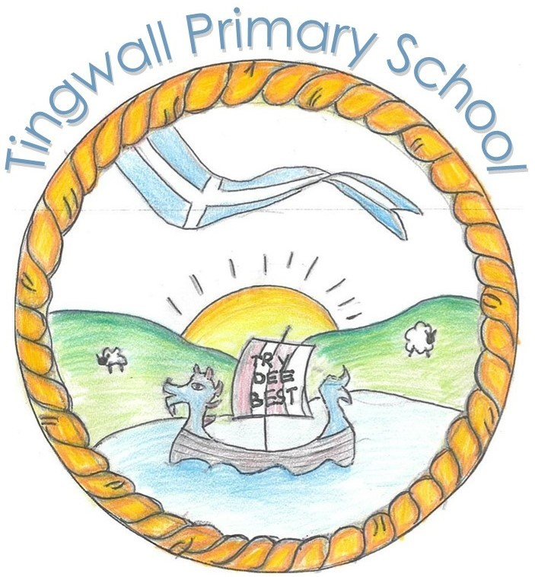

**Tingwall Primary School Term 1 Newsletter 2025**

Welcome to our first newsletter of the year! We thought that having a regular newsletter would perhaps be a more manageable and informative way of sharing what all the classes in school have been up to alongside the continuous updates to the school website. Having the school website up and running should help everyone to find the information that they require across time rather than having to scroll back through emails or messages, by having all communication in the one place and available across time. Please remember to pop along to <https://blogs.glowscotland.org.uk/sh/tingwallprimaryschool/welcome/> for more photos and information.

What a busy term we have had! All our classes have been working hard at their learning and deserve their holidays. Please read over the next few pages to get a flavour of what each of the classes have been learning.

We continue to make big improvements to the school environment, inside and out, and the holidays will see new flooring being laid across the entrance area and the huts, with further painting taking place in some parts of the school to blend in with the new colour scheme.

Our School Improvement Plan will be uploaded onto the website shortly and I will be in touch to ask for your help with our new Nurturing Relationships and Positive behaviour Policy next term.

I hope you all have a lovely relaxing October holiday and look forward to welcoming wir bairns back on Wednesday 29th October.

Best wishes,

Lesley Simpson

**Term 2 Dates for your Diaries**

* 27th October – Inservice Training
* 28th October – Inservice Training
* 29th October - School opens for pupils
* 14th November – Children in Need
* 10th December – Nursery Christmas Stay and Play
* 11th December - P1-3 Christmas Concert (in afternoon)
* 11th December – P4-7 Christmas Concert (in evening)
* 12th December – Christmas Dinner!
* 12th December – Christmas Jumper Day
* 19th December – Last day of term

What do you think the school is doing well?

* Please mark homework x 3
* Predictable homework marking/returns
* Make the peerie area nicer!
* Updating staffing – website even if it’s just supply

What aspects of school do you think needs to improve?

What events or activities would you like us to start/stop?

How do you want us to involve you more?

* More communication between class teachers and parents
* More events for parents to get involved
* Parent helpers

**Consultation feedback from Learner Led Event**

At the Learner Led Event in September 2025, we asked you a few questions to gather your thoughts about some specifics. There wasn’t a huge response, but we have collated what you shared and have been looking at what our next steps could be.

We asked You said

We asked You said

We asked You said

We asked You said

We asked You said

* More learning updates
* I’m happy as it currently is
* Happy with everything – good communication
* Happy with how it is now

What information do you want from the school?

* The staff are polite and helpful
* Good community feel
* Nurturing environment & staff
* Good at communicating
* Inclusion & staff are approachable
* Lots of activities for the children and good at getting everyone involved
* An after-school club
* A breakfast club
* Shetland dancing
* Activities with buddies
* More Nursery inclusive activities
* P6/7 combined trip away from school

You didn’t ask for anything to stop!