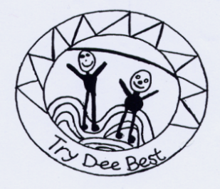
Tingwall Primary School Home Learning Guidelines
Aim – to ensure that any homework given provides a meaningful and enjoyable experience.

Regular | Occasional | Optional
- Reading – to help P1-3 pupils learn to read and to enable P4-7 to develop a love of reading (encourage a variety of resources e.g. comics, magazines, newspapers, books, e-books (on kindles, ipods, ipads etc) as well as having stories read to them and visual literacy e.g. films.  - Jolly Phonics for P1 & 2  - Reading and Comprehension websites:  https://www.teachyourmonstertoread.com  https://www.oxfordowl.co.uk  https://readtheory.org/auth/login  - Weekly Spelling words/activities  - Consolidation/Extension of Maths work covered in class including a special focus on learning times tables (pupils may be directed to websites or apps.) | - Class work to finish off  - Research  - Preparation for a Class talk  - Class challenges  - Work to support a particular problem a child may be experiencing | - Work linked to Termly Curriculum Activities for those who have more time and/or love learning. These suggestions will be indicated on termly Curriculum Overviews. Suggestions may include using some of the following websites:  - Maths: https://www.sumdog.com  - (pupils’ individual log-ins can be found in homework diaries)  - Maths, reading & language skills: https://www.skoolbo.co.uk (pupils’ individual log-ins can be found in homework diaries)  - Maths: http://www.coolmathgames.com  - Maths, English, Science: https://educationcity.com (pupils’ individual log-ins will be issued soon)  - Exercise and Dance: https://www.cyber-smart.co.uk/ (log in using school email tingwall@shetland.gov.uk and postcode ZE29SE)  - All curriculum areas – choose appropriate level: https://www.bbc.co.uk/search?q=Bitesize

This will result in a less formal approach to homework with fewer set pieces having to be completed and handed in to the class teacher. We believe that children need time to be children. When children are intrigued, or inspired by something they learn about in school, they naturally seek out more knowledge on their own, in their own time.

We would encourage you to involve your children in real-life situations, for instance:

- Handling money in shops
- Budgeting
- Online shopping/banking skills
- Reading, preparing and cooking recipes / preparing the evening meal (and clearing up afterwards!)
- Planning and organising trips
- Look after pets – cleaning / feeding / exercise

Any activities that the pupils have enjoyed, done well, are proud of, wish to reflect on or want to share, can be brought in /discussed with teacher and or class e.g. as part of ‘Achievement talks/Show and Tell
Finally, to quote a teacher in Texas, USA (Brandy Young), whose homework policy stirred up this current debate, we ask that when possible you “spend your evenings doing things that are proven to correlate with student success: Eat dinner as a family, read together, play outside and get your children to bed early.”

