Curriculum Overview Term 3

Literacy and English  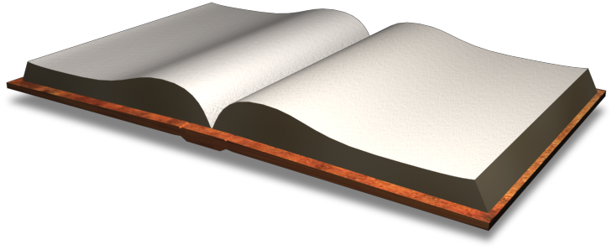 | Reading:  I can begin to use the strategies and resources I know with help.  I can increase my vocabulary by using context cues, other reading strategies, and resources (dictionary/thesaurus) with help.  I can read medium level chapter books.  I can expand my knowledge of different genres (e.g. realistic fiction, historical fiction, and fantasy).  I can begin to show my understanding of the difference between fact and opinion.  I can respond to issues and ideas in literature as well as facts or story events.  I can make connections to other authors, books, and perspectives.  I can participate in small group literature discussions with help.  I can choose reading materials at an appropriate level with help.  Vocabulary/Spelling: I can spell P5 common words correctly.  I can review my writing and edit my spelling, punctuation and grammar (omitted words, making sense etc.).  Writing (including Grammar/Punctuation):  I can vary the structure of my writing with help.  I can organise my ideas using notes.  I can write persuasively about ideas, feelings, and opinions.  I can create characters in stories with help.  I can write using carefully chosen language with help.  I can share my ideas with others.  I can use apostrophes, commas, and speech marks correctly with help.  I can use criteria for effective writing to set own writing targets with help.  I can share my ideas with others.  Listening and Talking:  I can listen for a specific purpose and share what I have learned in my own words.  I can show my understanding of notes I have created through explaining them to others.  I can put information I have learned from others into my own words.  I can use the main ideas, themes and purposes of a text to make connections (text-text, text-self, text-world).  I can use a range of ways to organise information I have gathered (graphic organisers, mind maps, posters etc.  I can identify suitable vocabulary to use to meet the needs of my audience.  I can demonstrate an understanding of what I have listened to/ watched by asking thoughtful and pertinent questions.  I can clarify points by asking questions.  I can clearly share information with others.  I can give a talk ensuring that the pace and volume is appropriate for the audience.
Maths and Numeracy  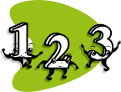 | Topics to be covered this term in differentiated groups include:  I can use a written method of addition and subtraction.  I can use the most appropriate strategy for solving addition & subtraction problems  I can use my table facts and mental methods to recall my times tables.  Time  I can tell the time in increments of 5 minutes and 1 minute times.  I can use timetables to help me plan my time.  I can measure how long tasks or events will take.  I can tell any time on 12 hour digital and analogue clocks.
Social Studies/ Sciences   | Robert Burns/WWII  I can listen to Robert Burns poems and explain which one I prefer and why.  I can discuss why Robert Burns was important, placing him within a historical sequence.  I can write a menu for a Burns Supper.  I can design a new tartan and design an outfit using it.  I can write a letter in a role as an evacuee from WWII.  I can describe how diets were different during WWII and why.  I can find out about women’s wartime jobs and what they entailed.  I can explain what the holocaust was and describe some events that happened.
Expressive Arts   | Art:  I can design a Viking outfit, complete my Starry night inspired image and talk about Van Gogh’s Art, complete my Blitz picture using different mediums, create a piece of Art based on enlargement using a frame, investigate different artists and designers and talk about them and draw a realistic eye.
 | Drama: Inspired by our topic, I can express my ideas, thoughts and feelings through creative work.
 | Music: I can communicate my ideas through musical activities and can follow performance directions during practical music making activities.
Technologies | I can use the internet to find out information.  I can use what I have learnt to support my learning in different ways.  I can stay safe online.
Religious and Moral Education  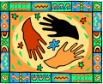 | I can show my understanding of values such as caring, sharing, fairness, equality and love.  I am becoming aware that people’s beliefs and values affect their actions.
Health and Wellbeing  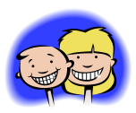 | P.E.  Gymnastics  I can explore balance, rotation, travelling, jumping and flight in different gymnastics contexts.  I can use a variety of different apparatus and floor situations to build confidence, resilience and improve my skills.
Modern Languages   | French:  I can greet others and share information about myself.  I know the days of the week and months of the year and can say the date.
Homework  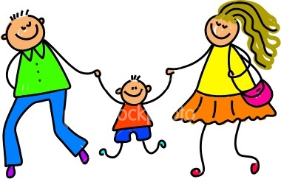 | Maths  https://www.sumdog.com/ (pupils’ individual log-ins can be found in diaries)  http://www.coolmath-games.com/  Maths, reading & language skills  www.readtheory.org (pupils’ individual log-ins can be found in diaries)  Spelling  www.spellingshed.com  Exercise and Dance  http://www.cyber-smart.co.uk (log in using school email tingwall@shetland.gov.uk and postcode ZE29SE)  All curriculum areas (choose appropriate level)  http://www.bbc.co.uk/education - Bitesize

