Curriculum Overview Term 3
P2/3
Literacy and English  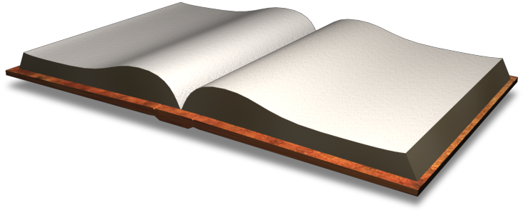 | Reading  - I can read for information.  - I can use the contents and index to locate the information that I need.  Writing  - I can compose a Body Parts description poem using similes.  - I can write Body Part Action Poem.  - I can create my own Funnybones story board.  - I can write instructions for how to carry out a lung capacity experiment.  Listening and Talking  - I can listen to other people in my group.  - I can give a short solo talk.  Spelling  - I can learn my weekly word list.  - I can spell tricky words accurately.
Maths and Numeracy  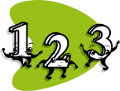 | Addition and Subtraction  - I can continue to develop my adding and subtracting skills.  Multiplication and Division  - I can share out a group of items by making smaller groups.  Money  - I can identify and name all coins and notes and give change.
Social Studies/ Sciences   | Topic – My Healthy Body  - I can examine and identify parts of the body that can move where bones meet.  - I can discuss the importance of having a healthy mind as well as a healthy body.  - I can identify where muscles are in our body and discuss those we use most often.  - I can discuss the importance of our skin and the nerves that help us feel.
Expressive Arts  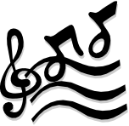 | Art: I can:  - complete my marble run design from last term  - design and create an Up Helly Aa shield  - design a Viking outfit  - use different mediums to create a burning galley picture  - recognise visual elements  - describe and discuss Alessi design work  - investigate different artists and designers and talk about them
Music:
- I can follow musical performance directions and show basic singing techniques and basic instrumental techniques with increasing confidence.
Technologies   | - I can use a range of information resources, such as a search engine or specific website to create a fact file about my body and staying healthy.  - I can create a model of the human brain with Paper Mache.
Religious and Moral Education  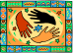 | Stories  - I can discuss special people from religions around the world.
Health and Wellbeing  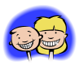 | - I can discuss how to keep my body healthy.  - I can take part in daily physical activities to keep my body healthy.  - I can discuss what foods are good for my health.
P.E.
I can take part in playground games during class P.E.
I can record how my heartrate changes during class P.E when doing a variety of activities.
Gymnastics.
I can learn new movements and gymnastics skills.
I can control my movements more fully whilst completing challenging tasks.
I can sustain positions and movements whilst learning. I can increase my flexibility. I can demonstrate resilience, confidence and determination in new and challenging situations.

  Modern Languages | French:  - I can talk about how I am feeling.  - I can say parts of the body in French.  - I can say colours in French.
Homework  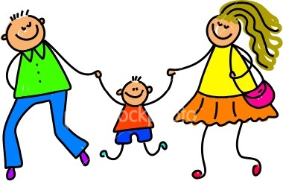 | Optional:  - Visit the library and enjoy some books of your own choosing.  - www.sumdog.com login details in front of your homework diary.  - Education city, Login details are in your diary.  - Keep a food and exercise diary for a week.

