How do I find my class notebook?

- Go on to the P7B Team and open the General channel. This is shown in a red circle below:
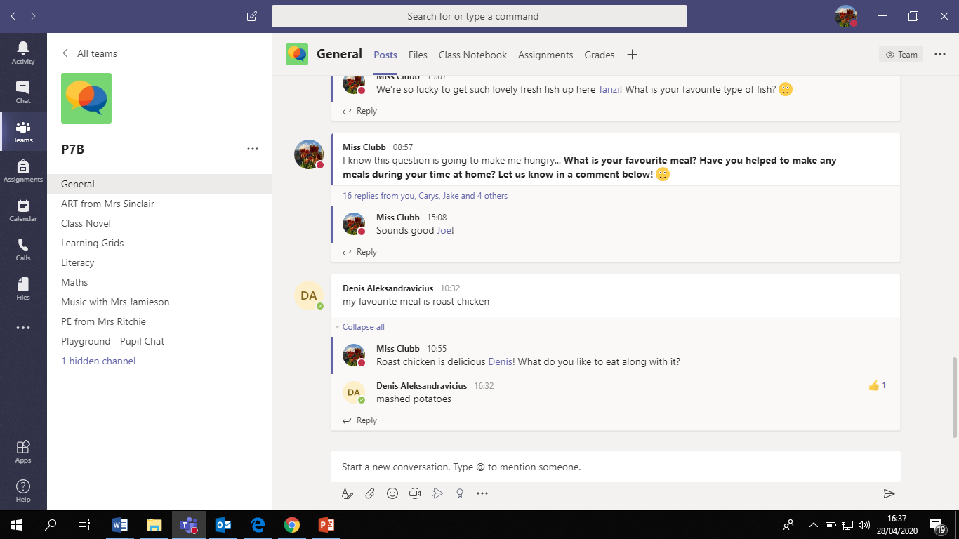

- Click on ‘Class Notebook’ at the top of the General channel. This will open up the notebook!
This is circled in the picture below:

