How do I add my work to my notebook?

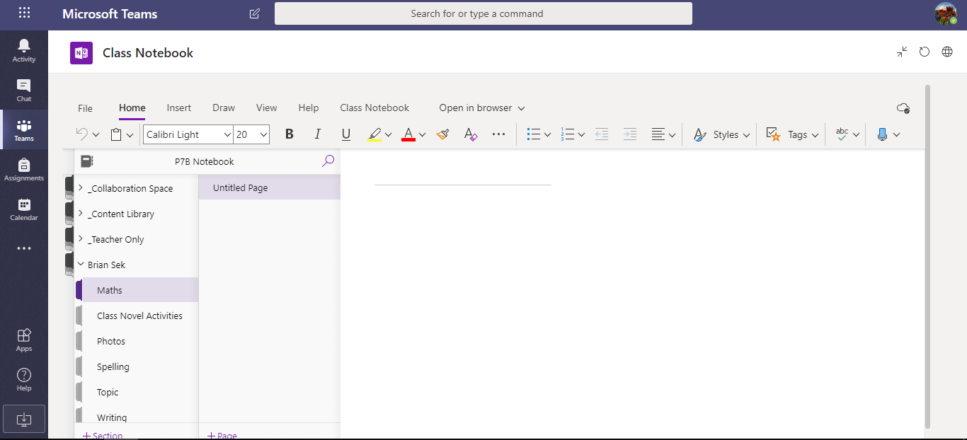
- When you have opened up your own notebook, you will see that it is split up into sections. This is shown in a red box in the picture below:
Your name will be here
- You need to choose the section where you want to add your work. For example, if you are adding your Class Novel comprehension, choose the ‘Class Novel Activities’ section. This is shown in a red box below:
Your name will be here
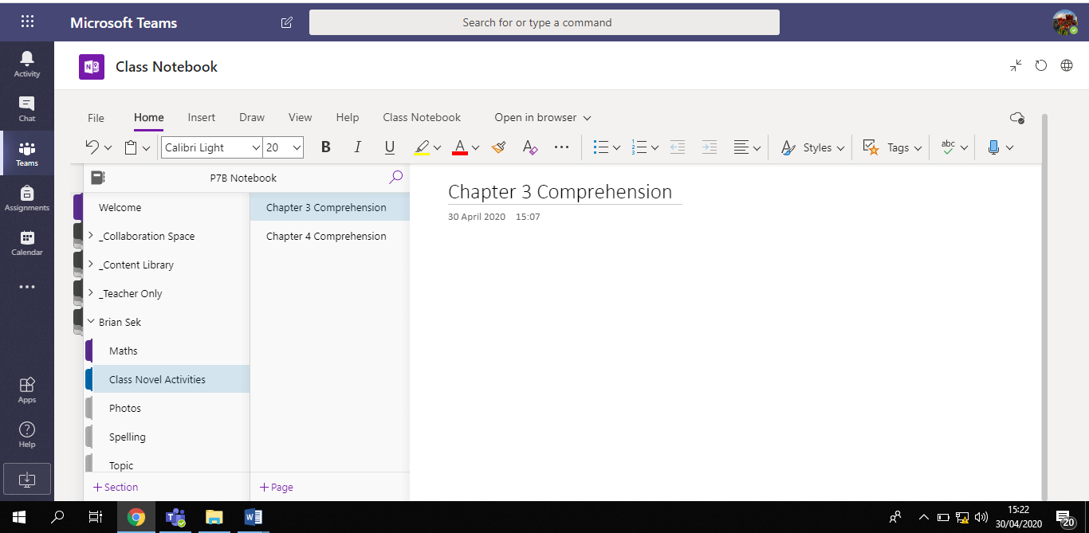
- When you click on ‘Class Novel Activities’ you will see that I have already split it up into separate pages for Chapter 3 and Chapter 4 comprehension. You can see this in the red box in the picture below:
Your name will be here

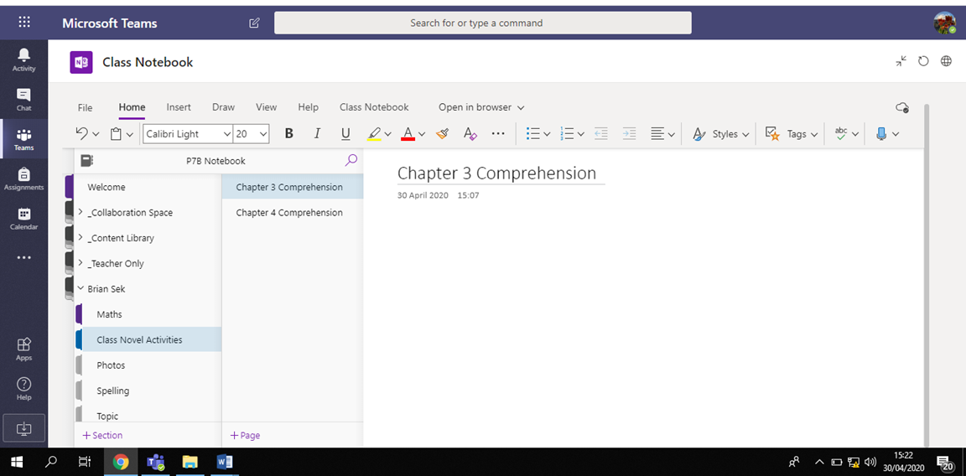
- Click on the section you want to add work to. For example, if you want to add Chapter 3 comprehension activities click on that page. You can see this in the picture below:
Your name will be here
- If you have done something extra and need to add a new page to that section of the notebook, simply click ‘+Page’ at the bottom of the page. This is shown in a red box below:
Your name will be here
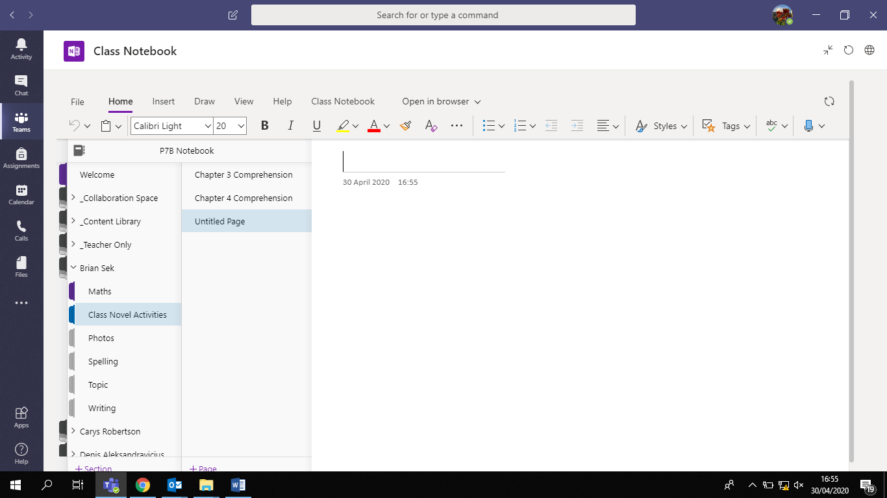
6. You will need to give your new page a title. Click in the area shown below in a red box and begin to type to add your title!
Your name will be here

You have three options for adding work to your notebook:
- Add a photo of your work
- Attach the document you have made (word document)
- Type your work right into notebook! (This is the easiest option ).
To add a photo of your work:
- Click on ‘insert’ at the top of the page. See red box below:
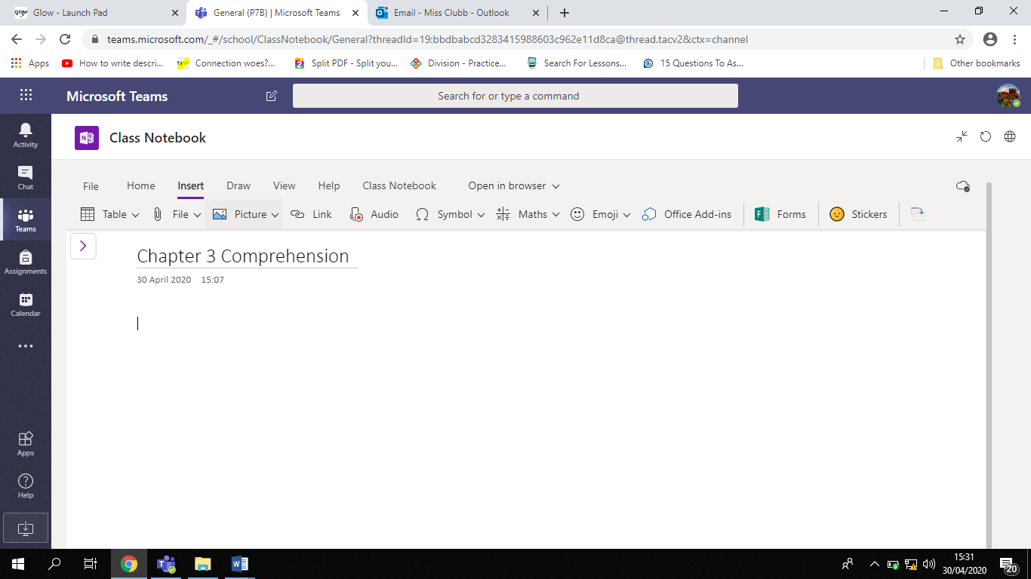

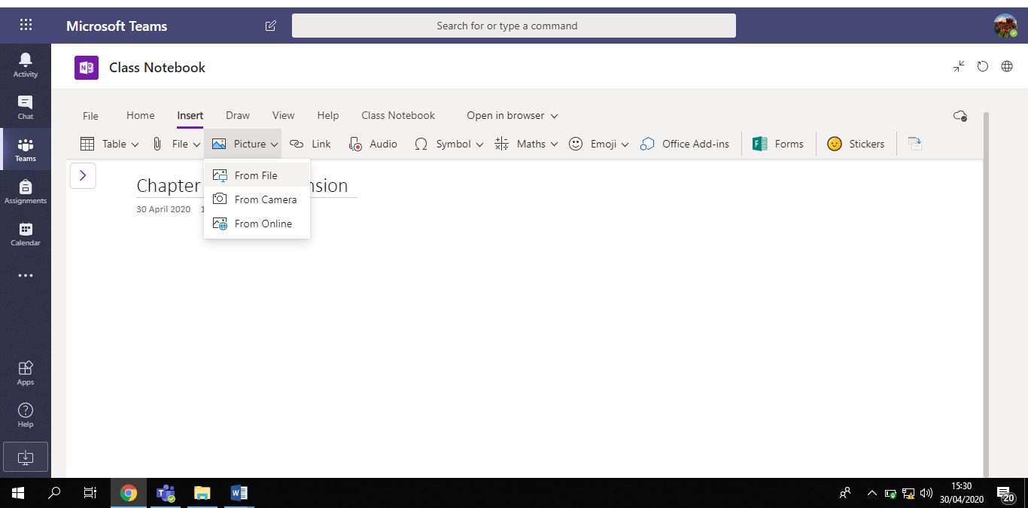
- Click on ‘picture’ and choose ‘from file’. This will let you search your computer or phone for the photo you are looking for. This is shown in a red box below:
This will let you have a look through your photos for the right one!
To attach your work if it has been done in a separate document (for example a story typed up in a word document):

- Click on ‘insert’ at the top of the page. See picture below:

- Click on ‘File’, as shown in a red box in the picture below:

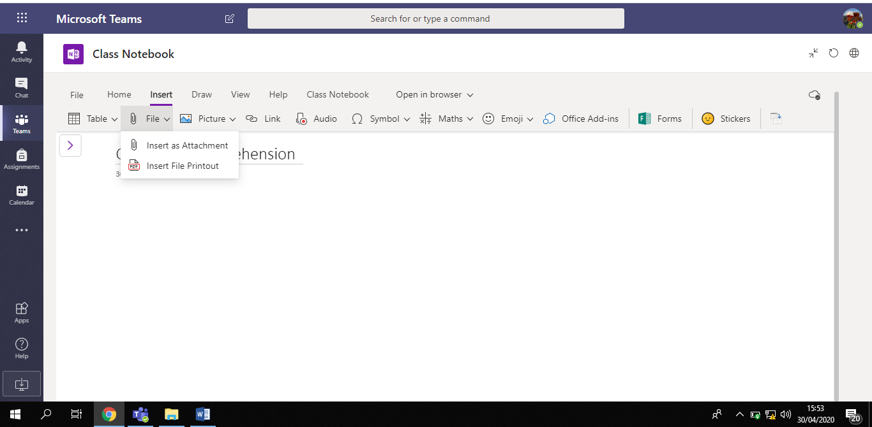
- When you click on ‘File’ you will see two options. This is seen in a red box in the picture below:
- You can choose either option!
‘Insert as attachment’ - this will let me see a little link to the document.
‘Insert file printout’ – this will let me see the whole page of the document in your notebook.

Either option is fine!

To add your work by typing it straight into your notebook:

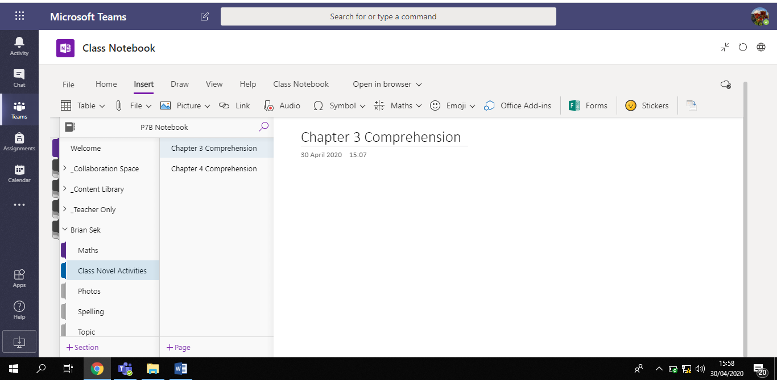
- Open the page you want to type into. For example, if I was adding my Chapter 3 comprehension, I would click on that page in my notebook. This can be seen in a red box below:
- Click on the blank space on the page, below the title ‘Chapter 3 Comprehension’. There are arrows pointing to this space in the picture below:
- Type straight into this space! Glow will automatically save your work for you! Magic!

How do I see Miss Clubb’s Feedback?

I will be able to see anything that you add to your own notebook. I will add my feedback to the bottom of the page in purple writing! Look out for it

I look forward to reading through all of your brilliant work!

