How do I find my own space on Class Notebook?
- When you open the class notebook, you will see a screen like the picture below. First of all, choose to make the notebook full screen so it is easier to see everything.

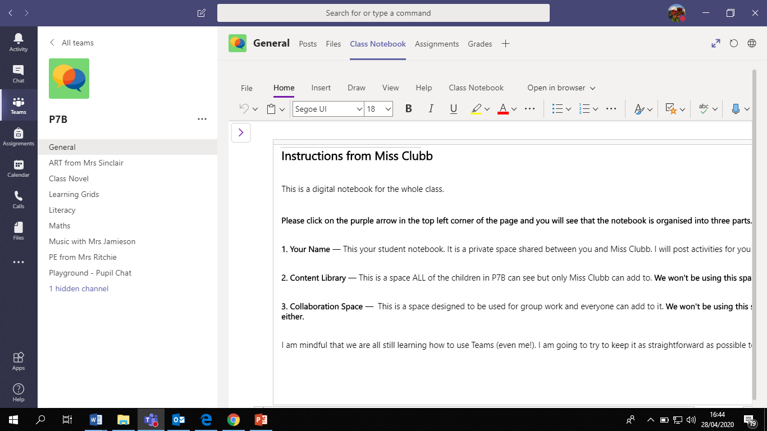
- Click on the arrows circled below to make the notebook full screen:
- Open the notebook menu by clicking on the purple arrow circled in the picture below:
- When you click on the purple arrow in Step 3, you will see three sections.
- Your Name
- Content Library
- Collaboration Space

- Click on your own name to see your own personal notebook.

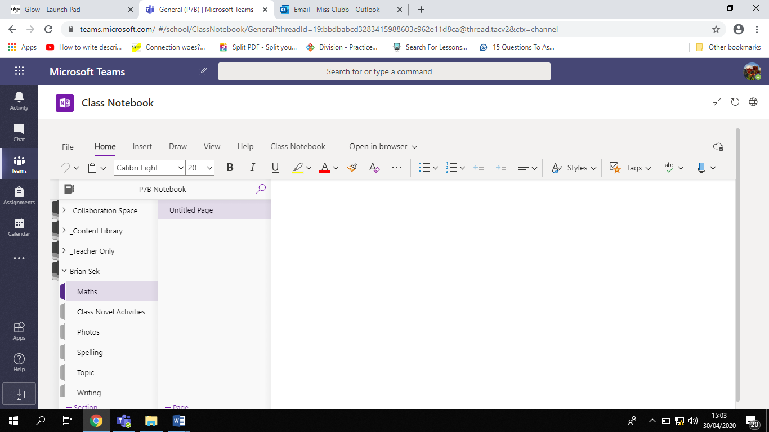
- When you open your own notebook you will see different sections below your name, as shown in the red box in the picture below:
Your name will be here

- You can click on the section where you want to add your work!

