Sumdog Challenges – How do I get on?
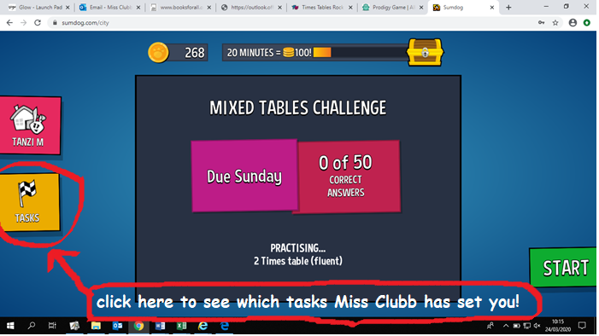
When you first log on to Sumdog (your parents were sent your Sumdog login details in an email) you will have to ‘race’ sumdog to the finish line and answer a few questions. Once you have done that, you will reach a screen which looks like this:
your teacher

Click on the ‘Tasks’ tab at the side of the screen and you will see your challenges!
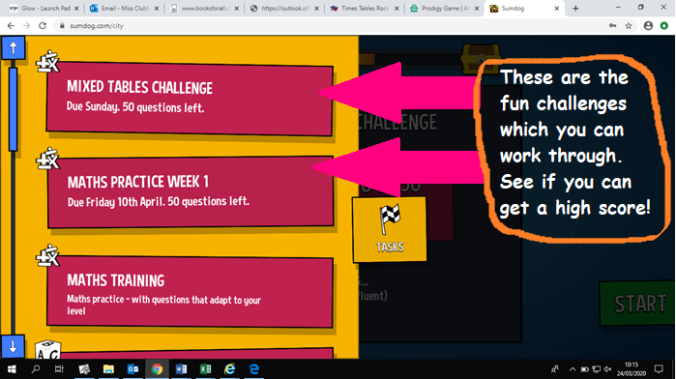
You will then see a screen which looks like this (remember: your challenges might have different names than the ones in the picture below)

Choose which challenge you would like to work on and try to get your best score! I will be able to check in and see how you are getting on! Have fun!

