How do I find a channel and a file on Teams?

When you click on the Microsoft Teams app, you will reach a page that shows you what teams you are in. Click on the ‘P7B’ team, which is shown in a red box in the picture:
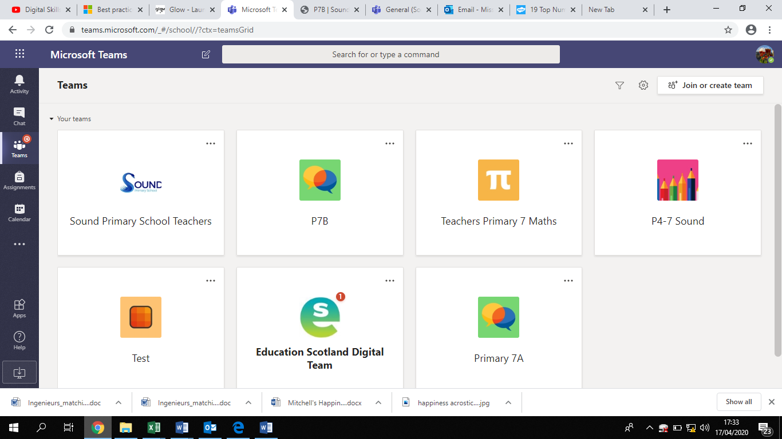

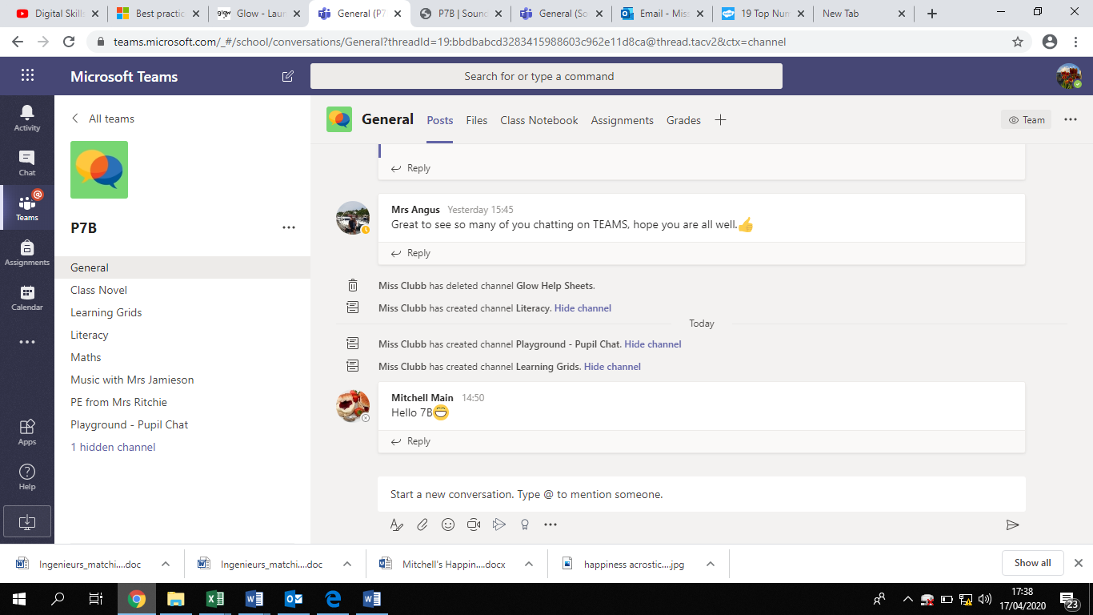
Click on the ‘P7B’ Team and that will take you to a page that looks like this:

The ‘General’ channel is like the home page for our class team. On the left hand side, you will see different channels in our class team. This is the different sections within the team. You can see the list of channels in a red box in the picture below:

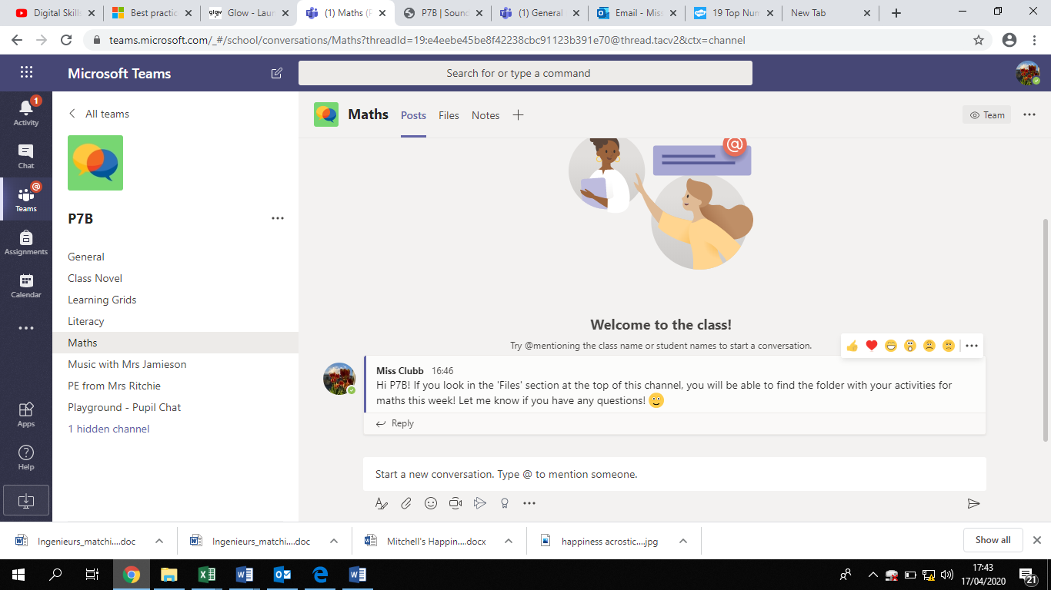
Choose which channel you want to look at by clicking on the channel name. For example, if I click on the ‘Maths’’ channel, it will take me to a screen like this:
At the top of each channel, there is a section called ‘Files’. This is where you will find the activities that you need to do for that subject. The picture below shows you the ‘Files’ section in a red box:
When you click on ‘Files’ you will see the folder for each week, which will have all of the activities you need in it! This can be seen below:
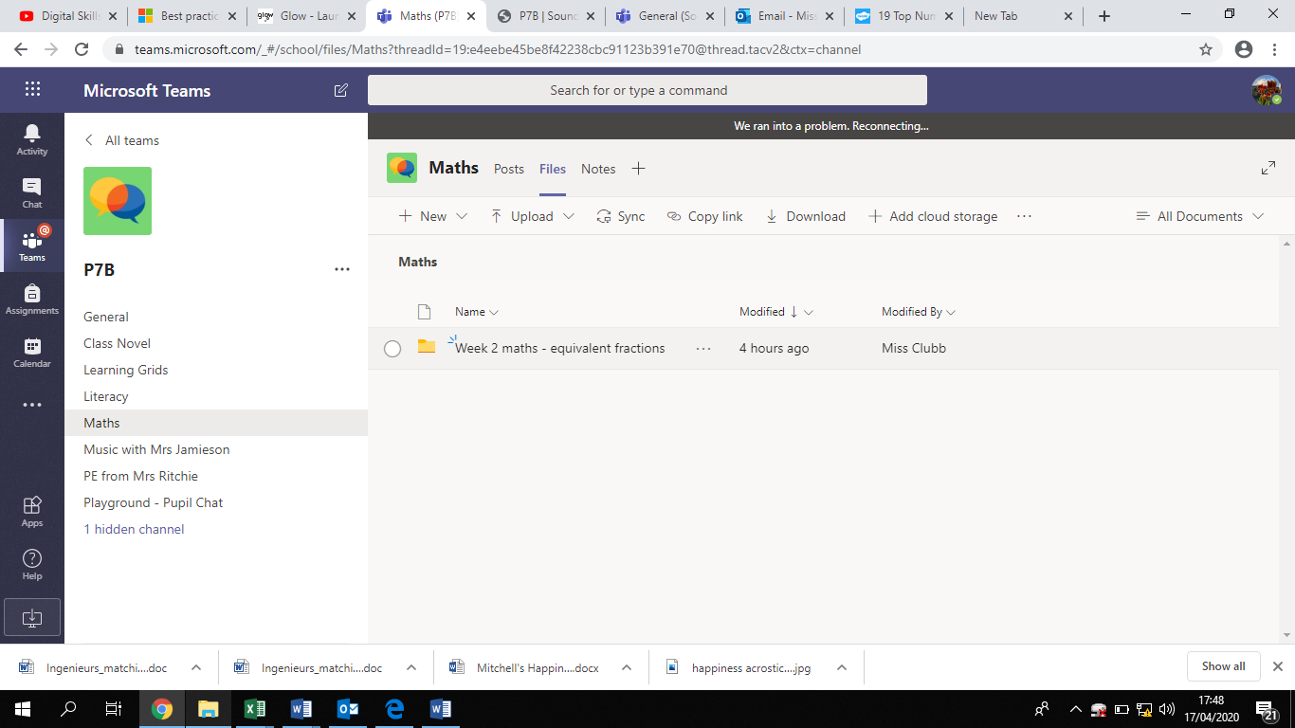
Let me know if you have any problems finding a file on our class team!

