How do I attach a file to an email?

- When you go to write your email, select the ‘attach’ option at the top of the screen, I have circled this in red in the picture below:
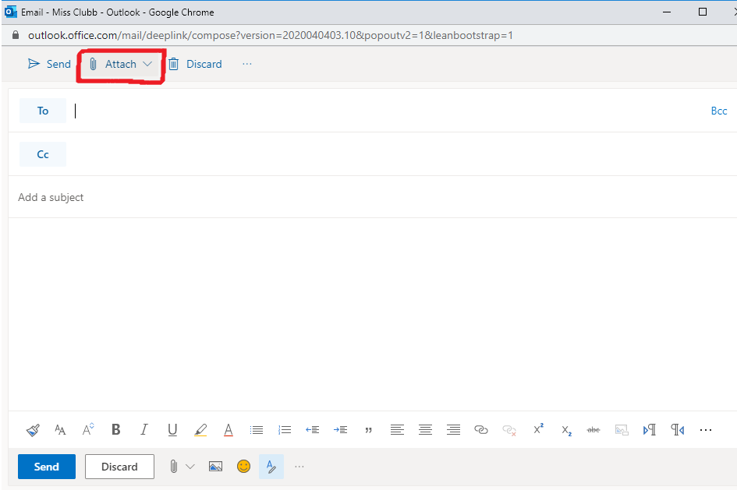

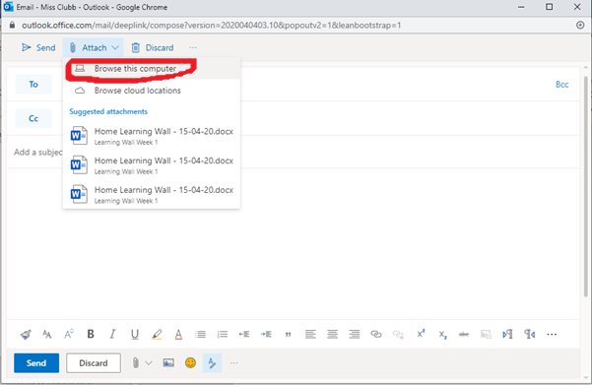
- You will see a few options when you click on ‘Attach’. Choose to ‘Browse this computer’. This will open up your documents and allow you to find the file which you want to attach. You can see this in the picture below:

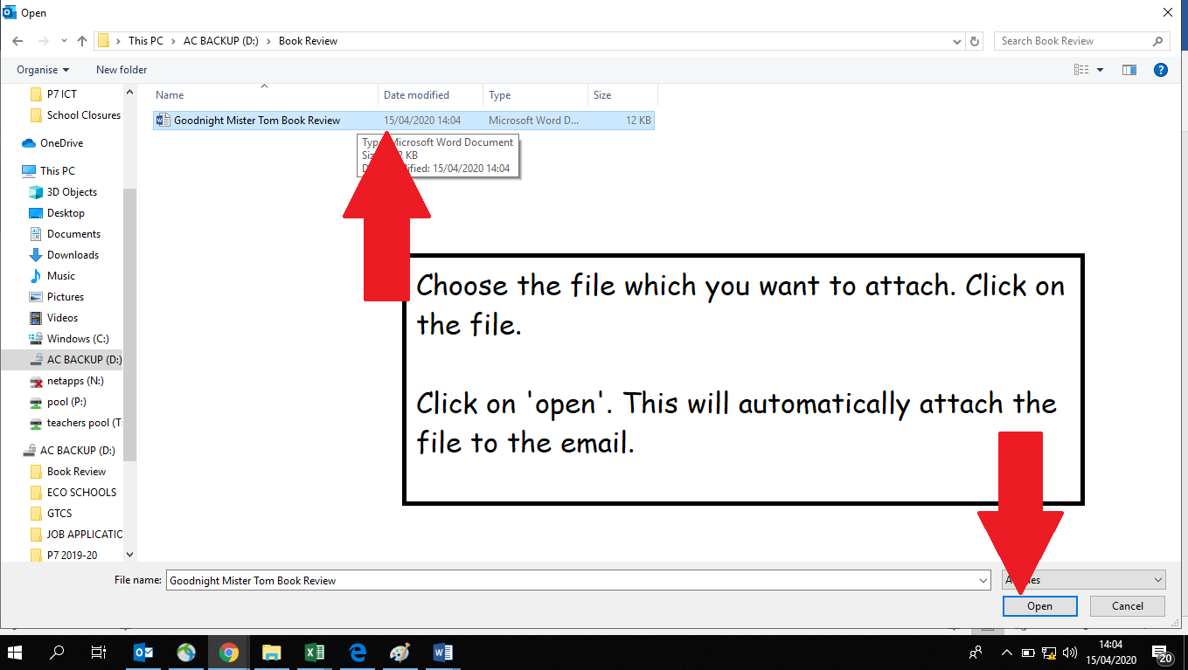
- Once you have clicked ‘Browse this computer’, it will open up a screen which looks like the picture below. Follow the instructions on the picture below to find a file and attach it to the email.

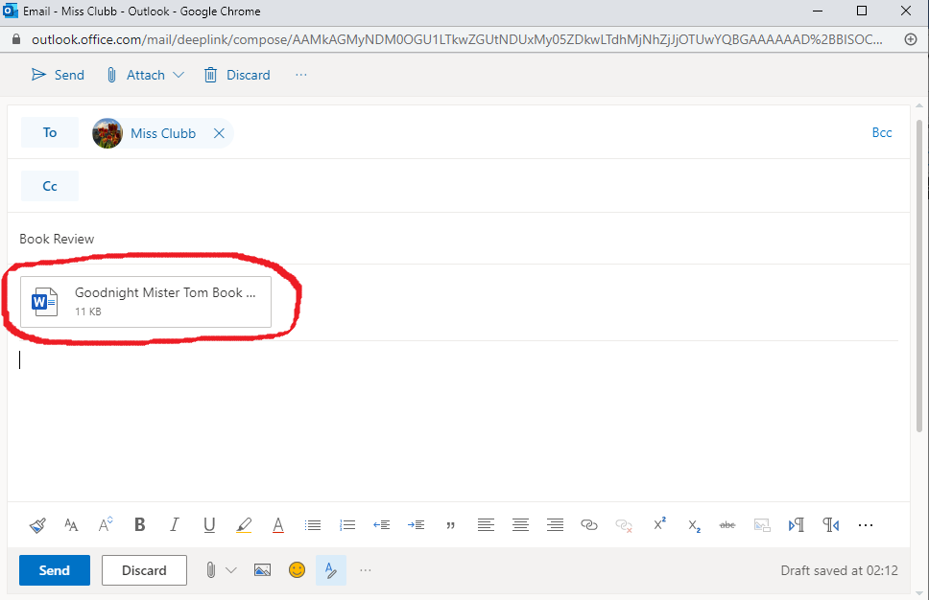
- You will know the file is attached to your email when you see it on the email, below where the ‘subject’ box is. The picture below shows what this will look like:

