How do I add a new tile to my Glow launch pad?

- When you first log into Glow, you will come to your ‘launch pad’ which is kind of like your home page. This will be filled with ‘tiles’ which are all of the apps you choose to have on your homepage which you use regularly.

- If you want to add a new ‘tile’ or ‘app’, scroll down on your launch pad until you see ‘Add’. This is shown on the picture below in a red circle:
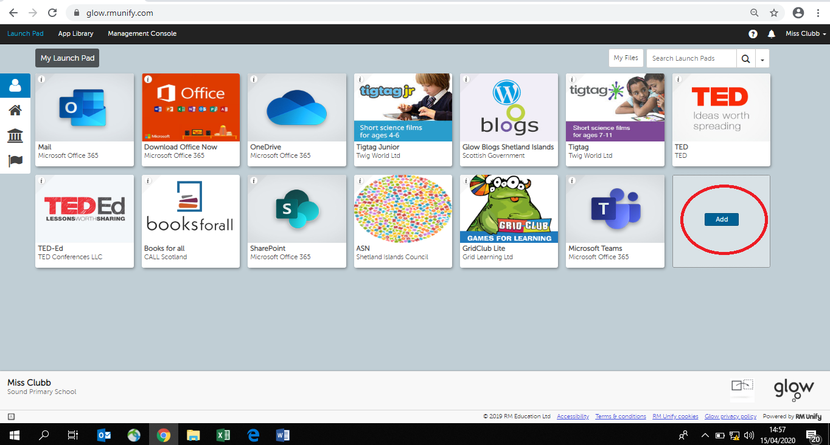

- When you click on ‘Add’ you will see that you can choose ‘App from Library’, click on this, as shown in the picture below:
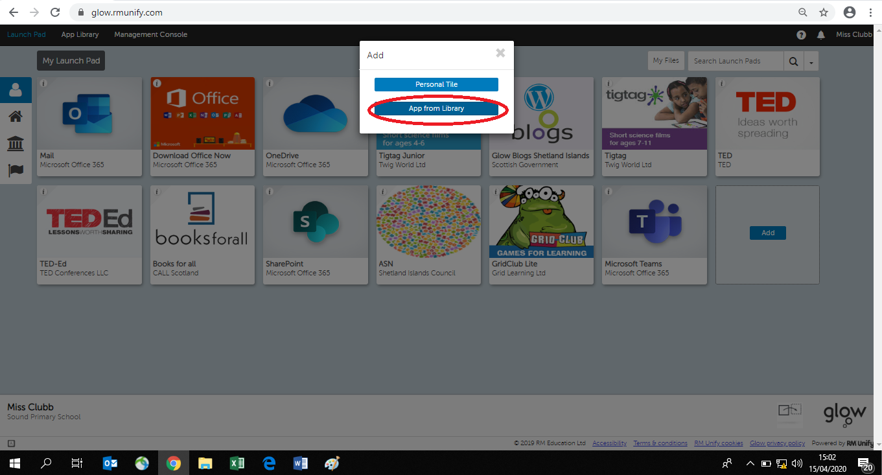

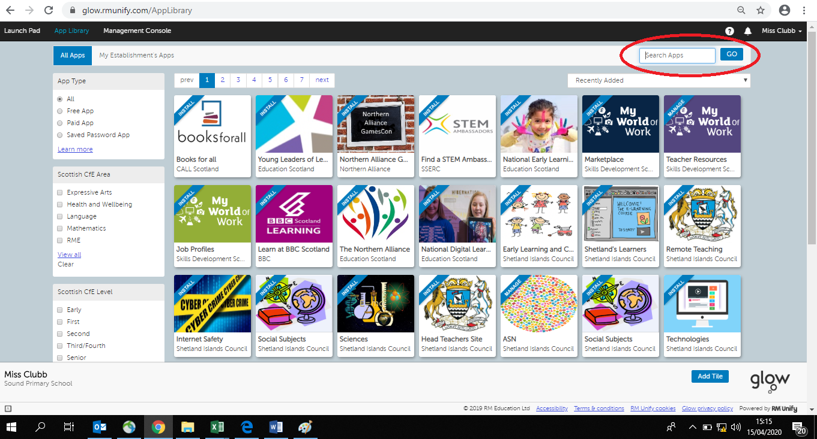
- You can search for the app that you are looking for by typing in the name of the app into the ‘search bar’. You can see this in a red circle in the picture below:

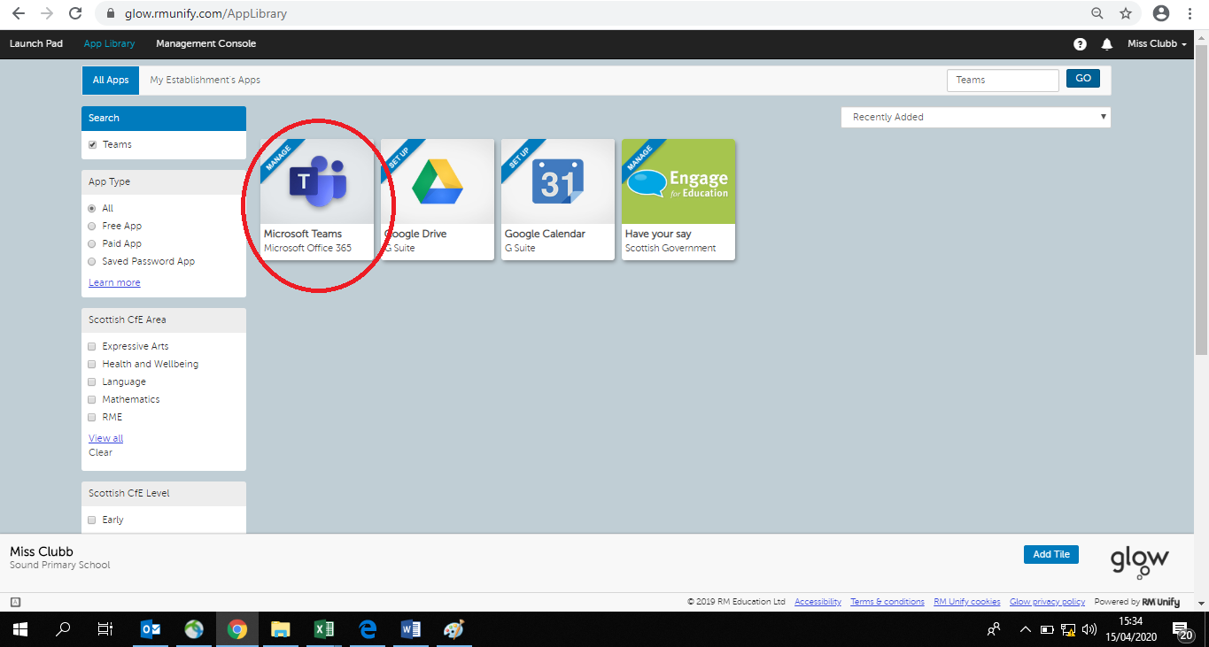
- The app that you have searched for should then come up. In the picture below, you can see that I have searched for ‘Teams’ as an example. Click on the app that you want to download.

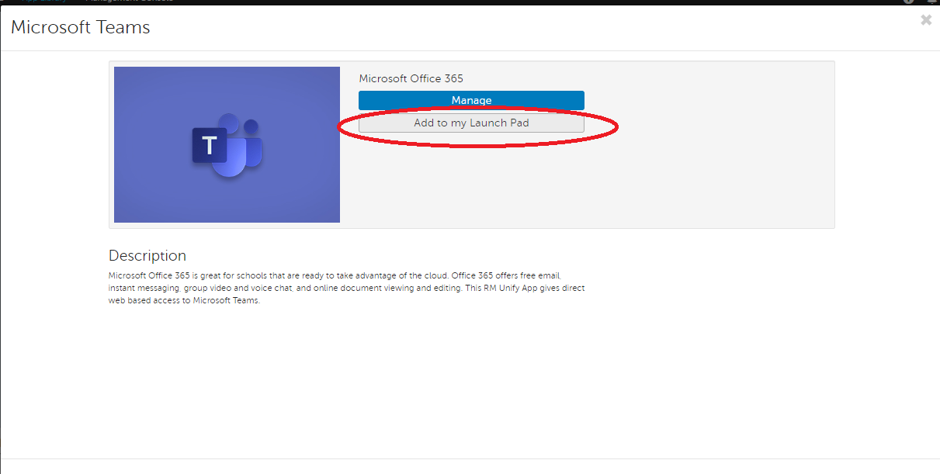
- When I click on the app which I want to download, you can choose ‘Add to my Launch Pad’. You can see this in the red circle in the picture below:

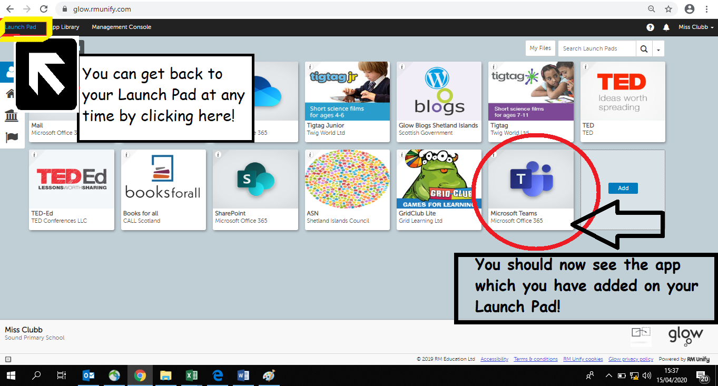
- You can get back to our Launch Pad at any time by clicking on the ‘Launch Pad’ button in the top left hand side of your screen – as I have shown in the picture below. You should now see the app which you have added and it will be ready to use! Well done!

