Optional Family Learning Grid
Festivals and Celebrations Project Primary 1 | Reading: Daily phonics revision using the phonics learning grid, the flip book and phonics cards. | Sumdog: https://www.sumdog.com/user/sign_in
Literacy | Mark Making: Make a name sign for your bedroom door, you could draw pictures of your favourite hobbies, toys or even use different colours and patterns to make your sign personal to you. | 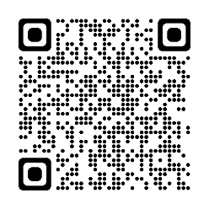  Festivals of Light Story: Listen to the ‘Little Glow’ story by Katie Sahota and Harry Woodgate.
Numeracy | Spend time together by playing a board game using a dice to practise counting. | Bake with your family, can you speak about the measurements and the time it takes to bake.
Other | Christmas - Take a walk through Lerwick to look at the Christmas lights and displays. | 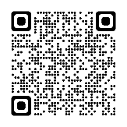  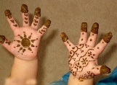  Diwali – Draw around your hand on a piece of paper and design a mehndi pattern.  Here is a clip about Diwali:
 | 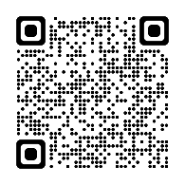  Hanukah – Eat your dinner in the candle light like Jewish people do to celebrate Hanukah.  Here is a clip about Hanukah: | Guy Fawkes/Bonfire Night – Watch the fire works with your family and take a photo of them or a bonfire.

