Sound Nursery
Working together to improve outcomes for learners to be the best that they can be.
Sound Nursery is an inclusive and nurturing environment where children have free flow access to indoor and outdoor spaces where they can lead their learning. Children have opportunities to experience high quality continuous provision based on their interests and needs. We are committed to working with families to ensure that your child makes progress and develops confidence to lead their learning. We have an open-door policy and welcome the opportunity to chat with you at any time.
We use the school environment as part of our nursery provision. We access spaces across the school, including the library, gym hall, sensory spaces and school grounds, all which enhance the children’s experiences and support transition to school.
Incredible Years underpins our nurturing approach and staff use the strategies actively in the setting. Our nursery rules are based on our nursery and school values. Almost all staff have completed Incredible Years training at the Shetland Family Centre. We also reflect the UNCRC rights in our practice and these are highlighted in our play statement.
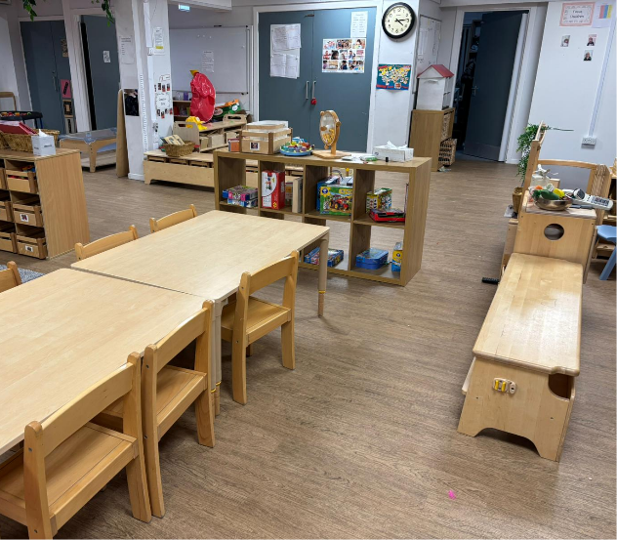
Our Nursery and School values are:
Determination Happiness Inclusion Safe Respect
We are open from 8:30am to 4:30pm, Monday to Friday.
Please visit our Nursery blog to find out more information:
https://blogs.glowscotland.org.uk/sh/soundnursery/

