Technologies  Primary 5A Term 4 Curriculum Information 2024  - Internet research for topic.  - Use computer software to produce posters, presentations and display data.  - Work through Coding Course. |  | English and Literacy  - Reading – Literacy World, Ginn 360 and Oxford Reading Tree books will be used in class as appropriate.  - Writing – Writing will mostly be topical. Functional writing such as writing instructions, experiment write-ups and some reflective accounts.  - Grammar/Punctuation – Continue to revise commas, quotation marks, adjectives and adverbs.  - Handwriting - Practice of joined script will continue to be encouraged.  - Vocabulary /Spelling – This is taught in class and supported by Nelson Spelling.  - Class Novel ‘A Stranger Came Ashore’ by Mollie Hunter. |  | Art  In art we are learning to construct a coil pot using clay. We are also learning to draw a landscape with a back, middle and foreground.
Topic: Water  - Learn about water as a resource and consider how water can be saved in the home.  - Learn about the different stages in the water cycle.  - Experiment with water – dissolving, floating and sinking, the changing state of water  - Learn about plants and the importance of water.  - Research main bodies of water and famous rivers and seas |  |  |  | Health and Wellbeing
- PE with Mrs Ritchie – netball, hockey, football.
- Daily Emotional Check in
- Daily Mile
- Relationships, Sexual Health and Parenting - Relationships, being safe, growing up, their bodies
Click here for information
Numeracy and Mathematics  - Money  - Fractions and Decimals  - Measure in order to find the length, weight and capacity  - Compile graphs and interpret data  - Revise mathematical language – multiple, factor, area, perimeter, etc. |  |  |  | Music  We will be linking music with environmental issues. Learning about the Landfillharmonic orchestra. Creating our own musical instruments out of waste materials. Write our own plastic pollution themed raps. Learn how music tells a story, looking at Traditional Scottish ballads, classical pieces and the importance of music in film and TV.
 |  | 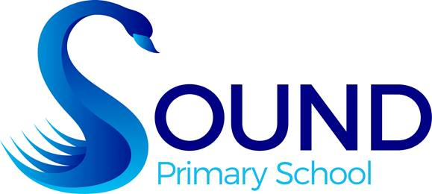

Modern Languages
German We will be learning greetings, days of the week, numbers to 10 and colours.
RME
- Buddhism
Our School Values this term are Inclusion and Happiness

