Please use the QR code to access our class blog.

Project Name  Stories of the Sea | Reading: Daily | Numeracy links  Sumdog  Times Tables Rock Stars: Play (ttrockstars.com)
Literacy | 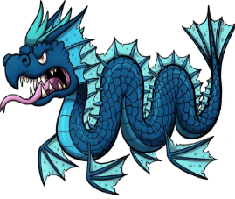  Create a Mythical Sea Creature  Be creative and make up your own story about a mythical sea creature. What does it look like? How does it live? Is it dangerous? | Research an Ocean  Choose one ocean to research. Gather your information and decide how you will present it back to the class. You could make a powerpoint, a poster or just read from your notes.
Numeracy | 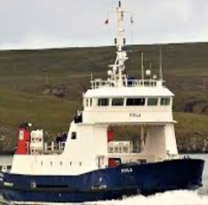  Shetland Ferry Timetable  Plan a journey to a Shetland island for a day. Use the SIC ferry timetable to decide when and where you would go. Decide how long you will stay for and when you will come back. | 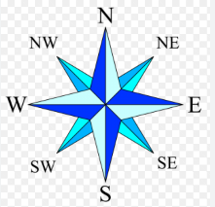  Compass Rose  Draw your own compass rose and  label with it each direction.  Colour it in neatly and carefully.
Other | Pier Walk  With an adult, have a stroll along one of the piers in Lerwick and note down the different boats that are tied up. Where are they from? Look for clues in their registration numbers and the flags they might have flying. | 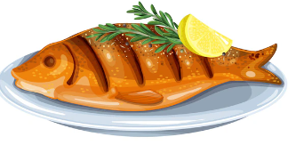  Fish Recipe  Help someone at home make a fish dish. Then write down the recipe for the class. Firstly list the ingredients then write step by step instructions.
 | 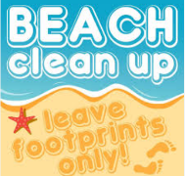  Beach Clean  Take a carrier bag and see if you can fill it with any rubbish that has been washed ashore. Help keep our beaches beautiful! | Interview  Is there someone you know that has a story about the sea? They might have been at the whaling. They might work on a fishing boat or have a job in the fish market.  Make up questions and note answers.

