Please use the QR code to access our class
blog.

Project Name  SPACE | Reading: Daily | Numeracy links  Sumdog  Times Tables Rock Stars: Play (ttrockstars.com)
Literacy | Design a Planet  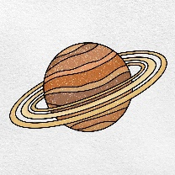  Design your own planet and describe what it would be like to live there. Is it a cold or hot planet? Is it gassy or rocky? What lives there? | 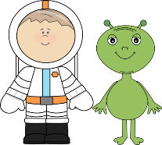  Diary Entry  Write the ‘day in a life of’ an astronaut OR an alien. Tell us their adventures in space.
Numeracy | Create a Model Rocket  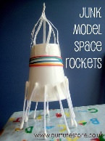  Be creative and make a ‘junk model’ of a rocket to bring into class. Think about the 3D shapes you have used to build your model. | 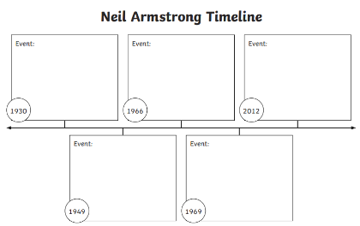  Make a Timeline  Research the life of Neil Armstrong and create a timeline to show his life and journey into space.
Other | Space Quiz  Make up a space quiz to take back into the class. Remember you need to know the answers! Maybe Mrs Leask could make a Kahoot quiz with your questions! | Constellation Spotting  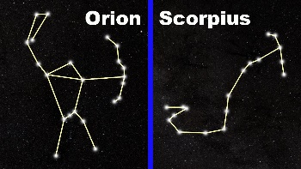  On a clear night, see if you can spot some constellations. Can you name them? Can you draw them?
 | 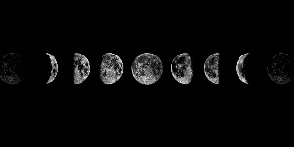  Moon Tracking  Moon diary – track the moon over a month and make a note of how it changes. | 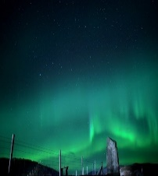  Northern Lights Hunt  Go for an aurora hunt and see if you can see the Mirrie Dancers. Can you draw a picture to re-create what you see?
Please email pictures of work to gw21leaskcaroline@glow.sch.uk

