Home Learning Grid Term 1 Week 4 P4A
Numeracy | Literacy | Health & Wellbeing
The maths activities always reflect what we have been working on during the previous week.  Click on the link to find a game to practise matching big numbers to the number words. Why not try a challenge on “fast fruit”  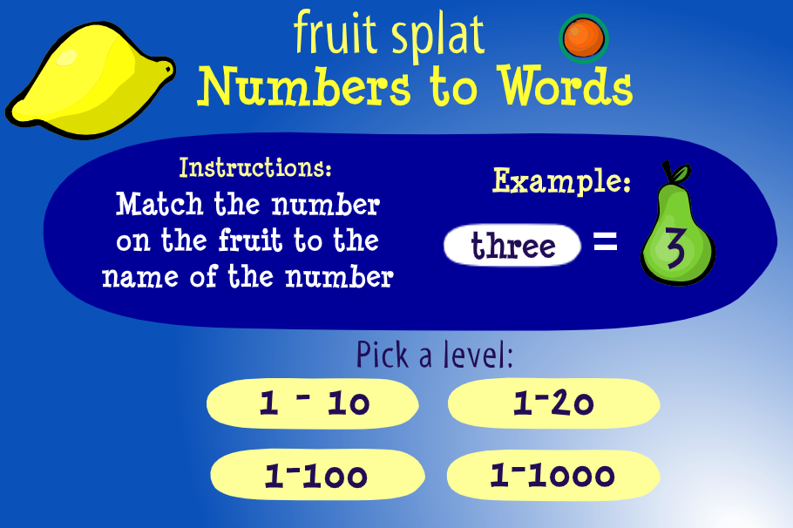  Number Words - Early Math- Fruit Splat Game - Math Game (sheppardsoftware.com) | 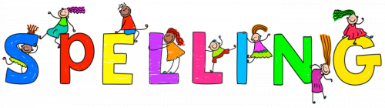  Spelling homework is a follow up from the week’s lesson. You will find a choice of fun spelling activities and the spelling lists for the term in assignments. The second assignment is the sheet you can write on if you have no printer or find it difficult to upload work.  There will be a spelling test on Friday, so please make sure you have practised before then. (Please keep the jotter at home) | Walking Eye Spy – On one of your walks this week, see if you can spot something that begins with each letter of the alphabet.
Reading pages can be found in your class notebook in TEAMS in the homework section.
Reading books will go between home and school and should be kept in a bag.
If you have any questions or concerns, please email me at: gw08hutchisonjulie@glow.sch.uk
Please share any learning with me by returning a photograph or writing on the sheet in assignments.
All tasks should be returned by Friday morning each week. Thank you

